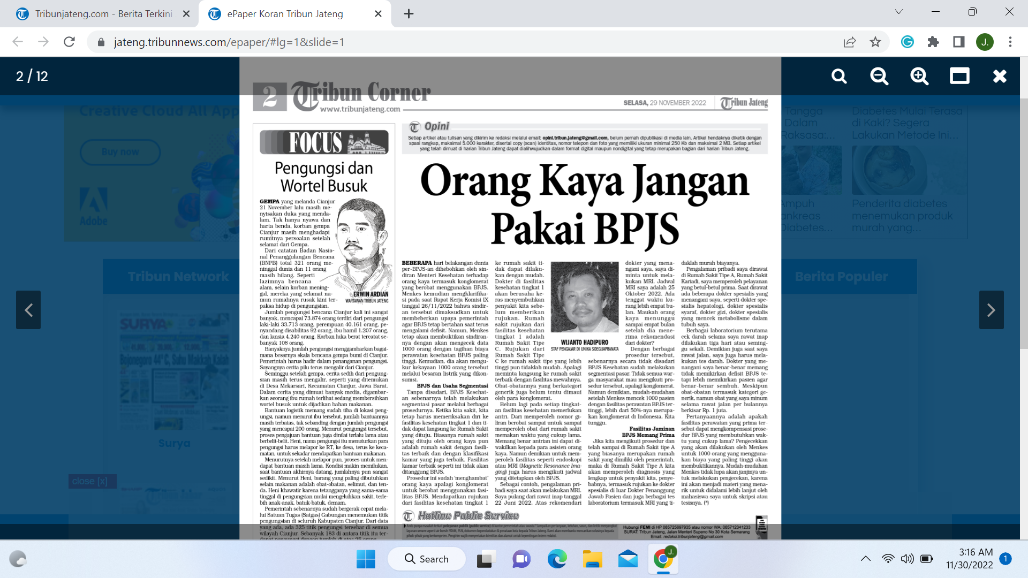

<https://jateng.tribunnews.com/epaper/#lg=1&slide=1>