GAMIFICATION SMART OFFICE AT PT GLORI INVESTAMA BERJANGKA
SURABAYA

Vincent Christian Y¹ , Andre Kurniawan Pamudji², Stephani Inggrit Swastini Dewi³

Department of Information Systems Soegijapranata Catholic University

Pawiyatan Luhur Sel. IV No.1 Street, Semarang, Indonesia
20n20004@student.ac.id ¹,andre.kurniawan@unika.ac.id ², stephaniinggrit@unika.ac.id ³

ABSTRACT
Organizations have adopted digital transformation in a number of operational areas, including human resource management, as a result of the development of information technology.Employee attendance management is one area that has drawn a lot of attention.
Conventional attendance systems frequently result in problems like late arrivals, missed check-outs, and decreased employee engagement because they prioritize administrative recording while providing little motivational value.
This research focuses on the development and implementation of a smart office based attendance system enhanced with gamification features at PT Glori Investama Berjangka Surabaya. The system is designed for Management Trainee (MT) employees and incorporates game-based elements, including points, attendance streaks, leaderboards, rewards, and chance-based mechanisms, to encourage discipline and consistency in attendance behavior.
Implementing Gamification in smart office attendance system helps maintain a shed to follow the discipline and also increase engagement. The new attendance recording system serves not only as an effective means of maintaining punctuality but acts also as a strategic practice to help the organization develop employees with high morale and performance. Keywords: attendance system, employee discipline, gamification, management trainee, smart office
Keywords: attendance system, employee discipline, gamification, management trainee, smart office
I. INTRODUCTION
One of the leading initiatives through which organizations can improve management of business processes and human resources is Digital Transformation. Information systems today move beyond information aggregation by enabling efficiency, transparency and evidence-based managerial decision-making. The smart office is an environment within the workplace that incorporates information systems and automation technologies to facilitate productive work practices and operational efficiency.
Attendance by employees is a key factor in human resource management and related to discipline and performance. And sadly many companies still employ either traditional or partially digital attendance systems which provide very little interaction and offer no motivational features. This leads to common issues like tardiness, incomplete attendance logging and little engagement by employees.
Gamification is broadly acknowledged as a useful technique for tackling motivational problems in non-game settings. Gamifying can inspire motivation, increase engagement, and affect user behavior by incorporating components of games in everyday activities. Previous studies also have shown that elements like points, leaderboards, and rewards can enhance user performance when they are introduced through the right design strategies
The existing attendance system at PT Glori Investama Berjangka Surabaya was only for administrative purposes, and did not provide motivational feedback for employees, especially Management Trainee. To overcome this limitation, in this study we implement an attendance system based on smart office that incorporates gamification elements to improve employee discipline and work consistency. This study aims to develop a gamified attendance system, implement it in practice, and conduct an evaluation of the effects of its early introduction.
II. Method

2.1 Research Design
This study used a descriptive and developmental research design in which the system was developed and implemented directly in a real organizational environment. This approach is commonly applied in information systems research to examine how digital systems support organizational processes and users[1],[2].
The system development process followed the Waterfall model, which consists of sequential stages including requirements analysis, system design, implementation, testing, and evaluation. This model is appropriate for organizational information systems that have clearly defined and stable requirements [1].

2.2 Population and Sample
The population of this research consisted of 100 Management Trainee (MT) employees at PT Glori Investama Berjangka Surabaya. All MT employees were involved during the system implementation phase, as they were the primary users of the smart office attendance system.
For system evaluation, 31 MT employees participated as respondents. The use of partial population data is acceptable in descriptive information system studies when the focus is on usability, acceptance, and initial system impact [2].

2.3 Data Sources
This research used two types of data sources: primary data and secondary data.
2.3.1 Primary Data
Primary data were collected through questionnaires distributed to Management Trainee employees after they used the gamified attendance system. The questionnaire captured user perceptions related to attendance discipline, consistency, motivation, and system usability. Questionnaires are widely used to evaluate usability and user experience in information system research [3].

2.3.2 Secondary Data
Secondary data were obtained from textbooks, journals, and conference proceedings related to information systems, digital attendance systems, smart office concepts, gamification, user experience, and motivational theory. These sources provided the theoretical foundation for system design and evaluation [6], [7].

2.4 Data Collection Method
The primary data collection technique used in this study was a questionnaire survey. Questionnaires are commonly applied in information system evaluation to assess user perceptions, motivation, and system acceptance after implementation[3].
The questionnaire was distributed after users had experienced the system for a certain period. Collected data were analyzed descriptively to identify trends related to discipline improvement, attendance consistency, and user satisfaction.

2.5 System Development Method

The attendance system was developed using the Waterfall software development model, which consists of the following stages.

2.5.1 Requirement Analysis
This stage involved identifying problems in the existing attendance system, including employee tardiness,forgotten checkouts, and low motivation. Previous studies indicate that digital attendance systems using QR Code technology improve accuracy and reduce manipulation when properly designed[8], [9].

2.5.2 System Design
The system design stage focused on designing the system architecture, database structure, user interface, and gamification mechanisms .The smart office concept guided system integration to support efficiency, security, and centralized monitoring [10]. Gamification elements were selected based on established game design principles and motivational frameworks [4], [11].

2.5.3 Implementation
The system was implemented as a webbased application using PHP and MySQL. This technology combination is widely used for developing modern web-based information systems due to its flexibility, efficiency, and suitability for handling transactional data [12].

2.5.4 Testing
Testing was conducted through functional testing of attendance features, including QR code based check-in and check-out, gamification logic, leaderboard updates, and reward redemption. This stage ensured that the system operated.

2.5.5 Evaluation
System evaluation focused on analyzing attendance behavior changes before and after the implementation of gamification. Gamification elements such as points, streaks, leaderboards, and rewards were evaluated based on their influence on motivation, discipline, and consistency[5], [6],[13].
From an organizational perspective, the integration of gamification into attendance and human resource processes aligns with digital human resource management practices aimed at improving discipline, motivation, and sustainable organizational performance [14],[15].
III RESULT
Before the implementation of the gamified attendance system, the attendance records showed a high number of employees who failed to complete the daily check-out process. System data indicate that approximately 35 out of 100 employees (35%) forgot to perform check-out during the pre-gamification period.
After the implementation of gamification, a significant improvement was observed. The number of employees who forgot to check out decreased to 8 out of 100 employees (8%). This represents a 27% reduction in forgotten check-out cases.
This improvement indicates that the application of gamification rules specifically the reset of attendance streaks and loss of accumulated points when check-out is not completed effectively encouraged employees to complete the attendance process properly.
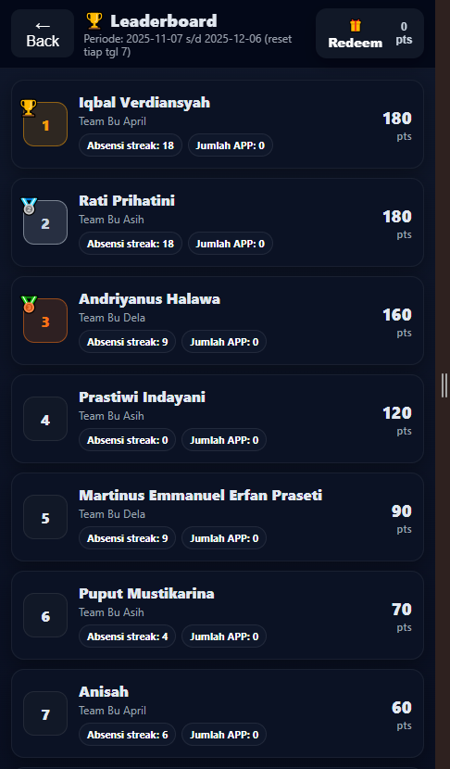
Figure 1. Gamified Smart Office Attendance Application
An example of the leaderboard that MT employees see is shown in Figure 1. The tab shows ranking positions according to the points garnered during the active period. It allows each user to view their total points, attendance streak, and number of approved appointments (APP). This shows how you do compared to MT staff. You get ranked with others, which motivates you to keep attending and working hard to stay ahead.
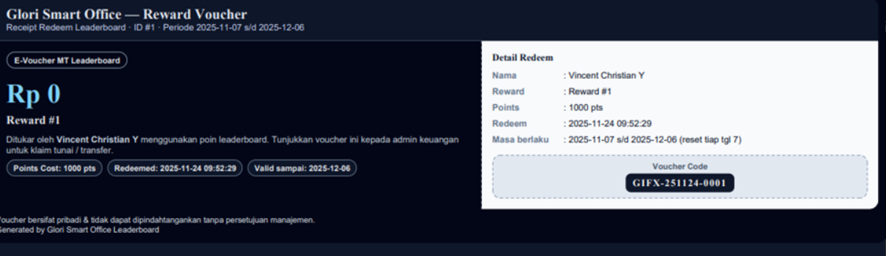
Figure 2. Reward Redemption and Voucher Interface Viewed by MT
The MT staff reward page is shown in Figure 2. Here you can see the rewards and points needed to get them in each category. The system stops you from redeeming rewards if you do not have points or if the reward quota is already fulfilled. This helps keep the motivation going by connecting attendance to rewards.
.
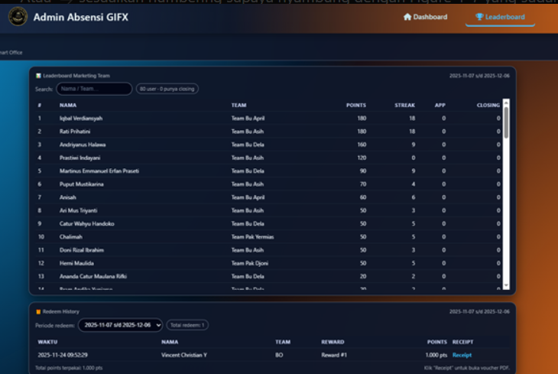
Figure 3. Reward Redemption and Voucher Interface Viewed by MT
The admin dashboard, as shown in Figure 3 is where administrators and HR people can see everything that is going on with the office attendance application. This is the place where they can control the gamification system. The admin dashboard is like a page, for administrators and HR representatives to look at the smart office attendance application and its gamification system.Currently, the leaderboard shows Management Trainee (MT) employees who rank on the leaderboard according to their total points earned during the active leaderboard.
The table in the figure contains more fine-grained informative columns such as employee name, team, total points, streak of attendance days, number of approved appointment (APP) and closed. This data enables administrators to check employee performance and ensure that points awarded tally with reported attendance and work actions.
The system also records the history of reward redemptions. The displayed data includes the redemption time, employee identity, reward category, and points used. This monitoring feature helps maintain transparency and supports administrative verification of the gamification reward process.
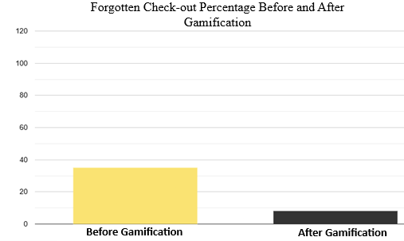Figure 4. Comparison of Forgotten Check-out Percentage Before and After Gamification

As shown in Figure 4, the comparison of forgotten check-out percentages before and after gamification illustrates a substantial improvement in employee attendance behavior. Attendance Consistency Attendance , consistency was evaluated based on the ability of employees to maintain-

-uninterrupted attendance over the observation period. Prior to gamification, only 20 out of 100 employees (20%) demonstrated consistent attendance without interruptions.
Following the implementation of the gamified system, attendance records show a substantial improvement. The number of employees maintaining consistent attendance increased to 70 out of 100 employees (70%). This reflects a 50% increase in attendance consistency over the two-month period.
The data demonstrate that the introduction of points accumulation, leaderboard ranking, and reward incentives successfully motivated employees to maintain consistent attendance behavior across multiple working days.
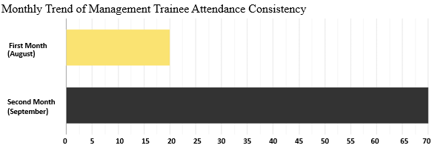
Figure 5. Monthly Trend of Management Trainee Attendance Consistency
As presented in Figure 5, prior to gamification, only 20 out of 100 employees (20%) demonstrated consistent attendance without interruptions.Check-in punctuality was analyzed by comparing the number of late arrivals before and after the implementation of gamification. Before gamification, system data show that 40 out of 100 employees (40%) frequently arrived late.
After two months of gamification implementation, the number of late employees decreased to 23 out of 100 employees (23%). This represents a 17% reduction in tardiness.
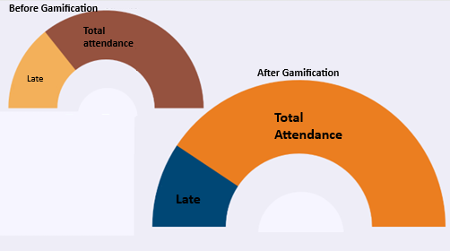
Figure 6. Comparison of Tardiness Levels Before and After Gamification
As shown in Figure 6, before gamification, system data indicate that 40 out of 100 employees (40%) frequently arrived late The decrease in late arrivals indicates that gamification mechanisms, such as bonus points for punctual check-in and the preservation of attendance streaks, positively influenced employee arrival behavior.
- DISCUSSION
In addition to the system-based attendance data, user feedback was collected to support the interpretation of the results and to evaluate system acceptance and future feasibility. Although questionnaire data are not the primary results of this study, they provide important contextual insight into how the gamified system was perceived by its users.
The researchers asked users directly if they could keep using the gamified attendance system for a time.The results were clear: every single respondent, which was 100% said yes it could be used in the future.This shows that users really like the system.
The system seems to fit with how people work every day and the culture of the organization.It appears to be a fit.
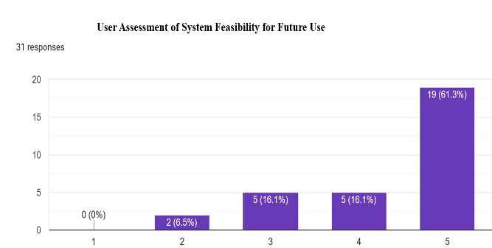
Figure 7. What Users Think About Using The System In The Future
As you can see in Figure 7 every single person who responded said that The System can be used all the time from on. The people in charge of The System made sure it works well because they listened to what users had to say about the problems they had with The System. Most users, seventy one percent of them said that they did not have a lot of trouble using The System.
Some users had a small problems like they did not understand how to get their rewards or the rules, about how points and streaks work. The main things that The System does are working fine and are easy to use.. If The System had better instructions and a nicer interface it would be even easier for people to use The System.
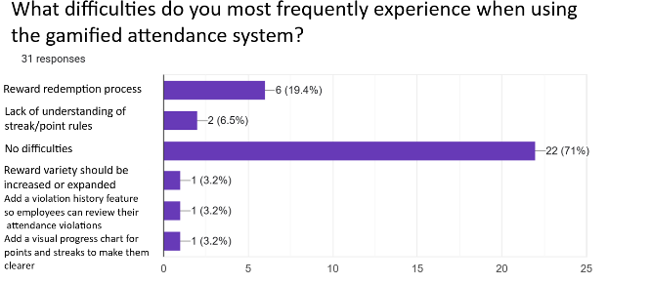
Figure 8. Difficulties in Using the Gamified Attendance System
Reported Based on the results in Figure 8 nobody said they had problems using the gamification attendance system because it was attractive.The data showed that most respondents rated the gamification system as attractive.This means the gamification system was successful, in making it interesting and motivating.
The results also show that people changed their attendance behaviour and the gamification design made going to attendance more enjoyable.It turned a routine into something more fun.The gamification system worked well in making attendance a pleasurable experience.
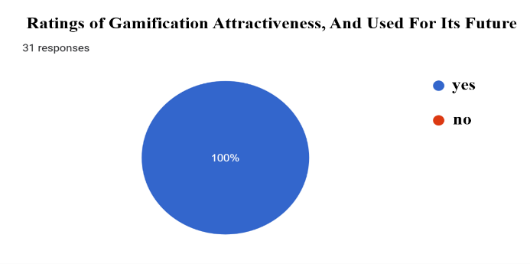
Figure 9. User Ratings of Gamification Attractiveness
User feedback on gamification shows it can be pretty attractive.People especially liked the points, leaderboard and reward system shown in figure 9.The ended feedback also backs this up.
Some users thought the system was "good" or "interesting”.Others had ideas on how to make it better.Some suggestions, for improvements included:adding types of rewards, making the mobile interface work better, sending notifications before streaks reset, adding a feature to track violations.
This helps with self-evaluation.These requests show users are really engaged with the system.They think it can be made better.The gamification system seems to have a perceived advantage of
Users and want to see its capabilities enhanced.
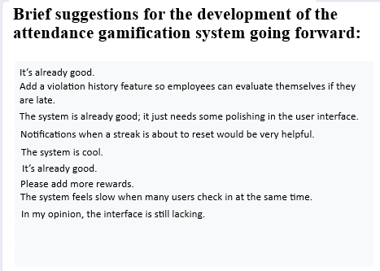
Figure 10. Summary of User Suggestions for Future System Development
Table 10 shows what users think about how the system can be made better.
The user feedback overall says that the attendance system with gamification is an idea. It helps employees to come to work on time. They like using it. The system is also easy to use. It is useful.
It also shows that gamification is a thing when it is used properly in a smart office. It helps people to behave better. They have a good experience with the system. The gamification attendance system is a way to make sure employees come to work on time. The user feedback is positive, about the gamification attendance system.
IV. Conclusion
This study uses gamification technology to improve the consistency and discipline of employees at PT. Glori Investama Berjangka Surabaya when it comes to attending the office. The study looked at data from 100 Management Trainee employees over two months August and September. It found that using gamification technology made a difference in how employees attended the office.
It is clear that gamification was successful in getting employees to attend the office on time. After the gamification technology was introduced employees were less likely to be late. The study shows that adding gamification elements, such as points and rewards to attendance activities can change employee behavior. These elements can help employees develop discipline and consistency in following the rules.
The employees who used the system had things to say about it. They found it easy to use. It fit well into their daily work. The system was able to change employee behavior for the better. This study shows that gamification technology can do more than just improve administration. It can also help create a work environment at the smart office.
The gamification technology used in this study can be improved in the future. For example it could be made to work on mobile devices and the rewards system could be made more interesting. The system could also be designed to send reminders to employees to help them stay on track. This would help keep the employees motivated and engaged in the term. The study of gamification technology at PT. Glori Investama Berjangka Surabaya shows that it can be a tool, for improving employee behavior and creating a positive work environment at the smart office.
ACKNOWLEDGMENT
We are really thankful to PT Glori Investama Berjangka Surabaya for agreeing to be part of this study and for their help throughout.
We especially want to thank the Management Trainee employees at PT Glori Investama Berjangka Surabaya because they played a role in this and gave us great ideas every step of the way.
We are also very thankful to the lecturers at Soegijapranata Catholic University for guiding us and providing advice and help whenever we needed it to complete this research.
We learned a lot about Gamification Smart Office at PT Glori Investama Berjangka Surabaya.PT Glori Investama Berjangka Surabaya and its employees were very helpful to us. We are really grateful for that.
The study on Gamification Smart Office, at PT Glori Investama Berjangka Surabaya was an experience.PT Glori Investama Berjangka Surabaya helped us a lot.
REFERENCES
[1] J. S. Valacich, C. Schneider, and M. Hashim, Information Systems Today: Managing in the Digital World. Pearson, 2023. doi: https://studentebookhub.com/wp-content/uploads/2024/preview/9780136524427.pdf
[2] V. S. Windyasari, I. H. Mursyidin, A. C. Andaria, Herlinda, and V. Y. P. Ardhana, “Pengenalan Sistem Informasi Secara Umum,” 2024. Accessed: Jan. 20, 2026. https://media.hadlacorp.com/wp-content/uploads/2024/10/Buku_Pengenalan_Sistem_Informasi-Share.pdf
[3] M. Schrepp et al., “On the Importance of UX Quality Aspects for Different Product Categories,” International Journal of Interactive Multimedia and Artificial Intelligence, vol. 8, no. 2, p. 232, 2023. doi: 10.25968/opus-3394.
[4] E. Çeker and F. Özdamli, “What ‘Gamification’ Is and What It’s Not,” European Journal of Contemporary Education, vol. 6, no. 2, pp. 221–228, 2017. doi: 10.13187/ejced.2017.2.221.
[5] E. D. Mekler, F. Brühlmann, A. N. Tuch, and K. Opwis, “Towards Understanding the Effects of Individual Gamification Elements on Intrinsic Motivation and Performance,” Computers in Human Behavior, vol. 71, pp. 525–534, Jun. 2017. doi: 10.1016/j.chb.2015.08.048.
[6] M. Sailer, J. U. Hense, S. K. Mayr, and H. Mandl, “How Gamification Motivates: An Experimental Study of the Effects of Specific Game Design Elements on Psychological Need Satisfaction,” Computers in Human Behavior, vol. 69, pp. 371–380, Apr. 2017. doi: 10.1016/j.chb.2016.12.033.

[7] J. Koivisto and J. Hamari, “The Rise of Motivational Information Systems: A Review of Gamification Research,” International Journal of Information Management, Elsevier Ltd., Apr. 01, 2019. doi: 10.1016/j.ijinfomgt.2018.10.013.
[8] R. P. Tumanggor and E. Asril, “Sistem Informasi Absensi Karyawan Menggunakan QR Code (Quick Response) di PT. Redes Jaya Perssada,” Employee Attendance Information System Using QR Code (Quick Response) at PT. Redes Jaya Perssada, 2021. doi: 10.24014/JITACS.v2i2.xxxx.
[9] M. S. Faizin Ridho, “Perancangan Sistem Informasi atau Aplikasi Monitoring Absensi Karyawan pada PT. Socfindo Menggunakan QR Code Berbasis Web,” 2024. Accessed: Jan. 20, 2026. [Online]. Available: https://journal.beaninstitute.id/index.php/sikom/article/view/12/195
[10] T. F. Prasetyo, D. Zaliluddin, and M. Iqbal, “Prototype of Smart Office System Using Based Security System,” in Journal of Physics: Conference Series. Institute of Physics Publishing, May 2018. doi: 10.1088/1742-6596/1013/1/012189.2018. doi: 10.1088/1742-6596/1013/1/012189.
[11] F. J. Gallego-Durán et al., “A Guide for Game-Design-Based Gamification,” Informatics, vol. 6, no. 4, Nov. 2019. doi: 10.3390/informatics6040049.
[12] S. Sotnik, V. Manakov, and V. Lyashenko, “Overview: PHP and MySQL Features for Creating Modern Web Projects,” International Journal of Academic Information Systems Research, vol. 7, no. 1, pp. 11–17, 2023.https://openarchive.nure.ua/handle/document/21601
[13] L. Rodrigues et al., “Gamification Works, but How and to Whom?: An Experimental Study in the Context of Programming Lessons,” in Proceedings of the 52nd ACM Technical Symposium on Computer Science Education (SIGCSE 2021). Association for Computing Machinery, Mar. 2021, pp. 184–190. doi: 10.1145/3408877.3432419.
[14] Textbooks for Hong Kong, Human Resource Management, 2021. Accessed: Jan. 20, 2026. https://www.opentextbooks.org.hk/system/files/export/32/32088/pdf/Human_Resource_Management_32088.pdf
[15] M. La Torre, A. Trotta, H. Chiappini, and A. Rizzello, “Business Models for Sustainable Finance: The Case Study of Social Impact Bonds,” Sustainability, vol. 11, no. 7, Apr. 2019. doi: 10.3390/su11071887.

