HISTORY OF MANUSCRIPT PUBLICATION
(APMR/ASIA PACIFIC MANAGEMENT REVIEW)

THE IMPORTANT ROLE OF CONSUMER CONVICTION VALUE IN IMPROVING INTENTION TO BUY PRIVATE LABEL PRODUCT IN INDONESIA

Berta Bekti Retnawati
Elia Ardyan
Naili Farida

Dept. of Management, Faculty of Economics
and Business
Soegijapranata Catholic University

DAFTAR ISI

I | SUBMISSION ACKNOWLEDGEMENT …………………………………………….. | 3
 | April 19, 2016 ……………………………………………………………………………. | 3
II | INVITATION TO REVISE MANUSCRIPT APMRV…………………………………. | 4
 | December 21, 2016………………………………………………………………………… | 4
III | AUTHORS RESPONSE FOR REVIEWER COMMENTS (BY APMR SYSTEM) … | 5
 | January 10, 2017 ………………………………………………………………………… | 5
IV | RECEIVED RESUBMISSION APMRV ………………………………………………. | 15
 | July 3, 2017 ……………………………………………………………………………… | 15
V | INFORMATION OF ACCEPTANCE…………………………………………………… | 16
 | July 5, 2017 at 1:36 PM ………………………………………………………………… | 16
VI | INFORMATION OF TRACK ARTICLE [APMRV_96] ACCEPTED IN ASIA PACIFIC MANAGEMENT REVIEW …………………………………………………. | 17
 | July 5, 2017 at 3:05 PM …………………………………………………………………. | 17
VII | SYSTEM FOR TRACK THE ACCEPTED ARTICLE ………………………………. | 18
VIII | FULL ARTICLE JOURNAL (PUBLISHED) …………………………………………. | 19

I.SUBMISSION ACKNOWLEDGEMENT
April 19, 2016
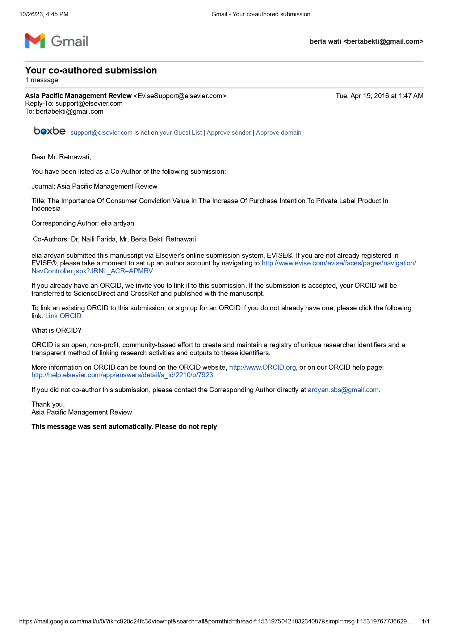

II. FWD: INVITATION TO REVISE MANUSCRIPT APMRV_2016_113
December 21, 2016
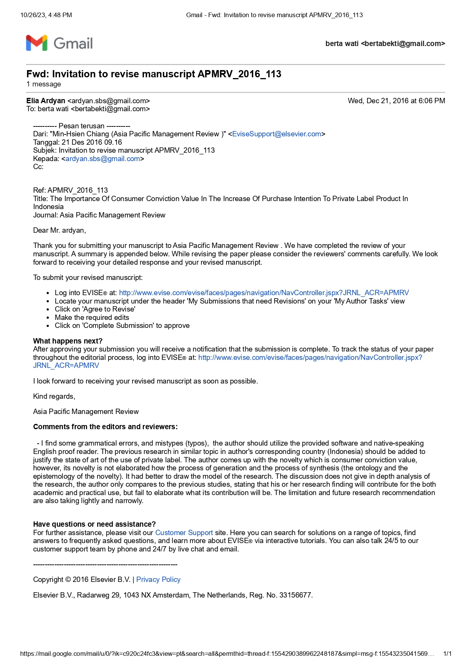

III. AUTHORS RESPONSE FOR REVIEWER COMMENTS (BY APMR SYSTEM)
January 10, 2017

Comments from the editors and reviewers | Responses from authors
I find some grammatical errors, and mistypes (typos), the author should utilize the provided software and native-speaking English proof reader. | We have tried to improve the grammar by checking and re-checking the translation that has been done so that the results of the manuscript can be better
The previous research in similar topic in author's corresponding country (Indonesia) should be added to justify the state of art of the use of private label. | We add literature related to the topic and occurring in Indonesia to complement the business phenomena that occur
The author comes up with the novelty which is consumer conviction value, however, its novelty is not elaborated how the process of generation and the process of synthesis (the ontology and the epistemology of the novelty). It had better to draw the model of the research. | We have added a figure explaining the ontology and epistemology of the emergence of variable novelty presented in this article. Novelty variable is elaborated and the conceptual mapping is systematic and supported by previous research. business phenomena that occur
The discussion does not give in depth analysis of the research, the author only compares to the previous studies, stating that his or her research finding will contribute for the both academic and practical use, but fail to elaborate what its contribution will be. The limitation and future research recommendation are also taking lightly and narrowly. | It has been added to strengthen the systematic emergence of new variables, the contribution of the findings in this article is an important finding and can be taken as a managerial application in business, especially private label products, regarding the importance of convincing consumers in supermarket private labels that compete with national products.
REVISION OF MANUSCRIPT:
The Importance of Consumer Conviction Value In The Increase Of Purchase Intention To Private Label Product In Indonesia

Abstract
The purpose of this study is to investigate price perception, quality perception, and attitudes toward consumer conviction value and intention to buy private label. Seven hypotheses were developed and tested using the data which were collected from consumers who have tried private label in Indonesia. Data were analyzed using SEM to test all hypotheses. Four of the all hypotheses are significant. The novelty of the model proved that consumer conviction value could be a bridge for the research gap between attitudes and purchase intention. The influence of the perception on private label quality on purchase intention was rejected based on this empiric research. This empiric research gives a challenge for private label to further improve the quality of their products to align with national brands in order to be able to increase purchase intention to private label.

Key words: Private Label, Consumer Conviction Value, Attitude, and Purchase Intention
Paper Type: Reseearch Paper

1. INTRODUCTION
Generally, companies label their products using national label or private label (Dawes & Nenycz-Thiel, 2013). Private label is often used by retail, wholesalers or distributor. Private label is known as homebrands, storebrands or own label brands (De Wulf, Odekerken-Schroder, Goedertier, & Van Ossel, 2005). Usually, private label uses the name of the retail or wholesaler or distributor (J. Boyle & Lathrop, 2014; Hyman, Kopf, & Lee, 2010; Walsh & Mitchel, 2010). Beneke and Carter (2015) define private label brands as brand that is exclusively sold through certain retail.
The increasing modern retail demands the businessman to seek for opportunities and creativities to build competitive advantage which is able to attract the customers to shop in their retails. Private label does not only grow in Indonesia. Ngobo (2011) explained that the use of private label is very important in some European countries, such as Switzerland (54%), Germany (40%), and France (32%). Among the creative and innovative efforts is selling private label).
Supermarkets have increased the use of private label in its marketing strategy (Pepe, 2012). Private label becomes a source of profit for the supermarket and threaten national brands (Quelch and Harding, 1996). Some researchers explain that private label is able to improve decision where consumers will buy (Nies and Natter, 2012), increase store loyalty, control distribution channel and increase consumer loyalty (Ailawadi & Keller, 2004; Ailawadi & Steenkamp, ​​2008; Levy & Weitz, 2007; Patti & Fisk, 1982; Richardson, Jain, & Dick, 1996). The increase of the quality of private label will increase storemarket (Sudhir and Talukdar, 2004), marketshare (Erdem, Zhao, & Valenzuela, 2004), store image (Nies and Natter, 2012) and the intention to buy private label (Richardson et al., 1996 ; Semeijn, Van Riel, & Amrosini, 2004) .Private label is also able to increase competitiveness (Corstjens and Lal, 2000). Private label will be able to increase storeloyalty and profitability compared to national brands (Collins-Dodd and Lindley, 2003) through increased gross margin (Corstjens and Lal, 2000; Ward, Shimshak, Perloff, & Harris, 2002).
Empirical studies on private label attracted the attention of researchers to explore various things associated with it. Private label products are proven to experience surge and rapid growth in various countries so as to attract the attention of researchers to look at it from various consumer perspectives. Abril and Martos-Partal (2013) examines the innovation of private label products and store loyalty. While some other researchers examine consumer attitudes and purchase intention in private label (Burton, Lichtenstein, Netemeyer, & Garretson, 1998; Garretson, Fisher, & Burton, 2002; Walsh & Mitchell, 2010).
In the study of consumer attitudes, still there are differences in results that open up opportunities for review and a model development to bridge the differences. There is a positive and significant relationship between consumer attitude and purchase intention as shown in the study of Garretson et al. (2002) and Burton et al. (1998), by examining the attitude of consumers on daily need supermarkets in the US, with the results stating that positive attitude towards private label and purchase intention are the priority of consumers’ need fulfillment. Other studies that are consistent with the results of previous studies are conducted on three product categories namely orange juice, cereal and mineral water (R, E. Goldsmith, Flynn, Goldsmith, & Stacey, 2010). The results of this study demonstrated a positive correlation of consumer and purchase intention in all three product categories even when compared to national brands in the three categories of the same product. The survey was conducted on 300 respondents in the US.
Aresearch conducted by Walsh and Mitchell (2010) showed different results. The study was conducted in a supermarket located in Germany, involving 600 consumers in four categories of products (bread, chocolate, popcorn, and granolabars). The study showed that consumer attitude on private label does not have a positive and significant effect on product categories that are studied, although the indicators of attitude used in the research are similar with the ones developed by Burton et al. (1998)
Studies on private label that have been done in various countries give references to other studies done in other countries having a significant growth in private label. This what triggers the researcher to do a research in Indonesia where the development of private label products has increased both in number and brands offered. The differences that still exist in the research on consumers’ attitude towards private label purchase intention is another triggering factor and refers to the persistence of the gap in the research of consumer attitude toward purchase intention to private label products.
The purposes of this research are:
- Testing the influence of consumers’ attitude towards private label on private label purchase intention.
- Testing the influence of private label quality perception on private label purchase intention.
- Testing private label price perception on private label purchase intention
- Testing the influence of consumers’ attitude towards private label on consumer conviction value.
- Testing the influence of private label quality perception on consumer conviction value
- Testing the influence of private label price perception on consumer conviction value
- Testing the influence of consumer conviction value on private label purchase intention

2. LITERATURE REVIEW
2.1. Consumer Conviction Value
The research gap among various empirical researches about consumer attitude and purchase intention to private label product makes it possible to further develop what variable can bridge the two things. The establishment of concept novelty in the form of consumer conviction value refers to empirical researches on the significance of marketers’ understanding on learning process and dynamic knowledge development of the consumers on recent values which become the standard values of the consumers to determine a good product (Flint, Blocker, & Boutin, 2011). The need to survive in a competitive advantage requires that companies and marketers know in detail what was intended by consumers and the levels of satisfaction perceived. The concept of customer value anticipation is a strong link between customer satisfaction and loyalty. While the research referring to the importance of customer relationship quality with certain brand is strongly influenced by consumers’ beliefs of previous experiences (Juan & Ye, 2011).
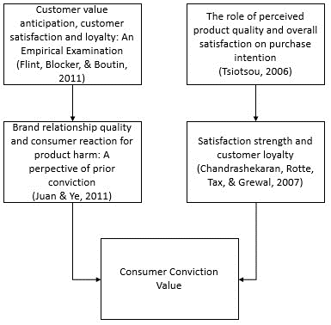

Fig. 1. Epistemology of Consumer Conviction Value. Source: Developed for this research
Consumer conviction value in private label is required as a driving factor and motivation for consumers in an effort to make purchasing decisions and take action more actively. In consumer conviction value, consumers will lead to the next active measures, that is, purchase intention to private label products, supported by price perception conviction, quality perception conviction, and the conviction that finding information is an appropriate action, as well as the conviction that private label brand is comparable to national brands that have already existed in the market.
We define consumer conviction value as a consideration power perceived by consumers related to the follow-up action, that is, the intention to buy private label products after consumers feel sufficiently convinced with the perception of price and quality, and the belief that searching for information is an appropriate act, as well as the belief that private label brands are comparable with the national brands that have already been existed.
2.2. Price Perception and Private Label Quality
Initially, private label presented a cheap price and low quality compared to national brand (R. E. Goldsmith et al., 2010), due budget segment fulfillment (J, Boyle & Lathrop, 2014). In the development, all those perceptions changed (Rossi, Borges, & Bakpayev, 2015). Private label grows in various types of retail (M, Boyle, 2003; Liljander, Polsa, and Van Riel, 2009). Private label products were positioned as "good", "better" and "best" (Geyskens, Gielens, & Gijsbrechts, 2010). The impact of the increase in the quality of private label is that consumers began to change the evaluation of private label (Mendez, Oubina, & Rubio, 2008).
Perception of the quality of private label is believed both by practitioners and a variety of empirical research literature have a tendency of growing and increasing (Walsh & Mitchell, 2010). Private label quality is approaching the quality of national brands. This is a reasonable consequence since product choice is growing variously demanding brand owner to prioritize quality at an attractive price to capture consumers' intention to buy (RE Goldsmith et al., 2010 ).
An appropriate price perception on private label products will be in line with the desire to get adequate product quality. Consumer simultanous concern both for price and quality is a major concern for retail companies in creating and offering private label products. Private label products will always be compared with national products so private label should have the advantage of being able to attract the attention of consumers to make choice. The approach of low price advantage, with a low product risk perception will encourage consumers to have a purchase intention in trying and buying private label brand products (J. Boyle & Lathrop, 2014; Tsiotsiu, 2006).

2.3. Consumer Attitude towards Private Label
Understanding consumer attitudes refers to the tendency of consumer perception especially on private label (Walsh & Mitchell, 2010). There are three forming attitudes of consumers on private product, they are, consumer price perception, marketing constructs, and deal proneness constructs. Perception becomes `price forming first factor in consumer attitudes. Awareness of the price, value, and the ratio between quality and price drive consumer attitude towards private label. The belief that private label should always be under the price of national brand products have become inherent in it, so that consumers will receive the differences in the quality of private label compared to national brands on the condition that the price is cheaper (Burton et al., 1998) . Marketing constructs that give positive driving factor for consumer attitudes are self perception as intelligent learners and various choices of private label allowing consumers to choose products that offer the fulfillment of their needs. For another dimension that is brand loyalty including private label store brands, buying impulsiveness and risk aversion is seen to have a negative driving force in consumer attitude towards private label. These factors weaken the consumer attitudes due to the strength of the perception of national brands which already has a strong position in the minds of consumers (Burton et al., 1998). The next driving factor is deal proneness constructs that reinforce the view that consumer attitudes would be more positive towards private label due to consumer confidence at the private label’s lower price compared to national brands. The constant promotion of privat label builds a good and positive consumer attitude on private label.

2.4. Private Label Purchase Intention
Intention is the most important construct that determine certain act. Intention is the predictor of actual behavior (Azjen, 1991). In the context of purchasing, intention to buy is a precedent step from indulging in the actual buying behavior (De Magistris & Gracia, 2008). Purchase intention represents a possibility to be willing to buy product or service in the future (Wu, Yeh, & Hsiao, 2011). Consumer purchase intention refers to the attempt to buy a product or service (Diallo, 2012).

3. HYPOTHESES
3.1. The Influence of Consumer Attitude on Purchase Intention to Private Label
Consumer attitude is a tendency to respond to the existence of the product, in this case is a private label product, which positively become the driving force for consumer wishes to purchase in the next time. This can be understood from the perspective of the theory of Planned Behaviour (Azjen, 1991) stating that consumers will have a consistent behavioral attitudes, especially positive attitude to a particular object, so in this case also relates to private label products. A positive attitude is demonstrated by consumers in various fields of private label products category which has a tendency to a higher share of sales in any retail outlets. The positive influence of attitudes and purchase intention is increasingly widespread in various categories of products that have a low social risk such as salt, flour, sugar, and others (Walsh & Mitchell, 2010). This is not true for the categories of product used by the consumers in socializing with others (such as wine, cakes, coffee and others), in which private label has a lower position in the minds of consumers. Consistent with Planned Behaviour theory, consumers with a positive attitude toward private label will affect the intention to buy a product (Azjen, 1991) .Consumers' positive feeling and attitude toward a product or service of private label store will influence his / her purchase intention (Das, 2014)
Based on the explanation, the first hypothesis proposed is:
H1 : Consumer attitude on private label is able to significatly increase purchase intention to private label.

3.2. The Influence of private label quality perception on private llabe purchase intention
The perception of private label quality is believed both by practitioners and a variety of empirical research literature to have a tendency of growing and increasing (Walsh & Mitchell, 2010). Perception of quality is consumer evaluation of the overall brand excellence and / or advantages (Erdil, 2015). Perception is the way consumers assess the quality of the product by relying on their consumption experiences (Kakkos, Trivellas, & Sdroloas, 2015). Cronin, Bradt, and Hult (2000) explain that the perception of quality will be able to increase the interest of consumers to make purchasing behavior
Quality of private label compared to national brands is getting equal and not much different. This is a common consequence of the growing variety of products that requres retail owners to promote the quality of a product at an attractive price to attract consumers' intention to buy (Ronald E. Goldsmith, Flynn, Goldsmith, & Stacey, 2012) . A study conducted by Nenycz-Thiel and Romaniuk (2011) explain that only 8% of the market in the UK and 20% of the market in Australia refused Private label. One of the reasons for the refusal is due to the low quality of private labels. The quality of the product will be able to drive consumer behavior meaning that the higher the quality of a product, the higher the interest of consumers to buy (superior sensory perceptions) (Ailawadi & Keller, 2004; Bao Bao, and Sheng, 2011; Batra and Sinha, 2000; Das, 2014).
Based on the explanation, the second proposed hypothesis is:
H2 : Perception of Private Label quality is able to significantly increase purchase intention

3.3. The Influence of Private Label Price Perception on Purchase Intention
Price has been regarded as an indicator of the cost of the product and an important parameter in marketing literature (Erdil, 2015). The perception of consumer fairness prices played an important role in customer satisfaction and subsequent purchase behavior (Heo & Lee, 2011). By creating the perception of relatively low prices, the retailer intends to have a positive influence on consumer loyalty in Store brand (Beristain & Zorrilla, 2011). One of the reasons why consumers refused Private label is the inclusion of the price (Rao, 2005).
Based on the explanation, the third proposed hypothesis is:
Hypothesis 3: Perception of private label price is able to significantly increase purchase intention

3.4. The Influence of consumer attitude, quality perception and price perception of private label on consumer conviction value
Consumer conviction value is needed as consumers’ driving factor in the efforts of making purchase decision and doing more active actions. In consumer conviction value, consumers will go to the next active action that is the intention to buy private label supported by conviction on price perception, quality perception and the conviction that searching for information is an appropriate action, and the conviction that private label brands are equal to natinal brands that have already existed in market.
As what has been explained before, the benefits gained by retailers from the production of private label brands are the increase in overall profits in product category, the increase in gross margin of private label brands (higher than national brands), and the ability of retailers to show their differences from other competitors. The benefits are the factor that will create an improvement in overall marketing strategies in the efforts to increase consumer loyalty in choosing private label in retail stores. The strategy of quality, consistency and promotion improvement is part of marketer’s efforts to ensure the improvement of quality, consistency and values for consumers (Ronald E. Goldsmith et al., 2012; Walsh & Mitchell, 2010).
Price perception is a subjective interpretation on product’s monetary value such as whether the product is cheap or expensive (Beneke & Carter, 2015).
Based on the explanation, the proposed hypotheses are:
H4: Consumer attitude towards private label will significantly increase consumer conviction value
H5: Perception of private label quality will significantly increase consumer conviction value.
H6: Perception of private label price will significantly increase consumer conviction value

3.5. The Influence of Consumer Conviction Value on Purchase Intention to Private Label
The value that is felt has a key role in consumer decision and the willingness to get product ownership (Grewal, Krishnan, Baker, & Borin, 1998). Consumer will trust more in private label as their choice in smart shopping. This high conviction will be the driving and generating power in doing the following proactive action, that is having purchase intention to private label products (J.Boyle & Lathrop, 2013).
Based on the explanation, the proposed hypothesis is:
H7: cosumer conviction value will sigifnicantly increase consumer’s puchase intention to private label.

4. RESEARCH METHOD
4.1. Population and Sample
This research uses survey research design to investigate population by selecting and investigating samples driven from the population to find out relative occurance, distribution, and inter variables relationship. The population of this research is consumers that have purchased private label products in retail stores in Indonesia. Retail industries in Indonesia undergo a significant growth . Currently, big, middle and small scale retails are growing in line with consumer’s need to buy products in retail stores.
Private labels in retail outlets which are used as research location experienced good growth in product categories and variants of the products offered, as summarized in Table 2 on a wide range of private label products in the outlets. This research was conducted at various outlets that provide a wide range of private label products. The name of the outlets as shown in table 2 are Carrefour, Hypermart, Indomaret, Alfamart, Superindo, Giant, and Lottemart. Samples were obtained using purposive method, that is, consumers who have purchased private label more than twice on private label brands as well as convenience method. A number of consumers met were shopping in some retail outllets.

The number of sample target to be distributed is 200 according to sample measurement guidelines for maximum Likelihood Estimation technique. The selected respondents were consumers encountered while shopping at the retail outlets. Of the 200 samples that were distributed, there are 188 samples can be collected and meet eligibility to be processed. There are 181 respondents.
The demographic characteristics of respondents including sex, age, latest education, status, and income per month, are summarized as follows:
Table 1. Respondents Demographic Characteristics
Note | Frequency | %
Gender :
Male | 87 | 48,07
Female | 94 | 51,93
Age:
17-20 years | 55 | 30,39
21-30 years | 43 | 23,76
31-40 years | 45 | 24,86
41-50 years | 38 | 20,99
Latest Education:
Senior High School | 101 | 55,80
Graduate | 77 | 42,54
Post Graduate | 2 | 1,10
Others | 1 | 0,55
Status:
Not Married | 112 | 61,88
Married | 69 | 38,12
Income/month:
1-2 million | 79 | 43,65
2-4 million | 63 | 34,81
4-6 million | 39 | 21,55
Occupation:
Private Employees | 39 | 21,55
Entrepreneur | 28 | 15,47
University Students | 76 | 41,99
Housewife | 38 | 20,99

The above table shows that female respondents in this study are more than male ones, with the age of the largest age group is 17-20 years old, and most have senior high school education. It seems that most of the respondents are students and or those who do not continue their studies, but immediately working on their respective fields.

4.2. Measurement
In this study, each question is measured using a scale of 10, where the answers close to 1 means "strongly disagree" and close to 10 means "strongly agree. The following is the measurements in this study:
Perception of private label quality. Perception of private label quality is defined as the consumer assessment on the overall quality of private label products. Indicators used in this study were adopted from Walsh and Mitchell (2010), among others: (1) Private label products quality is consistent / maintained; (2) Private label products are well made; and (3) Private label products have standard quality appropriate with product category
Consumer attitude on private label. Consumer attitude on private label is defined as a tendency of consumer perception, especially a positive attitude to a particular object, that is, private label. Indicators of consumer attitude on private label were adopted from Burton et al. (1998), among others: (1) being glad when private label products sought after are available and (2) Selecting private label products for most categories of products.
Perception of private label price. Perception of private label price is defined as the consumer assessment on the amount of rupiah paid by consumers on the purchase of private label products. Indicators of private label price perception were adopted from Walsh and Mitchell (2010), among others are: (1) Reasonable price for private label products; (2) Buying private label products are more economical than national brand; and (3) The price of private label products is in accordance with the quality offered.
Consumer conviction value. Consumer conviction value is defined as consumer earnest belief on a variety of considerations as a driver for the next active action on private label products. We propose two indicators of consumer conviction values, namely: (1) Believe in the good quality of private label products and (2) Believe in the excellence of private label products that can be equated to national brand
Purchase intention to private label. Purchase intention to private label is the driver of consumer attitude to try, buy, and consume private label products available at retail outlets visited. Indicators of interest in buying private label were adopted from Walsh and Mitchell (2010), among others are: (1) When need a specific product category, consumers have the intensity to search for information on private label products, and (2) Having a desire to buy the necesary private label product.

4.4. Data Analysis
Descriptive statistical analysis is used to describe the characteristics of the respondent, the sample, and the study variables as they are; describe the demographic characteristics of respondents in terms of age, education, gender, amount of income, family size, and more. Analysis is also used to discuss respondents’ response to the indicators of the constructs examined in this study. To test the hypotheses of the research model developed in this study, the technique of structural equation modeling (SEM) is used. Amos version 20 is used for data processing
5. RESULT
The value of Chi-square is 51,516; Prob is 0.267; GFI is 0.957; AGFI is 0.928; CFI is 0.988; TLI is 0.982; CMIN/DF is 1,120; and RMSEA is 0,026, it has fulfilled the requirements of structural fit model testing, so model analysis can be done to test the proposed hypotheses.

5.1. Hypothesis Testing Result
The analysis of structural full model that has been done with the AMOS program explains the proposed hypotheses. The following is the explanation for each hypothesis tested in this study:
Estimation parameter to test the influence of consumer attitude on purchase intention to private label shows a significant result with CR value of 1.149 and probability of 0.250. The value does not meet the requirements for hypothesis acceptance because the value of cr> 1.96 which is a rejection of hypothesis 1. The results stated that the hypothesis of the better the attitude of consumers, the higher the consumer purchase interest in private label brands is not significant. These results support the findings of several previous studies of Walsh and Mitchell (2010) and Dai et. al, (2013) stating that there is no significant relationship between consumer attitudes and consumer purchase interest in private label brands.
Estimation parameter to test the influence of consumer quality perception on the intention to buy private label products showed nonsignificant results with cr value of -0.484 with a probability of 0.628. The values do not meet the requirements for hypothesis acceptance with the value of cr is <1.96; significance level above 0.01 which means a rejection to hypothesis 2. This hypothesis is not consistent with previous findings (Burton et al., 1998 (Ronald E. Goldsmith et al., 2012; Walsh & Mitchell, 2010). In this empirical study, consumers do not accord with the brand owners opinion in that the consumers think that private label brands are considered not to have equal qualities with national brands. Private label is still regarded as a retail product whose quality is below national brand.
In this hypothesis, estimation parameter to test the influence of consumer price perception on the intention to buy private label products showed significant results with cr value of -2.858 with a probability of 0.004. The value does not meet the requirement for hypothesis acceptance because cr value is > 1.96 at the 0.05 level, which means a rejection to hypothesis 3.
Hypothesis related to model novelty, that is, consumer conviction value for Hypothesis 4 to 7 are as follows:
In hypothesis 4, estimation parameter to test the influence of consumer attitude towards consumer conviction value on private label products showed a significant result with cr value of 4.396 with a probability of 0.000. The value meets the requirement for hypothesis acceptance because cr is > 1.96 at a significance level of 0.01, which means an unwarranted rejection to hypothesis 4. The results stated that the better the attitude of consumers on private label, the higher consumer conviction value in private label brands.
In hypothesis 5, estimation parameter to test the influence of consumers’ quality perception on consumer conviction value in private label products showed no significant results with cr value of 815 with probability equal to 0.415. The value do not meet the requirement for hypothesis acceptance becasue cr value is <-1.96, which means there is a reason to reject the hypothesis 5.
In hypothesis 6, estimation parameter to test the influence of price perception on cosumer conviction value in private label products showed a significant result with cr value of 2,035 with the probability of 0.042. The value meets the requirement of hypothesis acceptance because cr is > 1.96 at the 0.05 level, which means an unwarranted rejection to hypothesis 6. The results stated that the better price perception on private label products, the higher consumer conviction value in private label brands.
In hypothesis 7, estimation parameter to test the influence of consumer conviction value on consumer purchase intention to private label products showed a significant result with cr value of 2.382 with probability of 0.017. The value meets the requirement for hypothesis acceptance because cr is > 1.96 at the 0.05 level, which means no reason to reject hypothesis 7. The results stated that the better consumer conviction value in private label products, the higher consumer purchase intention in private label brands

The summary of hypothesis testing is as follow:
Tabel 2. Hypothesis Testing Result
No | Hypotheses | CR | p | Note
H1 | The better consumer attitude, the higher consumer purchase intention to private label brands (PLB). | 1,149 | 0.628 | rejected
H2 | The higher consumers’ perception of private label brand (PLB) quality, the higher consumers’ purchase intention to private label brands (PLB). | -0.484 | 0.250 | rejected
H3 | The better consumers’ perception of private label brands (PLB) price, the higher consumers’ purchase intention to private label brands (PLB) | -2.858 | 0.004 | rejected
H4 | The better consumers’ attitude on private label brands, the higher consumers’ conviction value on private label brands (PLB). | 4.396 | *** | accepted
H5 | The higher consumers’ perception of private label brands quality, the higher consumers’ conviction value on private label brands (PLB)). | 0.815 | 0.415 | rejected
H6 | The better consumers’ perception of private label brands (PLB) price, the higher consumers’ conviction value on private label brands (PLB). | 2.035 | 0.042 | accepted
H7 | The higher consumers’ conviction value on private label brands (PLB), the higher consumers’ purchase intention to private label brands (PLB). | 2.382 | 0.017 | Accepted

6. DISCUSSION
This study shows that the accepted hypotheses are H4, H6 and H7, while the rejected hypotheses are H1, H2, H3, and H5. The result of hypothesis 1 stating that the better consumer attitude, the higher consumer purchase intention is not significant. These results support the findings of previous study of Walsh and Mitchell (2010) and Dai et. al, (2013) stating that there is no significant relationship between consumer attitudes and consumer purchase intention in private label brands, and these results need to be bridged by the novelty of variables tested in this model. Another interesting finding is in hypothesis 2, 3 and 5, which was not in accordance with previous studies of (Burton et al., 1998). In this empirical research, consumers do not accord with the brand owners’ opinion in that consumers consider that private label brands are not equal with national brands. In addition to its effect on the quality perception, the perception of price is also very much influenced by assumptions that private label is still below the national brand. The results of this study indicate that the price of private label has a significant negative effect on purchase intention to private label.
Model novelty by proposing consumer conviction value proved to be a variable that can bridge the influence of consumer attitudes on consumer purchase interest in private label brands (PLB). The results of this research showed a positive attitude of consumers related to the value of consumer conviction value and prices of private label brands in retail industry. There was a positive reception in line with the full availability and ease of getting private label brands at retailers where consumers usually shop. This study also shows that the perception of the quality of private label is not as desired by retail brand owners. It is a challenge for brand owners to further improve and provide quality which is not different from the established national brands. The more easily consumers get the desired goods in retail stores require owners of existing private label to promote quality assurance increasingly closely with the national brands, so private label will be viewed positively in the minds of consumers. This will encourage consumers to get a good choice of brands and private labels have the same opportunity with the national brand in the minds of consumers, so that loyalty to private label will be higher as well.
This research besides giving academic contribution, also give practical contribution for retail practitioners to make use of the research results. This research contributes to research literature on private label in Indonesia to accommodate the recommendation of previous researches expecting a research on private label in countries having a good development in private label but have not been studied before. Hypotheses results both the relevant and the irrelevant with previous researches are expected to enrich literature and further develop academic research on private label. For practitioners, the research results are expected to be able to give inspiration on the importance of building private label brands which can always give positive attitude and perception especially about price and quality, so that private label brands can strengthen consumers’ loyalty on the existing retails.

IV. FWD: RECEIVED RESUBMISSION APMRV_2016_113_R2
July 3, 2017
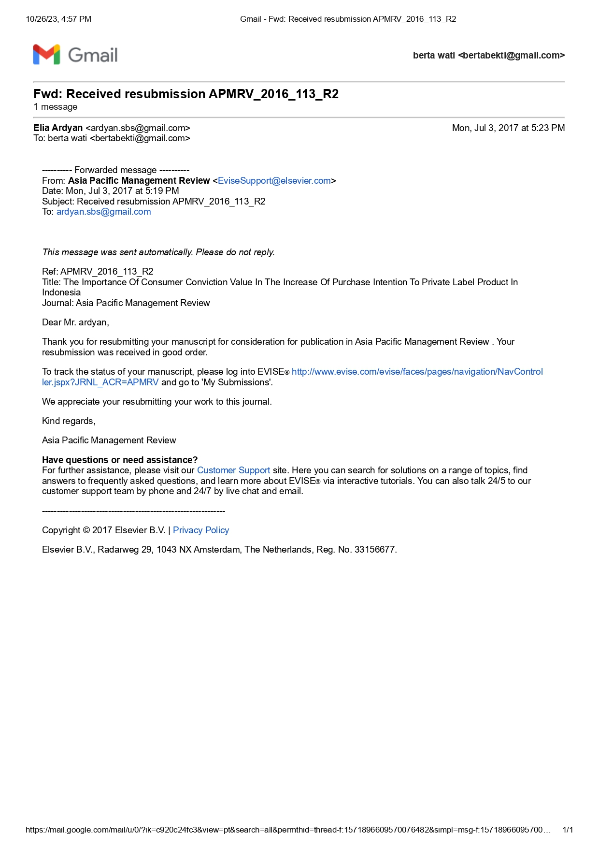

IV. ACCEPTANCE INFORMATION

July 5, 2017 at 1:36 PM

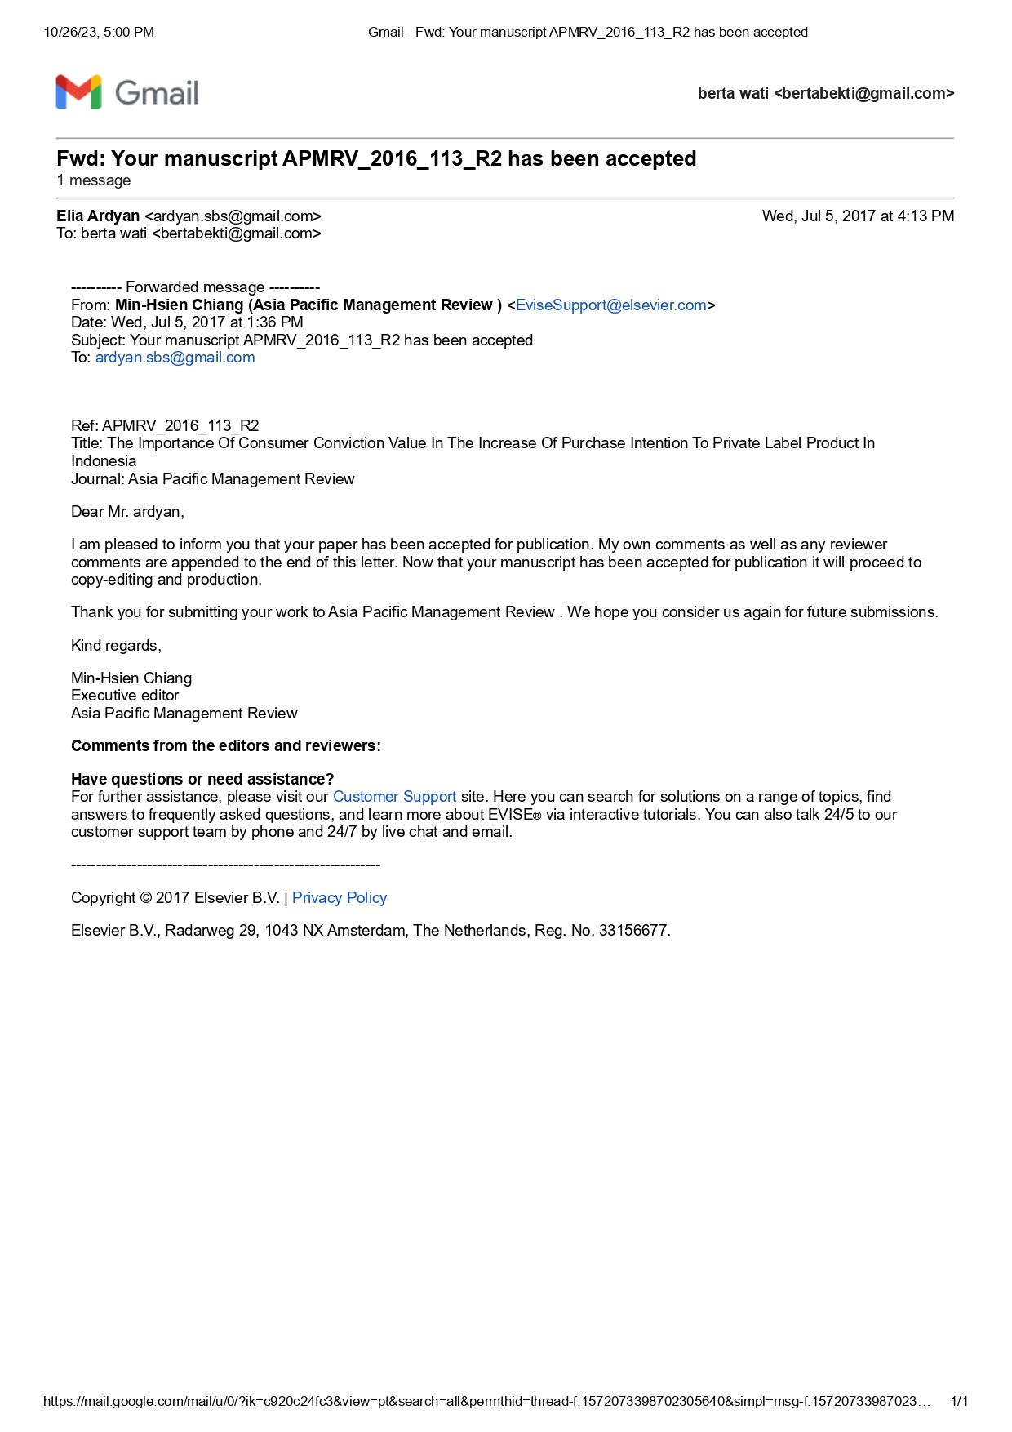

V. Track your article [APMRV_96] accepted in Asia Pacific Management Review

July 5, 2017 at 3:05 PM
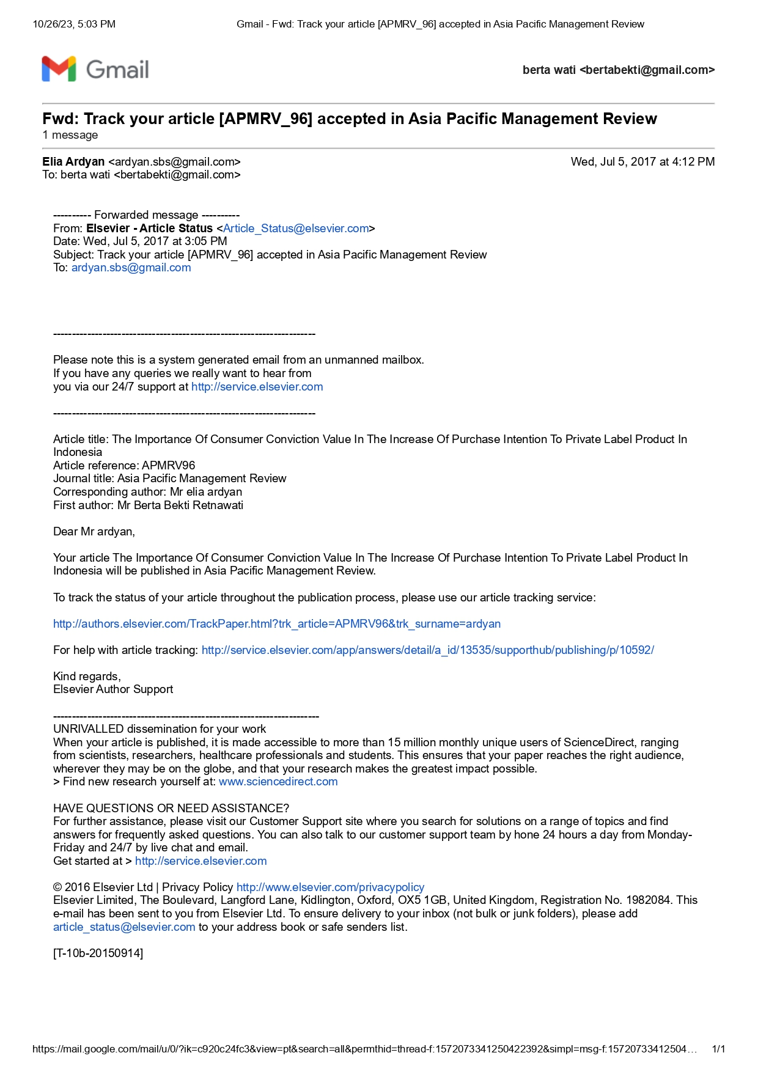

VI. SYSTEM FOR TRACK THE ACCEPTED ARTICLE
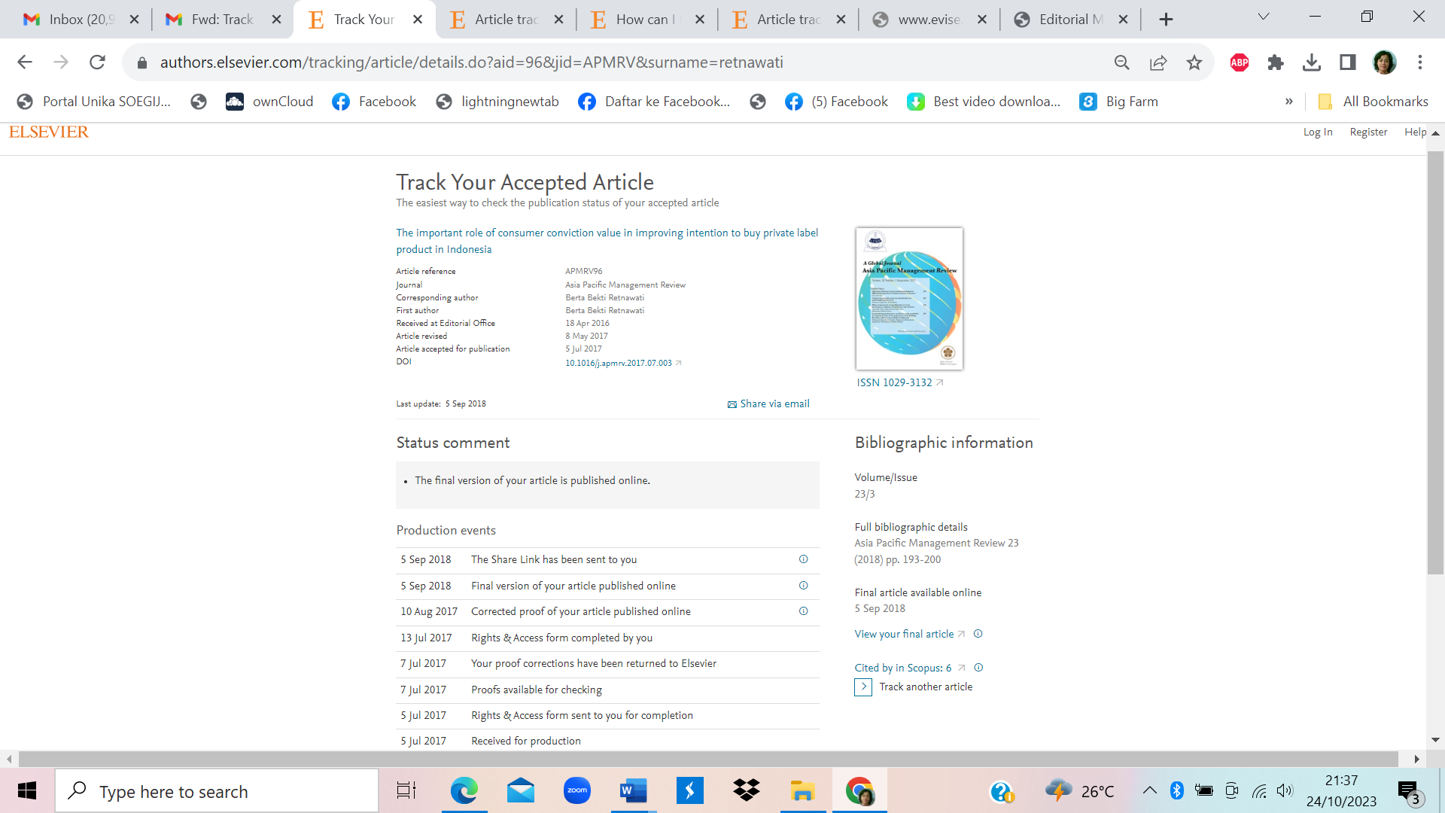

VII. ARTICLE JOURNAL (PUBLISHED)
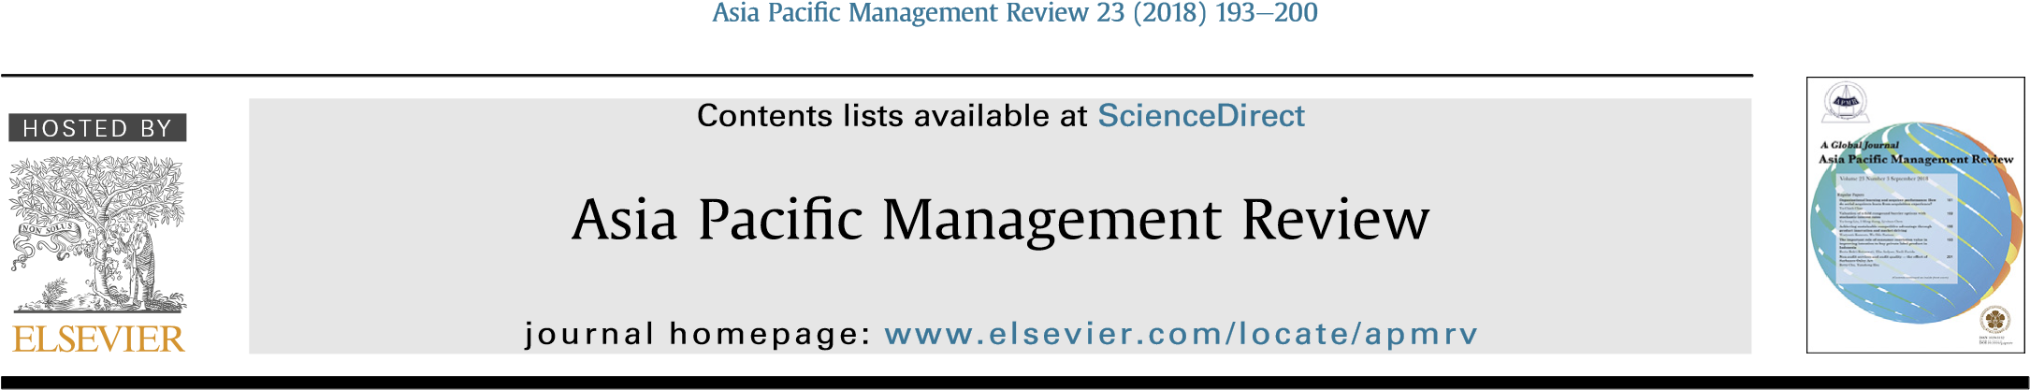
The important role of consumer conviction value in improving intention to buy private label product in Indonesia
Berta Bekti Retnawati ^{a, *}, Elia Ardyan ^{b}, Naili Farida ^{c}
a Faculty of Economics and Business, Soegijapranata Catholic University, Central Java, Indonesia b Management Program, Sekolah Tinggi Ilmu Ekonomi Surakarta, Central Java, Indonesia c Social Science Doctoral Program, Diponegoro University, Central Java, Indonesia

a r t i c l e i n f o | a b s t r a c t

Article history:  Received 18 April 2016  Received in revised form  8 May 2017  Accepted 5 July 2017  Available online 10 August 2017  Keywords:  Private label  Consumer conviction value  Attitude toward private label  Intention to buy private label | The purpose of this study is to investigate the price perception, perception of quality, attitudes toward consumer conviction value and intention to buy private label. Seven hypothesis were developed and tested using the data collected from consumers who have tried private labels in Indonesia. The Data was analyzed by SEM to test all the hypotheses. Four of all hypothesis were significant. The novely of the model gave proof that consumer conviction value could be a bridge of the research gap between attitudes and intention to buy. Perception quality of private label towards intention to buy was rejected from this empiric research. The empiric research gives a challenge for private label to further improve the quality of their products to align with the national brands and then it can increase intention to buy private label.  © 2017 College of Management, National Cheng Kung University. Production and hosting by Elsevier Taiwan LLC. All rights reserved.

Introduction
Generally, companies give their products’ brand with national label or private label (Dawes & Nenycz-Thiel, 2013). Private labels are often used by retailers, sellers or distributors, in which they are known as home brands, store brands or own label brands (De Wulf, Odekerken-Schroder, Goedertier, & Van Ossel, 2005). Usually, private labels will use the name of the retailers, sellers or the distributors (Boyle & Lathrop, 2014; Hyman, Kopf, & Lee, 2010; Walsh & Mitchel, 2010). Beneke and Carter (2015) defined private label brands as brands sold exclusively through certain retailers. (see
Fig. 1).
Increasing of modern retailers' growth, employers must find chances and creativities towards their competitive excellences and catch the society's intention by shopping in their retailers. Private label does not develop only in Indonesia, Ngobo (2011) explained that the use of private labels becomes very important in some countries in Europe including Switzerland (54%), Germany (40%), and France (32%). One of creative and innovative efforts is by selling a number of their own brands (private label).
Shimshak, Perloff, & Harris, 2002).
* Corresponding author.
E-mail addresses: bertabekti@gmail.com (B.B. Retnawati), ardyan.sbs@gmail. com (E. Ardyan), faridanaili@ymail.com (N. Farida).
Peer review under responsibility of College of Management, National Cheng Kung University.
http://dx.doi.org/10.1016/j.apmrv.2017.07.003
The empiric studies concerning private label take attention of researchers to explore many things related to them. The products of private label are acknowledged to have jump and rapid growth in many countries so they attract the researchers' attention to see this
1029-3132/© 2017 College of Management, National Cheng Kung University. Production and hosting by Elsevier Taiwan LLC. All rights reserved.
Supermarkets have increased the use of private labels in their marketing strategies (Pepe, 2012). Private labels become the source of benefit for the supermarkets and threaten national brands (Quelch & Harding, 1996). Some researchers explained that private label could increase the consumers' decision to buy (Nies & Natter, 2012), increase store loyalty, control distribution channel and increase consumers' loyalty (Ailawadi & Keller, 2004; Ailawadi & Steenkamp, 2008; Levy & Weitz, 2007; Patti & Fisk, 1982; Richardson, Jain, & Dick, 1996). The more increasing of private labels’ quality will increase the store market (Sudhir & Talukdar, 2004), market share (Erdem, Zhao, & Valenzuela, 2004), store image (Nies & Natter, 2012) and intention to buy private label (Richardson et al., 1996; Semeijn, Van Riel, & Amrosini, 2004). Private label is also able to increase the competitiveness (Corstjens & Lal, 2000). Private label will increase store loyalty and profitability compared to national brands (Collins-Dodd & Lindley, 2003) through increasing gross margin (Corstjens & Lal, 2000; Ward,
Customer value
an
Ɵ
cipa
Ɵ
on, customer
sa
Ɵ
sfac
Ɵ
on and loyalty: An
Empirical Examina
Ɵ
on
(
Flint, Blocker, & Bou
Ɵ
n,
2011)
The role of perceived
product quality and overall
sa
Ɵ
sfac
Ɵ
on on purchase
inten
Ɵ
on
(
Tsiotsou,
2006)
Consumer Convic
Ɵ
on
Value
Brand rela
Ɵ
onship quality
and consumer reac
Ɵ
on for
product harm: A
perpec
Ɵ
ve of prior
convic
Ɵ
on
(
Juan & Ye, 2011)
Sa
Ɵ
sfac
Ɵ
on strength and
customer loyalty
(
Chandrashekaran, Ro
Ʃ
e,
Tax, & Grewal, 2007)
Fig. 1. Epistemology of Consumer Conviction Value. Source: Developed for this research
from various perspective of consumers. Abril and Martos-Partal (2013) examined the innovation of private label products and shop loyalty. Meanwhile, some researchers examined consumers’ attitude and buying intention towards private label (Burton, Lichtenstein, Netemeyer, & Garretson, 1998; Garretson, Fisher, & Burton, 2002; Walsh & Mitchel, 2010).
In the study of consumers' attitude, there are still different results which can be restudied and developed for their models to relate these different results. There are positive and significant relationship between consumers' attitude and intention to buy shown by the research done by Garretson et al. (2002) and Burton et al. (1998), by examining consumers' attitude towards supermarket for daily needs in United States, with positive result of attitude towards private label and intention to buy the products as priority of supplying consumers’ needs. Another research which was in line with the result of the previous researches was done towards three products category including orange juice, cereal, and mineral water (Goldsmith, Flynn, Goldsmith, & Stacey, 2010). The result shown by this research had positive relation between consumers and intention to buy toward those three product categories compared to the same product categories with national label. The survey was conducted towards 300 respondents in United States.
The research conducted by Walsh and Mitchel (2010) showed different result. The research were done by supermarket in Germany involving 600 consumers with foru product categories (bread, chocolate, popcorn, and granola bars). It showed different result. The consumers’ attitude towards private label did not influence positively and significantly towards the product categories, while the attitude indicators in these researches were similar with the scale developed by Burton et al. (1998).
In Indonesia, the attractive power of private label consists of qualities, and the price of private label becomes the most important element in consumers’ decision making to buy the private labels (Untung, 2013). The consumers believe that well standardized qualities and competitive price become important parts in decision making to buy the private label. Basically, Indonesian consumers are very sensitive with price. The cheaper price with the same quality will tend to be bought by the consumers. Rahayu, Hussein, and Aryanti (2016) examined private labels in Malang, Indonesia. The result showed that perceived value and store image became important part in improving the loyalty of private label usage. Maulana (2012) believed that perceived value had to reveal equal benefits with the cost spent by the consumers.
The researches of private label done in many countries give reference to be done in Indonesia or other countries which have examined it and experience high development of private label relatively. This also support the researches done in Indonesia where the development of private label products has improvement in its quantities and labels offered and refers to the gap of research of consumers’ attitude towards intention to buy the private label products.
The purposes of this study are as follows:
- To analyze the influence of consumers' attitude towards their intention to buy the private label.
- To analyze the perception of private label quality towardsintention to buy private label.
- To analyze the price of private label towards intention to buyprivate label.
- To analyze consumers' attitude on private label towards thevalue of consumers' conviction.
- To analyze the perception of private label qualities towards thevalue of consumers' conviction.
- To analyze the perception of private label price towards thevalue of consumers' conviction.
- To analyze the value of consumers' conviction towards theirintention to buy private label.

Literature review
2.1. The epistemology of consumer conviction value
The research gap from various empiric studies between consumers' attitude and intention to buy private label products enables it to be further developed to encounter both sides. The building of renewal concept in form of consumer conviction value refers to empiric research related to the importance of marketers' understanding in learning process and development of dynamic knowledge of customers towards the newest values which become customers' standard in considering a good product (Flint, Blocker, & Boutin, 2011). The need of endurance in competitive excellence requires the companies and marketers to know in detail the consumers' expectation and the degree of their satisfaction. The concept of customer value anticipation becomes a strong connector between customers' satisfaction and loyalty. While the researches referring to the importance of consumers' quality of relation towards brands are very influenced by consumers’ conviction of previous experience (Juan & Ye, 2011).
The research of the influence of quality perception and whole satisfaction towards consumers' intention to buy shows that there are direct and indirect influences of consumers' involvement towards their intention to buy (Tsiotsiu, 2006). The consumers' active involvement is realized as unique activator towards consumers' intention to buy. The research of the strength of satisfaction influence towards consumers’ loyalty behavior gives a proof that there is strong relation in these (Chandrashekaran, Rotte, Tax, & Grewal, 2007).
Consumer conviction value in private label is needed as consumers’ booster and activator in deciding to buy and conducting other actions more actively. In consumer conviction value, the consumers will come to the next active action, that is intention to buy private label products, supported by conviction on price perception, conviction on quality perception, conviction that gaining information is right action, and conviction that private label brand is equal with national brands which has been previously in market.
We identified consumer conviction value as considered strength felt by consumers related to the next follow up that is intention to buy private label product after the consumers feel being convicted enough by price perception, high conviction towards quality perception, conviction that gaining information is right action, and conviction that private label brand is equal with the existing national brands.
2.2. Price perception and private label quality
At the beginning, private label presents low price and less quality compared to national brands (Goldsmith et al., 2010). This is caused by it wants to fulfill budget segment (Boyle & Lathrop, 2014). In its development, those perceptions change (Rossi, Borges, & Bakpayev, 2015). Private label develops towards various retails (Boyle, 2003; Liljander, Polsa, & Van Riel, 2009). Private label is positioned as “good”, “better”, and “best” products (Geyskens, Gielens, & Gijsbrechts, 2010). The impact of the improvement of private label quality is that the consumers begin to change their evaluation towards private label (Mendez, Oubina, & Rubio, 2008).
Quality perception towards private label is convicted by the practitioners and various empiric research literature to have tendency to more develop and increase (Walsh & Mitchel, 2010). The quality of private label is compared to national brands and it is getting equal and not different enough. This becomes plural things considering more various choices of products require the owners of retail brand to advance the quality by attractive price in order to get consumers’ intention to buy (Goldsmith et al., 2010).
Price perception which is according to private label products will be in line with the intention to get adequate product quality. Consumers' attention is simultaneously good for price-quality becomes main attention for retailed company in making and offering their private label products. Private label products will be always compared to national products so it must have excellences to catch consumers’ attention to choose private label products. The approach of low price excellence, and low risk of product will support the consumers have intention to buy in trying and buying the PLB products (Boyle & Lathrop, 2014; Tsiotsiu, 2006).
2.3. The consumers’ attitude towards private label
The understanding of consumers' attitude refers to tendency of consumers' perception particularly towards private label (Walsh & Mitchel, 2010). There are three consumers' attitude builders towards private label products, they are consumer price perception, marketing constructs, and deal proneness constructs. Price perception becomes the first factor of builder towards consumers' attitude, price consideration, values, and comparison between quality and price which gives support for consumers' attitude towards private label. The conviction that private label should be under the price of national brand product, has been coherent thing inside, so the consumers will receive different qualities offered by private label from national brands with their lower required price (Burton et al., 1998). While marketing constructs which give positive booster for consumers is self-perception as smart learners, the existence of private label choices that give chances for consumers to choose the products that supply their needs. For other dimension of brand loyalty, and shop brand which provides private label, impulsive purchase and avoiding risks considered to have negative support towards consumers' attitude towards private label. These factors weaken consumers' attitude caused by the strength of consumers' perception towards national branding which has had strong position in consumers' heart (Burton et al., 1998). The next supporting factor is deal proneness constructs which affirms consumers' attitude will be positive towards private label caused by consumers’ conviction with lower price compared to national branding and offered every time, so it forms good and positive attitude towards private label.
2.4. Intention to buy private label
Intention is important construct which can cause a certain action. Intention is predictor of actual behavior (Azjen, 1991). In the context of purchasing, intention to buy is precedent step from indulging in the actual buying behavior (De Magistris & Gracia, 2008). Intention to buy represents a possibility which will plan of have desire to buy products or services in the future (Wu, Yeh, & Hsiao, 2011). Consumer purchase intention refers to the attempt to buy a product or service (Diallo, 2012).

Hypothesis
3.1. The impact of consumers’ attitude towards intention to buy private label
Consumers' attitude is a tendency to respond product existence, private label products, which positively becomes supporting power for consumers to indulge in purchasing. This can be understood by Planned Behaviour theory perspective (Azjen, 1991), consumers will have consistent attitude, mainly positive attitude towards certain object, so it will relate to private label too. This positive attitude is shown by consumers in various categories of private label products (PLB) which have tendency to have higher sale section in each retail shop. The impact of this positive attitude and intention is larger on various product categories which have low social risks such as salt, wheat, sugar, and others (Walsh & Mitchel, 2010). It is different from the products used by the consumers to socialize with others (such as wine, cakes, coffee, and others), so private label has lower position in consumers' heart. It is consistent with Planned Behaviour theory, that consumers with positive attitude towards private label will have influences on intention to buy the products (Azjen, 1991). Consumers’ positive feelings and attitude toward a product/service or private label store will influence his/her purchase intention (Das, 2014).
Based on the explanation, we propose some hypothesis as follows:
H1. Consumers' attitude towards private label is able to increase intention to buy significantly.
3.2. The perception of quality of private label towards intention to buy private label
The perception of quality towards private label is believed by practitioners and various empiric research literature has tendency to develop and increase (Walsh & Mitchel, 2010). The quality of perception is consumers' assessment towards the excellence of the whole products and/or excellence (Erdil, 2015). The quality of perception is a way consumers assess certain products by relaying on their consumption experience (Kakkos, Trivellas, & Sdroloas, 2015). Cronin, Bradt, and Hult (2000) explained that quality perception will increase consumers’ intention to do purchasing.
The quality of private label is compared to national brands has more equality and not too much different. This becomes plural thing considering more various choices of products which asks the owner of retail brand to advance the quality with attractive price to get consumers' desire to buy (Goldsmith, Flynn, Goldsmith, & Stacey, 2010). Study conducted by Nenycz-Thiel and Romaniuk (2011) explained that only 8% of England market and 20% from Australia market refuse private label. One of the reason for refusal is the low quality of the private labels. The quality of the product will support the consumers' attitude that more qualified product will cause ore consumers’ intention to buy and superior sensory perceptions (Ailawadi & Keller, 2004; Bao, Bao, & Sheng, 2011; Batra & Sinha, 2000; Das, 2014).
Based on the explanation, we propose hypothesis 2 as follows:
H2. The perception quality of private label can improve intention to buy private label significantly.
3.3. The price perception of private label towards intention to buy private label
Price is considered as indicator of product cost and important parameter in marketing literature (Erdil, 2015). Consumers' usual price perception plays role and influences customers' satisfaction and next purchase (Heo & Lee, 2011). Creating relative lower price perception, retailers try to have positive influences towards consumers' loyalty towards store brand (Beristain & Zorrilla, 2011). One of consumers’ reasons to refuse price label is price listing (Rao, 2005). Other researches explained that price is important reason to buy private brand (Batra & Sinha, 2000; Burton et al.,1998; Sinha & Batra, 1999).
Based on the explanation, we propose hypothesis 3 as follows:
H3. Price perception of private label can increase intention to buy private label significantly.
3.4. Consumers' attitude, quality perception, and price perception towards private label towards consumers’ conviction value
Consumer conviction value in private label is needed as consumers’ support and activator in deciding to buy and conducting actions more actively. In consumer conviction value, consumers will come to next active action, that is intention to buy private label, supported by conviction on price perception, conviction that gaining information is the right action, and conviction that private label brand is equal with national products which have existed in market.
As the previous explanation, the benefit gained by retailers by the existence of PLB production that is increasing the whole profit in product categories, increasing gross margin on PLB is higher than national brand, and the ability of retailers make difference compared to the other competitor retailers. The benefits gained by retailers which will support the whole increasing marketing strategy increase consumers' loyalty to choose private label in related retailers. The strategy of quality correction, packaging, promotion become part of marketer's efforts to guarantee the quality improvement, consistency, and value for customers (Goldsmith et al., 2010; Walsh & Mitchel, 2010).
Price perception is subjective interpretation relating to product's monetary value such as if the product is cheap or expensive (Beneke & Carter, 2015).
Based on the explanation, we propose hypothesis 4, 5 and 6 as follows:
H4. Consumers' attitude towards private label will increase the conviction value significantly.
H5. Quality perception on private label will increase consumers' conviction value significantly.
H6. Price perception on private label will increase consumers' conviction value significantly.
3.5. Consumers’ conviction value towards intention to buy private label
Value is felt to have key role in consumers’ decision and willingness to gain product possession (Grewal, Krishnan, Baker, & Borin, 1998). Consumers will more believe private label as choice for them to buy excellently. This conviction will become supporter and activator for consumers to do next proactive action that is to have intention to buy private label product (J.Boyle & Lathrop, 2013).
Based on the explanation, we propose hypothesis as follows:
H7. Consumers' conviction value will increase consumers' intention to buy private labe significantly.

Research method
4.1. Population and sample
This research used survey research plan to analyze population by selecting and analyzing samples drawn from population to find relative events, distribution, and relation among the variables. The population in this research were consumers who bought private label product in retail shops in Indonesia. The growth of retail industry in Indonesia experiences rapid growth. Recently, the growth of retail with big, medium, and small scales increase in line with the consumers’ needs and providing the needs of products through purchases in provided shops (see Table 1).
Private labels in retail shops used as research place experience good development in product categories or offered product variant, like resumed in Table 2 about various types of private label products in various retail shops. This research was conducted in various shops providing various private label products, while shops used as places from which the respondents data taken, it was similar to retail shops in Table 2, they are Carrefour, Hypermart, Indomaret, Alfamart, Superindo, Giant, and Lottemart. The sample was acquired by purposive method, that consumers have purchased private label more than twice on private label brand and convenience method, a number of consumers met when they were shopping in some retail shops.
The number of target samples would be distributed was 200 according to sample measurement guideline for maximum Likelihood Estimation technique, the chosen respondents were consumers who were met when they were shopping in those retail shops. From 200 samples, 188 samples which could be collected and fulfilled the requirements to be analyzed were 181 respondents.
The characteristics of respondents’ demographic gender, age, last education, status, and monthly income. The resume is as follows:
The above table showed that respondents in this research for female respondents were more than male respondents, with the greatest age group 17e20 years, and most of them graduate from senior high school and it is clear that most of respondents were still university students or did not continue their study, but they work in their own fields.
Table 1
Respondents’ demographic characteristic.
Characteristics | Frequency | %
Gender:  Male | 87 | 48.07
Female | 94 | 51.93
Age:  17-20 years old | 55 | 30,39
21-30 years old | 43 | 23,76
31-40 years old | 45 | 24,86
41-50 years old | 38 | 20,99
Last Education:  High School | 101 | 55.80
Bachelor | 77 | 42.54
Magister | 2 | 1.10
Others | 1 | 0.55
Status:  Unmarried | 112 | 61.88
Married | 69 | 38.12
Weekly Income:  1-2 millions | 79 | 43.65
2-4 millions | 63 | 34.81
4-6 millions | 39 | 21.55
Occupation:  Private Employee | 39 | 21.55
Enterpreneurs | 28 | 15.47
University students | 76 | 41.99
House Wife | 38 | 20.99
4.2. Measurement
In this study, each question was measured with 10 scales. Every answer near to 1 was “very disagree” and near 10 was “very agree”. The following measurement is as follows:
Quality Perception on Private Label. Quality Perception on Private Label is defined as consumers' assessment towards the whole quality of private label products. This research indicators were adopted from Walsh and Mitchel (2010), such as: (1) Private label products’ quality was consistent/kept; (2) Private label product was made well; and (3) Private label products have had quality standard according to the category product.
Consumers' attitude of private label. Consumers' attitude of private label is defined as tendency of consumers' perception, particularly positive attitude on certain object that is private label. Consumers’ indicator attitude on private label was adopted from Burton et al. (1998), such as: (1) Willingness if desired private label is existed and (2) Choosing private label product for almost all product categories.
Price perception of private label. Price perception of private label
Table 2
Nu. | Hypothesis | CR | p | Explanation
H1 | Consumers' better attitude means consumers' higher intention to buy private label brand. | 1.149 | 0.628 | rejected
H2 | Consumers' higher quality perception towards private label brand means consumers' higher intention to buy private label brand. | 0.484 | 0.250 | rejected
H3 | Consumers' better perception on private label brand means consumers' higher intention to buy private label brand. | 2.858 | 0.004 | rejected
H4 | Consumers' better attitude towards private label brand means higher value of consumers' conviction towards private label brand. | 4.396 | *** | accepted
H5 | Consumers' higher quality perception towards private label brand means higher value of consumers' conviction towards private label brand. | 0.815 | 0.415 | Rejected
H6 | Consumers' better perception towards the price of private label brand means higher value of consumers' conviction towards private label brand. | 2.035 | 0.042 | Accepted
H7 | Consumers' higher value of consumers' conviction towards private label brand means higher intention to buy private label brand. | 2.382 | 0.017 | Accepted
The result of hypothesis examination.
is define as consumers’ assessment on the number of Rupiah that must be paid by consumers for purchasing private label product. The indicators of price perception of private label were adopted from Walsh and Mitchel (2010), such as: (1) Price is proper for private label product; (2) Buying private label product is more economic than national brand; and (3) Price of private label product is in accordance with the offered quality.
Consumer conviction value. Consumer conviction value is defined as true conviction from consumers on various considerations as supporter of next active actions towards private label. We propose two indicators from consumers’ conviction as follows: (1) Believe the real good quality of the needed private label product and (2) Believe the true private label product is proper to be placed next to national brands.
Intention to buy private label. Intention to buy private label is encouragement towards consumers’ attitude to try, to buy, to consume private label product which is available in retail shops they visit. The indicators of intention to buy private label were adopted from Walsh and Mitchel (2010), such as: (1) If the consumers need a category of certain product, they have intensity to gain the information on the private label product and (2) Have desire to buy private label product needed.
4.3. Data analysis
Descriptive statistic analysis was used to describe the characteristic of respondents, sample, and research variables. To describe the demographic characteristic from the respondents from various ages, education, gender, number of income, number of family members, and others. It also discussed respondents’ responds towards construct indicators studied in this research. To do the analysis towards the hypothesis from research model developed in this research, we used structural equality model (SEM) technique. Amos version 20 was used to analyze the data.

Result
5.1. Goodness of fit
The Chi-square score was 51.516, Prob. was 0.267, GFI was 0.957 AGFI 0.928, CFI was 0.988, TLI was 0.982, CMIN/DF was 1.120 and RMSEA was 0.026 have fulfilled the requirements of fit structural model test, so model analysis could be done to test the proposed hypothesis.
5.2. The result of hypothesis analysis
Analysis of full structural model done by AMOS program gives explanation towards proposed hypothesis. The followings are the explanation for the hypothesis analyzed in this research:
Estimation parameter to examine consumers' attitude towards intention to buy private label product showed significant result with cr value 1.149 and probability 0,250. The value did not fulfill the requirements of accepted hypothesis because cr > 1.96 so hypothesis 1 was not accepted. The result showed that customer attitude have positive and significant effect on intention to buy private label. This result supported the previous research result of Walsh and Mitchel (2010), that there is not significant relation between consumers' attitude and consumers’ intention to buy private label brand.
Estimation parameter to examine the impact of consumers’ quality perception towards intention to buy private label product showed not significant result with cr value 0.484 and probability 0.628. The score did not fulfill the requirements of accepted hypothesis because cr < 1.96 with significance degree more than 0.01 that means hypothesis 2 was not accepted. This hypothesis was not in line with the previous result (Burton et al., 1998). (Goldsmith et al., 2010; Walsh & Mitchel, 2010), in this empiric research, consumers had not had agreement with brand owner that private label brand is considered having not had equal quality with national brands. Private label is still considered as retail product which has lower quality than national brand.
In this hypothesis, estimation parameter to examine impact of consumers’ perception of price towards intention to buy private label product showed significant result with cr score 2.858 and probability 0.004. The score did not fulfill the requirements of accepted hypothesis because cr >1.96 with significance degree 0.05 that means hypothesis 3 was not accepted.
The hypothesis related to renewal model, consumer conviction value for Hypothesis 4 until Hypothesis 7 are as follows:
In Hypothesis 4, estimation parameter to examine the impact of consumers' attitude towards consumers' conviction towards private label product showed significant result with cr score 4.396 and probability 0.000. The score fulfilled the requirements of accepted hypothesis because cr >1.96 with significance degree 0.01 that means it is not reasonable to refused hypothesis 4. The result stated that consumers' better attitude towards private label product means consumers’ higher conviction towards private label brand.
Hypothesis 5, estimation parameter to examine consumers' quality perception of consumers’ conviction value towards private label product showed not significant result with cr score, 815 and probability 0.415. The score did not fulfill the requirements of accepted hypothesis because cr < 1.96 that means that it is reasonable to refuse hypothesis 5.
Hypothesis 6, estimation parameter to examine the impact of price perception on consumers' value conviction towards private label product showed significant result with cr score 2.035 and probability 0.042. The score fulfilled the requirements of accepted hypothesis because cr >1.96 with significance degree 0,05. It means it is not reasonable to refuse hypothesis 6. The result stated that better price perception towards private label product means consumers’ higher value of conviction towards private label brand.
In hypothesis 7, estimation parameter to examine the impact of score of consumers' conviction towards consumers' intention to buy private label product showed significant result with cr score 2.382 and probability 0.017. The score fulfilled the requirements of accepted hypothesis because cr >1.96 with significance degree 0.05 that means it is not reasonable to refuse hypothesis 7. The result stated that consumers' better value of conviction towards private label product means consumers’ intention to buy private label brand.
The summary of hypothesis examination is as follows:

Discussion
The result of this study showed that consumers' attitude could not increase intention to buy private labels. This research result was contradictive with planned behavior theory (Azjen, 1991). Planned behavior theory said that attitude is very influent for intention. This research result was also contradictive with some researches explaining consumers' attitude which could increase someone's intention to use private label (Chaniotakis, Lymperopoulos, & Soureli, 2009, 2010; Das, 2014; Jin & Suh, 2005). This result supported the result of previous research from Walsh and Mitchel (2010), that there was not significant relation between consumers' attitude and consumers' intention to buy private label brand, and this result needed to be accommodated by variable renewal examined in this model. There were some reasons that attitude could not increase someone's intention to buy private product. Firstly, private label products were not interesting. Private label product tends to imitate the existing products without innovation, so consumers in Indonesia see private labels products monotonous and not interesting. If private label had interesting perception, consumers would have positive attitude towards private label. This positive attitude will reduce intention to buy on manufacturer brand (Walsh, Shiu, & Hassan, 2012) and will increase intention to buy private label.
Quality perception is one of important variables to evaluate private label (Dick, Fain, & Richardson, 1997). Quality perception can not increase intention to buy private label. This research result was different from the previous result (Ailawadi & Keller, 2004; Bao et al., 2011; Batra & Sinha, 2000; Das, 2014). There were some reasons that quality perception can not increase intention to buy private label. First, consumers in Indonesia still believe that manufacturer brand is more qualified than private brand. In consumers' perception, the quality of private label is still under manufacturer brand (Wibisono, 2014) so higher quality can not influence significantly towards intention to buy private label. Secondly, perceived price should be able to increase intention to buy private label (Jin & Suh, 2005). Perceived price was also one of important factors to buy private labels (Batra & Sinha, 2000; Burton et al., 1998; Sinha & Batra, 1999). This research result was different from the result of previous research. Price can not increase intention to buy private product, and it has negative impact. There are some possibilities why price can not increase private label. First, private label's price in Indonesia tends to be cheaper compared to manufacturer brand. Cheap price usually has lower quality perception. It is because it reduces the cost to make the price cheap, consumers have perception that the quality is also reduced. That is what makes people tend to buy manufacturer product compared private product.
This research result found that consumers' better attitude and consumers' perception on private label brand (PLB) price means consumers' higher value of conviction towards private label brand (PLB). Other results explained that perception of quality was not significant towards consumers' intention to buy private labels. It can be concluded that retail industry in Indonesia, supporting factors for consumers' conviction value are consumers' attitude and their perception towards private label brand, while quality perception is not a kind of supporting factors for increasing private label. The result of this research showed that consumers' positive attitude is related to consumers' conviction value and price on private label brands in retail industry. There are positive acceptance along with availability and easiness to get private label brands in retail shops as a common place for consumers to buy. This research also showed that consumers' perception towards the quality of private label has not been accordingly with the retail owners' desire. This becomes a challenge for brand owner to fix and give same quality with existing national brands. Consumers are getting easy to get things they want in retail shops. It demands private label owners to advance quality guarantee which is similar with national brands, so private labels will be considered positively in consumers' heart. This can support consumers to get brand choices they can choose and private label can get same chance with national brands in consumers’ heart, so loyalty towards private label will be higher too.
Consumers' value of conviction can increase intention to buy private labels. The measurement of consumers' conviction, such as: (1) Believe the true good quality of needed private label products and (2) Believe the true private label product can be compared to national brands. Consumers must be sure on private label. One of the ways to make consumers be convicted is they understand the risks of using private label. Some literature explained that perceived risk can influence attitude to buy private labels (Glynn & Chen, 2009). When the consumers are not sure with private label have perception of big risks, so it can reduce someone's intention to buy private labels. Bhukya and Singh (2015) explained that there are 4 risks to be considered by consumers. They are perceived functional risk, perceived financial risk, perceived physical risk, and perceived psychological risk. Minimum risks and higher value of consumers' trust means that consumers' intention to buy is higher.
This research gave theoretic contribution. First, this research appeared novelty, a value of customers' conviction. In private label, value of customers' conviction is one of important factors to increase customers' intention to buy private label brands. The measurement of consumers' value of conviction are: (1) Believe the true good quality of needed private label and (2) Believe the true of private label product that can be compared to national brands. Secondly, in the context of retail industry in Indonesia, attitude, price perception, and quality perception cannot increase customers’ intention to buy private label brand. This research result was different from the previous research because the previous research explained that attitude, price perception and quality perception can increase intention to buy private labels.
This research also gave managerial implication. Manager must be able to increase customers' value of conviction because customers' value of conviction can increase customers' intention to buy private label brands. The way to increase intention to buy are focus on customers' attitude and perception on price. The way to increase customers' positive attitude towards private labels is by more advertising for private label. Private labels in Indonesia is rarely published or advertised. This is what makes people do not understand the quality of private label in Indonesia. Private labels is only identical with adopted product with no significant innovation. Communicate that private label product is a product which has cheap perception compared to national products. Indonesian tend to like cheap products. Therefore, communication is important to increase consumers’ attitude and perception towards price.

Limitation and future research
Basically, every research has some limitations. First, this research only focus on supermarket retail industry and frenchise retail industry. Beside it, there are many industries which have private label brand. Secondly, it gives less attention on moderator variables and control.
Suggestions for the next research are: first, search private labels for shooping good. There is possibility that the result will be very interesting for science. Secondly, use quality perception variable as moderating variable. In this research, it was found that quality perception can not increase consumers’ conviction value and intention to buy private labels. Therefore, use that variable as moderating.

References
Abril, C., & Martos-Partal, M. (2013). Is product innovation as effective for private labels as it is for national brands? Innovation: Management, Policy & Practice, 15(3), 337e349.
Ailawadi, K. L., & Keller, K. L. (2004). Understanding retail brand: Conceptual insights and research priorities. Journal of Retailing, 80(4), 331e342.
Ailawadi, K. L., & Steenkamp, J. B. E. M. (2008). Private-label use and store loyalty. Journal of Marketing, 72(6), 19e30.
Azjen, I. (1991). The theory of planned behavior. Organization Behavior and Human Decision Process, 50, 179e211.
Bao, Y., Bao, Y., & Sheng, S. (2011). Motivating purchase of private brands: Effects of store image, product signatureness, and quality variation. Journal of Business Research, 64, 220e226.
Batra, R., & Sinha, I. (2000). Consumer-level factors moderating the success of private label brands. Journal of Retailing, 76(2), 175e191.
Beneke, J., & Carter, S. (2015). The development of a consumer value proposition of private label brands and the application thereof in a South African retail context. Journal of Retailing and Consumer Service, 25, 22e35.
Beristain, J. J., & Zorrilla, P. (2011). The relationship between store image and store brand equity: A conceptual framework and evidence from hypermarkets. Journal of Retailing and Consumer Service, 18(6), 562e574.
Bhukya, R., & Singh, S. (2015). The effect of perceived risk dimensions on purchase intention an empirical evidence from Indian private labels market. American Journal of Business, 30(4), 218e230.
Boyle, M. (2003). Brand killers. Fortune, 148(3), 89.
Boyle, P. J., & Lathrop, E. S. (2014). The value of private label brands to US Consumer: An objective and subjective assessment. Journal of Retailing and Consumer Service, 20(1), 80e86.
Burton, S., Lichtenstein, D. R., Netemeyer, R. G., & Garretson, J. A. (1998). A scale for measuring attitude toward private label products and an examination of its psychological and behavioral correlates. Journal of the Academy of Marketing Science, 26(4), 293e306.
Chandrashekaran, M., Rotte, K., Tax, S. S., & Grewal, R. (2007). Satisfaction strength and customer loyalty. Journal of Marketing Research, 153(XLIV), 153e160.
Chaniotakis, I. E., Lymperopoulos, C., & Soureli, M. (2009). A research model for consumers' intention of buying private label frozen vegetables. Journal of Food Products Marketing, 15(2), 152e163.
Chaniotakis, I. E., Lymperopoulos, C., & Soureli, M. (2010). Consumers' intentions of buying own-label premium food products. Journal of Product & Brand Management, 19(5), 327e334.
Collins-Dodd, C., & Lindley, T. (2003). Store brands and retail differentiation: The influence of store image and store brand attitude on store own brand perceptions. Journal of Retailing and Consumer Service, 10(6), 345e352.
Corstjens, M., & Lal, R. (2000). Building store loyalty through store brands. Journal of Marketing Research, 37(3), 281e291.
Cronin, J. J., Bradt, M. K., & Hult, G. T. M. (2000). Assessing the effect of quality, value, and customer satisfaction on consumer behavioral intention in service environments. Journal of Retailing, 72(2), 193e218.
Das, G. (2014). Linkages of retailer personality, perceived quality and purchase intention with retailer loyalty: A study of indian non-food retailin. Journal of Retailing and Consumer Service, 21(3), 407e414.
Dawes, J., & Nenycz-Thiel, M. (2013). Analyzing the intensity of private label competition across retailers. Journal of Business Research, 66(1), 60e66.
De Magistris, T., & Gracia, A. (2008). The decision to buy organic food products in Southern Italy. British Food Journal, 110(9), 929e947.
De Wulf, K., Odekerken-Schroder, G., Goedertier, F., & Van Ossel, G. (2005). Consumer perception of store brands versus private brands. Journal of Consumer Marketing, 22(4), 223e232.
Diallo, M. F. (2012). Effects of store brand price-image on store brand purchase intention: Application to an emerging market. Journal of Retailing and Consumer Service, 19(3), 360e367.
Dick, A., Fain, A., & Richardson, P. (1997). How consumers evaluate store brands. Pricing Strategy & Practice, 5(1), 18e24.
Erdem, T., Zhao, Y., & Valenzuela, A. (2004). Performance of store brands: A crosscountry analysis of consumer store brand preferences, perceptions, and risk. Journal of Marketing Research, 41(February), 86e100.
Erdil, T. S. (2015). Effects of customer brand perceptions on store image and purchase intention: An application in apparel clothing. Procedia-social and Behavioral Sciences, 207, 196e205.
Flint, D. J., Blocker, C. P., & Boutin, P. J. (2011). Customer value anticipation, customer satisfaction and loyalty: An empirical examination. Industrial Marketing Management, 40(2), 219e230. http://dx.doi.org/10.1016/j.indmarman.2010.06.034.
Garretson, J. A., Fisher, D., & Burton, S. (2002). Antecedents of private label attitude and national brand promotion attitude: Similarities and differences. Journal of Retailing, 78(2), 91e99.
Geyskens, I., Gielens, K., & Gijsbrechts, E. (2010). Proliferating private-label portfolios: How introducing economy and premium private labels influences brand choice. Journal of Marketing Research, 47(5), 791e807.
Glynn, M. S., & Chen, S. (2009). Consumer-factors moderating private label brand success: Further empirical results. International Journal of Retail & Distribution Management, 37(11), 896e914.
Goldsmith, R. E., Flynn, L. R., Goldsmith, E., & Stacey, E. C. (2010). Consumer attitudes and loyalty towards private brands. International Journal of Consumer Studies, 34(3), 339e348.
Grewal, D., Krishnan, R., Baker, J. C., & Borin, N. (1998). The effect of store name, brand name and price discounts on consumers' evaluations and purchase intentions. Journal of Retailing, 74(3), 331e352.
Heo, C. Y., & Lee, S. (2011). Influences of consumer characteristics on fairness perceptions of revenue management pricing in the hotel industry. International Journal of Hospitality Management, 30(2), 243e251.
Hyman, M. R., Kopf, D. A., & Lee, D. (2010). Review of literature- Future research suggestion: Private label brands: Benefit success factors and future research. Journal of Brand Management, 17(5), 368e389.
J.Boyle, P., & Lathrop, E. S. (2013). The value of private label brands to U.S.consumers:An objective and subjective assessment. Journal of Retailingand Consumer Services, 20(1), 80e86.
Jin, B., & Suh, Y. G. (2005). Integrating effect of consumer perception factors in predicting private brand purchase in a Korean discount store context. Journal of Consumer Marketing, 22(2), 62e71.
Juan, S., & Ye, T. (2011). Brand relationship quality and consumer' reaction for product harm a perspective of prior conviction. Economic Management Journal, 01, 1e20.
Kakkos, N., Trivellas, P., & Sdroloas, L. (2015). Identifying driver of purchase intention for private label brands: Preliminary evidence from Greek consumers. Procedia-social and Behavioral Sciences, 175, 522e528.
Levy, M., & Weitz, B. A. (2007). Retailing management. New York, NY: McGraw Hill.
Liljander, V., Polsa, P., & Van Riel, A. C. R. (2009). Modelling consumer responses to an apparel store brand: Store image as a risk reducer. Journal of Retailing and Consumer Services, 16(4), 281e290.
Maulana, A. (2012). Brandmate: Mengubah just friends menjadi soulmates. Jakarta, Indonesia: Etnomark Consulting.
Mendez, L., Oubina, J., & Rubio, N. (2008). Expert quality evaluation and price of store vs manufacturer brands: An analysis of the Spanish mass market. Journal of Retailing and Consumer Service, 15(3), 144e155.
Nenycz-Thiel, M., & Romaniuk, J. (2011). The nature and incidence of private label rejection. Australasian Marketing Journal, 19(2), 93e99.
Ngobo, P.-V. (2011). Private label share, branding strategy, and store loyalty. Journal of Retailing and Consumer Service, 18(4), 259e270.
Nies, S., & Natter, M. (2012). Does private label quality influence consumers decision on where to shop? Psychology & Marketing, 29(4), 279e292.
Patti, C., & Fisk, R. P. (1982). National advertising, brand and channel control: An historical perspective with contemporary options. Journal of the Academy of Marketing Science, 10(1), 90e108.
Pepe, M. (2012). The impact of provate label sales penetration on category profitability. Journal of Business & Economics Research, 10(9), 513e519.
Quelch, J., & Harding, D. (1996). Brand versus private Labels: Fighting to win. Harvard Business Review, 74, 99e109.
Rahayu, M., Hussein, A. S., & Aryanti, R. (2016). Analysis pengaruh citra toko, citra merek produk private label, dan nilai yang persepsikan terhadap loyalitas pelanggan (Studi pada pelanggan Giant di kota Malang). Jurnal Ekonomi Bisnis, 21(1), 46e57.
Rao, A. R. (2005). The quality of price as a quality cue. Journal of Marketing Research, 42(4), 401e405.
Richardson, P., Jain, A., & Dick, A. (1996). Household store brand proneness: A framework. Journal of Retailing, 72(2), 159e185.
Rossi, P., Borges, A., & Bakpayev, M. (2015). Private labels versus national brands: The effects of branding on sensory perceptions and purchase intentions. Journal of Retailing and Consumer Service, 27, 74e79.
Semeijn, J., Van Riel, A. C. R., & Amrosini, A. B. (2004). Consumer evaluations of store brands: Effects of store image and product attributes. Journal of Retailing and Consumer Service, 11(4), 247e258.
Sinha, I., & Batra, R. (1999). The effect of consumer price consciousness on private label purchase. International Journal of Research in Marketing, 16(3), 237e251.
Sudhir, K., & Talukdar, D. (2004). Does store brand patronage improve store patronage? Review of Industrial Organization, 24(2), 143e160.
Tsiotsiu, R. (2006). The role of perceived product quality and overall satisfaction on purchase intentions. International Journal of Consumer Studies, 30(2), 207e217.
Untung, D. S. (2013). Potensi private label dalam menarik minat konsumen pada bisnis retail. Surabaya, Indonesia: Widya Mandala Catholic University.
Walsh, G., & Mitchel, V.-W. (2010). Consumers' intention to buy private label brands revisited. Journal of General Management, 35(3), 3e24.
Walsh, G., Shiu, E., & Hassan, L. M. (2012). Investigating the drivers of consumer intention to buy manufacturer brands. Journal of Product & Brand Management, 21(5), 328e340.
Ward, M. B., Shimshak, J. P., Perloff, J. M., & Harris, J. M. (2002). Effects of the privatelabel invasion in food industries. American Journal of Agricultural Economics, 84(4), 961e973.
Wibisono, B. (2014). Persepsi konsumen terhadap produk private label Indomaret: Studi pada Indomaret di Salatiga. Salatiga, Indonesia: Universitas Kristen Satya Wacana.
Wu, P. C. S., Yeh, G. Y.-Y., & Hsiao, C.-R. (2011). The effect of store image and service quality on brand image and purchase intention for private label brands. Australasian Marketing Journal, 19(1), 30e39.

