HISTORY OF MANUSCRIPT PUBLICATION
(IJSEM/International Journal of Services Economics and Management)

ADVANCING SALESPERSON PERFORMANCE WITH SALESPERSON ENERGIZING RELATIONSHIP: INDONESIAN PHARMACEUTICAL SALESPERSON STUDY

Berta Bekti Retnawati
Augusty Tae Ferdinand
Lalu Edy Herman
Elia Ardyan

Dept. of Management, Faculty of Economics
and Business
Soegijapranata Catholic University

DAFTAR ISI

I | SUBMISSION ACKNOWLEDGEMENT ………………………………………… | 3
 | November 3, 2017 ………………………………………………………………….. | 3
II | REFEREEING PROCESS: EDITOR COMMENTS (REVIEWER COMMENT) … | 4
 | May 24, 2018…………………………………………………………………………. | 4
III | SUBMISSION REVISED REMINDER…………………………………………… | 6
 | July 12,2018…………………………………………………………………………. | 6
IV | RESPONSE TO THE INSIGHTFUL SUGGESTIONS FROM THE REVIEWERS ((BY IJSEM SISTEM ) …………………………………………… | 7
 | July 20, 2018………………………………………………………………………… | 7
V | FINAL REFEREEING DECISION IJSEM: MANUSCRIPT ACCEPTANCE… | 17
 | October 5, 2018………………………………………………………………………. | 17
VI | REFEREEING PROCESS: EDITOR COMMENT (to upload author’s final version) ……………………………………………………………………………… | 18
 | October 9, 2018……………………………………………………………………… | 18
VII | EDITOR IJSEM: Author’s Agreement……………………………………………. | 19
 | October 12, 2018…………………………………………………………………….. | 19
VIII | EDITOR IJSEM: PROOF OF PAPER FOR CHECKING ……………………… | 20
 | October 19, 2018…………………………………………………………………….. | 20
IX | MANUSCRIPT AMENDMENTS………………………………………………….. | 22
 | October 31, 2018…………………………………………………………………….. | 22
X | EDITOR IJSEM: PROOF OF PAPER FOR APPROVAL……………………… | 25
 | November 14, 2018………………………………………………………………….. | 25
XI | INFORMATION ABOUT FINAL VERSION OF PAPER ……………………… | 27
 | January 31, 2019……………………………………………………………………. | 27
XII | SCREEENSHOOT ALL OF EDITOR’S EMAIL ……………………………….. | 20
XIII | FULL ARTICLE JOURNAL (PUBLISHED) ……………………………………. | 31

I.SUBMISSION ACKNOWLEDGEMENT
November 3, 2017
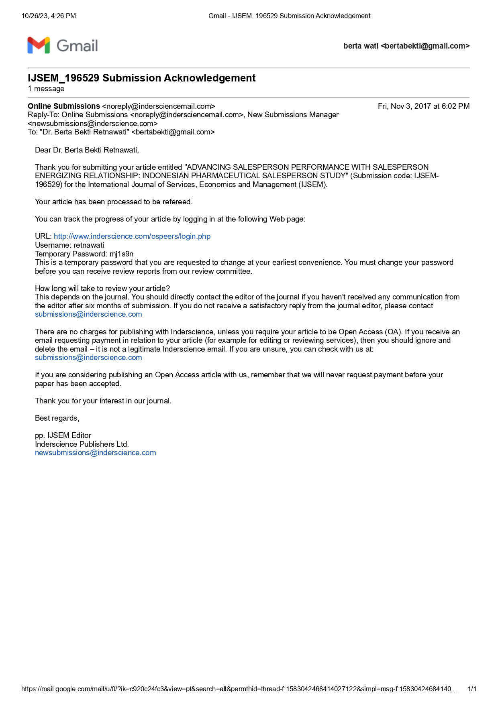

II. REFEREEING PROCESS: EDITOR COMMENTS (REVIEWER COMMENT)

May 24, 2018

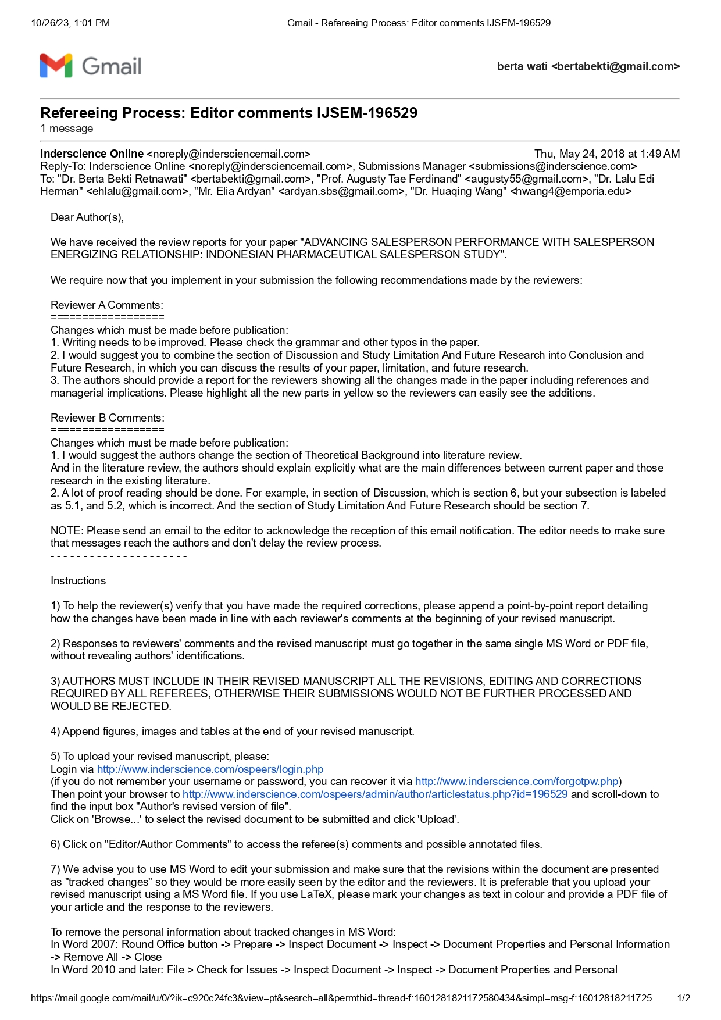

SUBMISSION REVISED REMINDER

July 12,2018
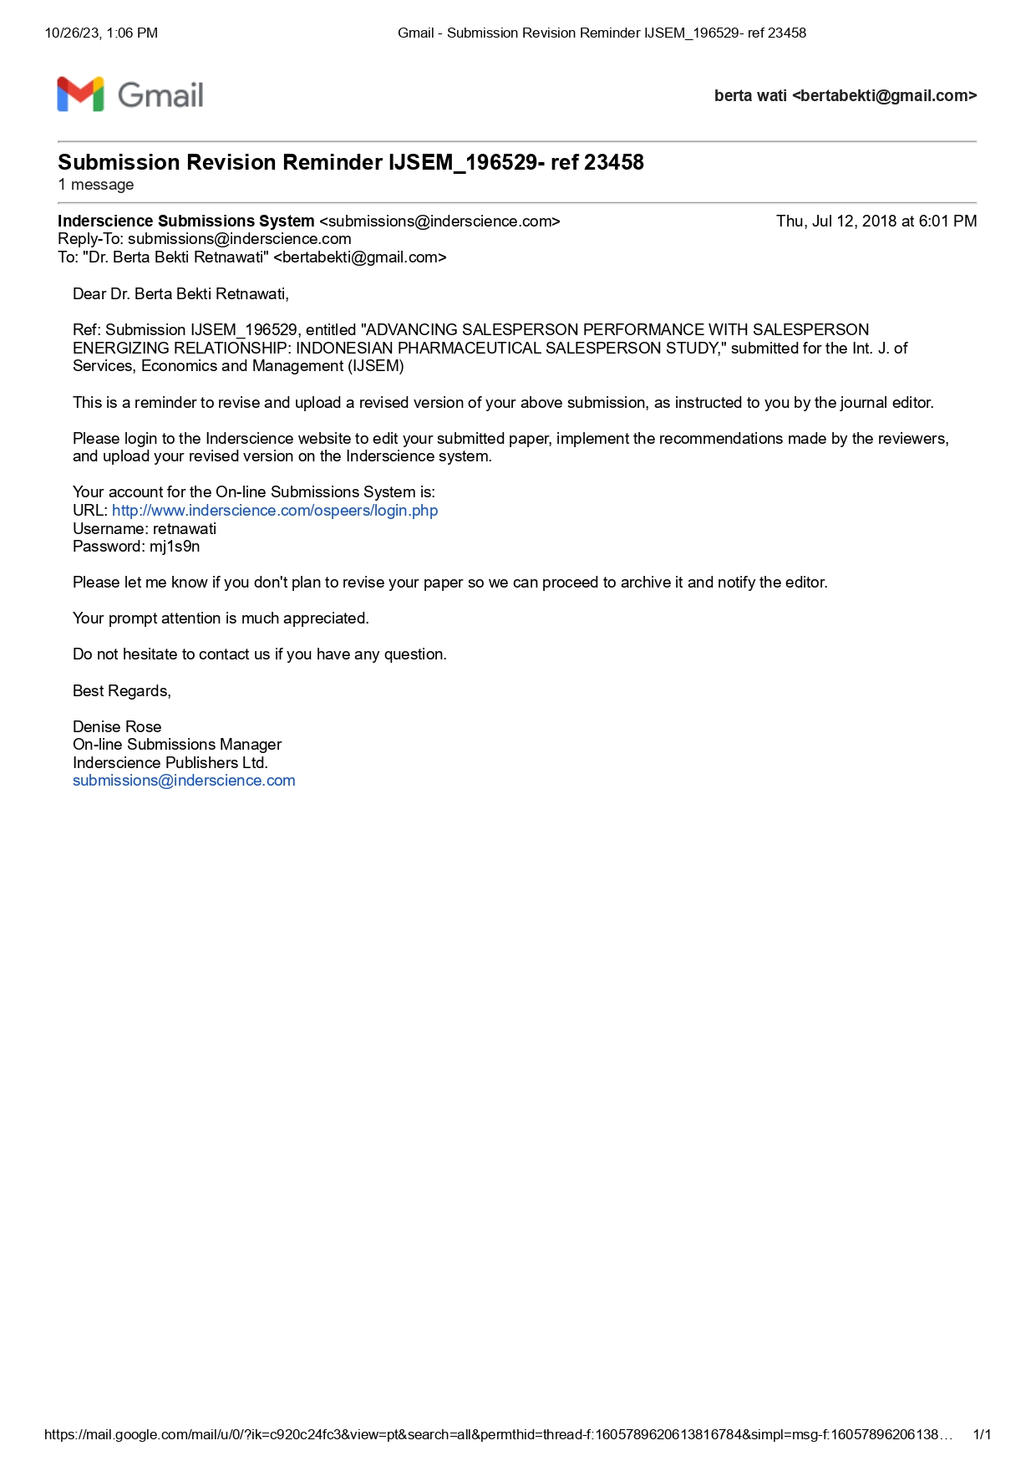

- RESPONSE TO THE INSIGHTFUL SUGGESTIONS FROM THE REVIEWERS
(Submit by IJSEM System)
July 20, 2018
POINT OF REVISION
Reviewer A
Reviewer Comment | Answer author
1. Writing needs to be improved. Please check the grammar and other typos in the paper | we tries to improve our writing
2. I would suggest you to combine the section of Discussion and Study Limitation And Future | we had combine the section of discussion and study limitation and future research into conclusion and future research
3. The authors should provide a report for the reviewers showing all the changes made in the paper including references and managerial implications. Please highlight all the new parts in yellow so the reviewers can easily see the additions. | we had highlighted all revision part

Reviewer B
Reviewer Comment | Answer author
- I would suggest the authors change the section of Theoretical Background into literature review.  And in the literature review, the authors should explain explicitly what are the main differences between current paper and those research in the existing literature. | we had changed its
- A lot of proof reading should be done. For example, in section of Discussion, which is section 6, but your subsection is labeled as 5.1, and 5.2, which is incorrect. And the section of Study Limitation And Future Research should be section 7. | we tries to improve our writing and we had combine the section of discussion and study limitation and future research into conclusion and future research (same with reviewer A)
Manuscript (Revision)
SALESPERSON ENERGIZING RELATIONSHIP: A DRIVER FOR ENHANCING SALESPERSON PERFORMANCE

Abstract. The current study aims at developing and testing a conceptual model on how to manage the salesperson’s customer orientation for enhancing salesperson performance, by introducing the concept of salesperson energizing relationship as a novelty in the sales management study. The research context is in the pharmaceutical industry in Indonesia, which holds a promising pharmaceutical market to the global market place. The structural equation model analysis is employed to test the hypotheses. The finding of this study demonstrates the pivotal role of salesperson energizing relationship in mediating the customer orientation and salesperson performance as well as the role of salesperson autonomy and relational capital in influencing salesperson performance. The originality of this study is in the important role of salesperson energizing relationship that contributing to enrich the sales management literature.

Keywords: customer orientation, salesperson energizing relationship, relational capital, salesperson autonomy, salesperson performance.

JEL Classification: M31

1. Introduction
Salespersons play an important role in business competition, especially in making ways for improving the sales performance. Salesperson performance improvement could be influenced by many factors such as competitive advantage. Sales person should strive for getting a level of competitive advantage as a basis for enhancing performance, particularly in building relationship with customers. Our literature study demonstrated the important role of customer orientation and adaptive-selling approach in leveraging the performance improvement (Franke & Park, 2006; Jaramillo & Grisaffe, 2009; Kaynak et al., 2016; Singh & Venugopal, 2015). Any salesperson with adaptive capability will be able to adjust and change the sales approach to match their customers. Salesperson should also have the ability to serve customers, to fulfill customer needs (Crosby et al., 1990), to create added values (Singh & Koshy, 2011), and to provide solutions for customers (Bonney & Wolliams, 2009; Sawhney, 2006; Tuli et al., 2007).
Studies on the role of customer orientation in enhancing sales persin performance has been conducted instensively and come out with a mix results. Some scholars demonstrate the significant influence of customer orientation to salesperson performance (Boles et al., 2001; Homburg et al., 2011; Kara et al., 2013; Keillor & Parker, 2000). Homburg et al. (2011) proves the curvilinear influence of customer orientation on salesperson individual performance. Meanwhile, Franke and Park (2006) find that customer orientation is not significantly influence salesperson performance in their cross-sectional study. Customer orientation, however, has a significant influence in a longitudinal study method (Franke & Park, 2006). Another study of Jaramillo and Grisaffe (2009) indicates no direct influence of customer orientation to salesperson performance but fully mediated by adaptive selling to improve salesperson performance. The facts that customer orientation cannot directly influence salesperson performance dan requires salesmanship skills and salesperson’s ability in managing their emotion are found in a study in India setting (Singh & Venugopal, 2015). Therefore, it is reasonable to include an intervening variable for mediating the relationship between customer orientation and salesperson performance.
The purpose of this study is to build and test a conceptual model on how to manage the salesperson’s customer orientation for enhancing salesperson performance. To do so, we insert into the model our a new concept of salesperson energizing relationship, together with relational capital and salesperson autonomy, then test the model in the pharmaceutical industry in Indonesia

2. Literature Review
2.1. Salesperson Energizing Relationship
Previous research has shown inconsistencies in the influence of customer orientation on salesperson performance. Another testing variable is required that can bridge the role of customer orientation there is salesperson performance (Jaramillo & Grisaffe, 2009; Schwepker & Good, 2012). This study provides a framework model by adding the concept of salesperson energizing relationship which is going to emphasize that the customer orientation will be more powerful in influencing the salesperson performance by passing through the mediating variable.
The energy in relationship refers to salesperson task to be able to manage and bind customers for a long-term period (Medhurst & Albrecht, 2016). Work Engagement becomes one that gives strong influence on individual factor besides other factor that is role ambiguity, ready for adaptiveness, cognitive aptitude, and selling-related knowledge that can give a direct influence on salesperson performance (Dong et al., 2015; Medhurst & Albrecht, 2016). Employee engagement or work engagement enables salespeople to have organizational commitment and awareness to achieve optimal performance (Di Mascio, 2010; Medhurst & Albrecht, 2016). Di Mascio (2010) dan Medhurst and Albrecht (2016) also explained that the dimension of affection in work engagement is energy. affection engagement is defined as an experience that actively describes a sense of enthusiasm, energy and positive stimulation. This energized dimension provides a person with a high degree of focus, attention, and concentration.
The energizing relationship can also be illustrated through a concept from Anderson et al. (2010) who has identified and analyzed the practice of networking that can run well within the existing entrepreneurial growth by applying span of networking growth concept. The Pierre Bourdieu’s habitus concept becomes the platform/basis of one’s mental or cognitive structure in encountering the dynamic environment. Habitus itself is a cognitive thinking where someone is trying to do what and how something is formed. There are five spans in either networking growth or relation that are formed from the interaction of the two sides, which are relation characterized by liberating that is able to explore future needs, relation with inspiring characteristic that is able to explore and correct the existing deficiencies, relation with visioning characteristic that is able to show the future superiority, relation with articulating characteristic that is able to determine the current advantages, and relation which is characterized by implementing that is able to demonstrate that this relationship deserves to be continued. Based on those concepts of work engagement and entrepreneurial networking, here, the researcher provides a definition for salesperson energizing relationship as the salesperson’s ability in binding customers to make a long-term relation characterized with liberating, inspiring, visioning, articulating, and implementing relationships. This salesperson energizing relationship has the potential to become a mediator between customer orientation to maximally support the achievement of sales force performance.

2.2. Customer Orientation
Customer orientation has long been extensively studied in the sales force management literature, since the first SOCO coined by Saxe and Weitz (1982). Customer orientation which is owned by the salesperson during the interaction with customers provides a positive effect in strengthening satisfaction and establishing customers’ trust on the company and the salesperson (Arndt & Karande, 2012; Homburg et al., 2011; Kaynak et al., 2016). Customer orientation in various researches in marketing management is described as “The practice of marketing concept at the level of individual salesperson and customer” (Saxe & Weitz, 1982). The definition of customer orientation is expressed as a marketing management implementation where a salesperson tries to ascertain the needs and tries to satisfy the customers. The effort in customer satisfaction requires a mastery of as much information about customers to know the needs, desires, behaviors, and styles of communication needed to interact with the customers (Homburg et al., 2011; Singh & Venugol, 2015; Stock, 2016). In carrying out the role to implement the customer orientation, salesperson is required to as a consultant for the customer or as a customer advocate to be able to provide services that delight the customer in not only a moment interaction but the long run (Kaynak et al., 2016; Pousa & Mathieu, 2013). It is hoped that the customer orientation will enable the salesperson performance to increase along with the customer acceptance to the interaction satisfactions that occur between them.

2.3. Relational Capital
Study on relational capital is rooted in the conception of invisible assets by Hiroyuki Itami in Japanese, 1980 (Sullivan, 2000), social capital and intellectual capital as framed in the management research intensively (Bontis, 2004; Chia-Yi & Chang, 2015; Falcone & Castelfranchi, 2011; Mubarik et al., 2016; Sullivan, 2000; Welbourne & Padrdo-del-val, 2009) demonstrated the essence, support, function, and key role of intellectual capital in enhancing human capital effectiveness in terms of worker’s performance, organizational performance. Discussion of relational capital in this study is rooted in the theory of intellectual capital as appeared in the study of Bontis (2004), in which they pinpointed three main elements of intellectual capital as human capital, structural capital, relational capital in a format that human capital and structural capital are driver for enhancing relational capital and ultimately relational capital is key determinant for human capital effectiveness. Another root is in social capital theory as appeared in the study Tata and Prasad (2015) that classified Social capital as structural social capital and relational social capital.
Study on salesforce management is rooted in the human intellectual capital theory as indicated human capital as a key anchor for driving, leveraging and enhance performance. How important human intellectual capital in sales organization is seen in the practices that most of sales managers devote considerable efforts for enhancing salesperson hard-competence and ultimately soft-competence in building social relationship (Chia-Yi & Chang, 2015), those org-ware is believed as a determinant for enhancing human capital effectiveness. On the basis of human intellectual theory, our way to understand relational capital is to understand the essence of human capital, at the first side is understanding the hard type of intellectual capital, named as structural capital indicated by the quantity of workforce such as salesman, sales supervisor, quantity of network, number of member of distribution channel, structure of relationship such as contracted relationship or voluntary relationship, pattern of transactional involvement within network relationship (Bontis & Fitz-ens, 2002; Chia-Yi & Chang, 2015) such as by contract involvement or voluntary involvement. At the second side is soft type of intellectual capital, named as relational capital, indicated by quality of relationship, the developed and embedded trustworthiness between members of relationship, professional and social obligation attached to the formation of relationship, commitment consensus in strengthening attributes for a mutually benefit relationship (Falcone & Castelfranchi, 2011; Mubarik et al., 2016; Terawatanavong et al., 2007; Welbourne & Padrdo-del-val, 2009).
Relational capital in this study is defined as portfolio of soft attributes developed and embedded in cultivating a network in three aspects 1. Interdependency with respect on autonomy in each party; 2.Relational Strength for creating value; 3. Value creating in benefit and justice. Relational capital could be seen mainly as quality of relationship that even though several parties or individual are committed in a relationship, but what is more important in that committed bond is each parties are high respect on autonomy of individual in interdependence and trust (Terawatanavong et al., 2007) and mutual respect within parties (Miocevic, 2016). A relational capital is cultivated in a manner that it has a specific quality that adding value for both parties as a basis for strengthening the added value relationship. This means that any relationship to be developed between parties should be a value creation chain that gain access to value-added information and knowledge needed for generating a added value performance (Johansson, 2007). A relational between parties is recognized as capital if the relationship has potential for creating reciprocal benefit and justice for a long term bond between partier characterized by mutual respect, mutual trust, reciprocity and friendship (Miocevic, 2016) as a basis for creating and enhancing performance.

2.4. Salesperson Autonomy
Today, the term autonomy is one of the hottest topics that is always interesting to study further of its effects in the workplace. Basically, every employee wants to have the freedom to work and be in an environment that respects the work outputs of more than targeted. Autonomy at work is described by the empowerment of the employees in making their own decisions, having goals and targets of their works, and deadlines, and also working on their own ways. A salesperson is a spearhead of a company to carry out marketing activities of products. A salesperson is required to possess the ability to sell high in order to convince the potential buyers to willingly buy the product offered. Creativities of a salesperson in marketing activities has become a very necessary thing and is believed to give contributions on innovation, effectiveness, and company’s performance (Shalley et al., 2004).
Job autonomy shows a confidence from the principal or supervisor in the ability and responsibility of a salesperson. Salesperson autonomy is an ability of a salesperson to understand the main job or problem encountered followed by actions to tackle them (Wang & Netemeyer, 2002). In this case, salesperson autonomy demonstrates the salesperson’s creativity in carrying out his work freely and responsibly based on the corridors specified by the company. Creativity is believed to be able to build the company’s competitive ability in adjusting itself to the changes in the competitive landscape to build competitive excellence (Shalley et al., 2004).
Granting an autonomy to the salesperson to do the job will help to create a good climate in the sales working group, in which the salesperson will be able to work based on the rules and concepts made by himself according to the conditions of market realities. The availability of empowerment and salesperson autonomy will stimulate the emergence of creative ideas that are expected to be able to apply in their work, develop, and further spread the ideas to the team. The salesperson’s involvement in the decision-making and autonomy perceptions acquired is an important prerequisite for creative results (Amabile et al., 2004).

2.5. Salesperson Performance
The discussion on salesperson performance is extremely important in salesforce management (Piercy et al., 1998). A salesperson’s sales performance measurement has now been quite long based on sales quota achievement, and the salesperson’s comparative performance in the previous unit (Babakus et al., 1996). Salesperson performance is evaluation on his/her behavior, whether or not his/her behavior contribute to the accomplishment of company’s goals (Churchill et al., 1993). Many factors should be considered to improve salesperson performance. Firstly, the factors come from inside the company. These factors from the inside can take such forms as managers asking the salesperson to be involved in the effort of team-based sales (Piercy et al., 1998), salespersons who are always oriented to learning (Nguyen et al., 2006; Paparoidamis, 2005; Sujan et al., 1994), salespersons having high emotional inteligence (Kadic-Maglic et al., 2016; Pettijohn et al., 2010), salespersons having presentation skills (Johlke, 2006), salespersons oriented to customers (Cross et al., 2007; Singh & Das, 2013; Singh & Venugopal, 2015), and so on. Secondly, the factors come from outside the company. These factors coming from the outside can be market potential (Churchill et al., 1993) and social value (Swenson & Herche, 1994).

3. Model Development and Hypotheses
3.1. Customer Orientation, Salesperson Energizing Relationship and Salesperson Performance: Mediating Effects of Salesperson Energizing Relationship
However, in addition to the results that have not been inclusive yet to directly influence the customer orientation on the salesperson performance that is characterized by the literature gap still available questioning how customer orientation process is able to strengthen the sales performance (Jaramillo & Grisaffe, 2009; Singh & Venugol, 2015). The same thing was also questioned by Plouffe et al. (2009), how orientation works in influencing the salesperson performance. Responding to the questions Singh and Venugol (2015) offers a mediation with the salesmanship skills where there contain several dimensions to strengthen the salesperson performance, they are the ability of prospecting potential customers, delivering messages, and closing the sale, however, it has not looked specifically on the persuasive power that enables the salesperson in winning the customers’ hearts.
In this study, the impetus that begins with customer orientation is forwarded by strengthening the salesperson energizing relationship which will potentially enhance the final output, the salesperson performance. Strengthening the findings from Singh and Venugol (2015) which confirmed the importance of managing salesperson’s emotions in interacting with customers requires support of forces in the interaction with the customers, i.e. the energy in the relationship itself. Energized that becomes a part of complex cognitive process illustrates a mental state characterized by the high levels of focus, attention, and concentration (Medhurst & Albrecht, 2016). Mentally, energized also illustrates the condition of someone who is active, alert, and quickly understand (receptive), and responsive to changes in information and stimuli. In relation to the process of interaction with customers by accommodating the entrepreneur behaviors, energized can be applied in various conditions of interactions. A salesperson with an energetic interaction capability is expected to strengthen the ability in achieving the maximum salesperson performance.
Based on those previous literature review and explanations, this research presents hypotheses that deal with the influence of customer orientation, salesperson energizing relationship, and sales force performance as follows:

H1.Salesperson with high level of customer orientation will lead to high level of salesperson energizing relationship
H2.Salesperson with high level of customer orientation will lead to high level of salesperson performance
H3.Salesperson with high level salesperson energizing relationship will have increased level of salesperson performance

3.2. Relational Capital and Energizing Relationship
Relational capital which clearly appeared in network research has attracted scholars interest for its ability to create performance, especially its ability to enhance human capital effectiveness (Bontis & Fitz-ens, 2002) in a sense that interconnectedness between persons based on mutual respect, mutual trust, friendship and reciprocity (Miocevic, 2016) are expected to form a basis for exploring future possibilities such as need, challenge, prospect for growth in the future (Anderson et al., 2010). Relationship quality by nature is indicated by closeness’ connectedness that is potential for creating happiness in work and life (Capaldi et al., 2014) as a basis for human capital involvement in energizing their relationship. Relational capital based on its core value of relationship quality is a platform for creating values in a form that value creation is a result of resource sets when they are linked, joined and interfaced for producing value both for seller and buyer (Haas et al., 2012)
Relational capital is proved to serve as a leverage for job satisfaction (Nguyen & Nguyen, 2011) for those involved in marketing activities in inspiring, visioning, articulating, and implementing value creation process in the relationship, in turn to enhance human capital effectiveness. In the spirit of relationship marketing, a relationship is only beneficially built if the parties involved in the relationship can fulfil their promises (Hunt, 1997) as a driver for human capital effectiveness in term of value creation success for all parties in the relationship circle. Therefore the following hypothesis is proposed.
H4. Relational capital has a positive impact on salesperson’s energizing relationship

3.3. Relational Capital and Salesperson performance

A popular idiom in marketing world” Your Network Is Your Net Worth” demonstrates the importance of relationship, especially network in creating performance both individually and organizationally. This is one of the essences of this study; that building relationship that energizes the involvement of parties in relational capital is pivotal for value creation. A strong tie in relationship which is mirrored in meeting customer needs in a manner that shows that the salespersons are knowledgeable, the salesperson’s knowledge of products is beneficial to customer and it is irreplaceable (Choi et al., 2015). Feeling of justice fulfillment in a relational capital setting is potential for affecting salesperson’s commitment to providing superior customer value (Schwepker, 2016) in the sales encountering process. Therefore, the following hypothesis is proposed.
H5. Relational capital has a positive impact on Salesperson performance

3.4. Salesperson Autonomy, Salesperson Energizing Relationship and Salesperson Performance
Salesperson is one of a company’s human resources who can give great contribution to the achievement of the company’s goals. However, salespersons are frequently in dilemma because they are responsible for two main duties, i.e. sales productivity and customer satisfaction. The greater autonomy level in their job will be found by salespersons as a freedom in interacting with customers (Pettijohn et al., 2010). When salesperson’s freedom is limited in making decisions in their job, they will be less capable of offering customer-oriented solutions, because they can only share the standard solutions as instructed by the company.
Autonomy is one basic characteristics of a profession, as a form of freedom for professionals to perform their professional activities based on individual assessment for the implementation of their knowledge. Giving greater yet controlled job autonomy to salesperson becomes something highly crucial nowadays. A leader can provide supports to salespersons, including assingning job with substantial freedom, independence, and flexibility in their jobs, as well as the procedures they should use. A well-developed salesperson autonomy will have core characteristics such as varied expertises developing, task identity, task significance and feedback from job.
Salesperson performance is intended to be sales productivity, and it deals only with the factors directly controlled by the salesperson. Salesperson performance is measued by how great is the sales output being produced (Churchill et al., 1985). Challagalla and Shervani (1996) suggest that salesperson performance is a level at which salesperson can achievethe sales target set to themselves. The salesperson profession is a challenging one, in which one should have high creativity in meeting the set output target and should be customer-oriented to create satisfaction in the customers. The job autonomy given to salesperson will affect their competence and creativity (Kauffed, 2006) and improve performance. Job autonomy can improve salesperson performance since they think themselves capable and more confident in performing their duties (Gellatly & Irving, 2001; Langfred & Moye, 2005).
H6. The higher Salesperson Autonomy, the higher Salesperson Energizing Relationship
H7. The higher Salesperson Autonomy, the higher Salesperson Performance

Figure 1. Empirical Model
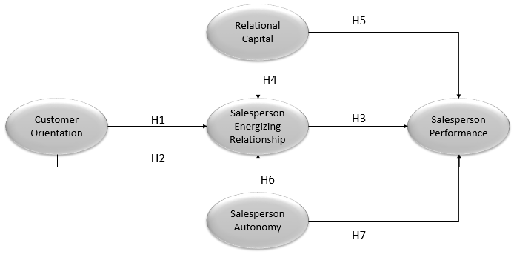

4. Method
4.1. Sample
The setting of sampling in this study followed the advices from Saxe and Weitz (1982) suggestion where the measurement of customer orientation is expected to follow several required conditions:
- Salesperson has a set of alternative approaches when they interact with customers
- Customer is under complex purchase situation, requires some considerations and thoughts prior to making purchase decision.
- There is an interactive relationship between salesperson and customers.
- Repeat sales and refferals become important sources in the interaction between salesperson and customer.

The sample in this research is taken from salespersons within pharmaceutical industry in Indonesia, a developing country with promising pharmaceutical industry prospect at both Asia and global levels. The data are collected from pharmaceutical companies which have been go public in Indonesia. The reason for choosing companies which have been go public is due to the researchers’ belief that these companies are more transparent and they have Good Corporate Governance (GCG). The term salesperson in this research means the company’s ambassador/detailer entrusted to represent the company to promote their products professionally and credibly and full of integrity to doctors in such a way that these doctors are convinced and prescribe the company’s products to their patients.
The sampling techniques used in this research are purposive sampling and convenience sampling which constitute nonprobability sampling techniques. The sampling techniques apply certain criteria, i.e. the respondent should be pharmaceutical salespersons who have worked for the current companies during the data collection for two (2) years or more, assuming that these persons have performed many sales activtities and interacted with customers.
It is necessary to do data screening and trimming as an effort of ensuring the data feasibility for the next testing stage. The data screening is performed by testing the response consistency of each respondent, by judging the extreme standard deviation. Meanwhile, the data trimming is done by judging the consistency between closed and open responses fulfilled by the repondents. In total, responses are given by 350 respondents and the number of returned questionnaires is 295 (response rate 84%), with 16 data (cases) failing to qualify for such reasons as having less than a year experience and 27 data (cases) failing to complete the questionnaire consistently, thus these data are disposed of. The remaining data come from 252 respondents. The outlier of the remaining data is 47 data (cases), leaving 205 questionnaire data feasible for further testing.
The description of these 205 respondents are as follows: the number of male and female salespersons is quite balanced, i.e. 59% and 41%, while their age ranges from 25 to 50 years old, most of them are married (82%), and most of them have worked for 10 to 15 years for their companies (26%) and followed by those who have worked for 3 to 5 years for their company (21%). Finally, in regard to the number of teammates in a work team, the most range is 2-5 people (70%).

4.2. Measurement
In measuring all variables, this research uses self reported measuring instruments which have been validated in previous studies, and have been standardized in many studies in marketing management literature for both customer orientation, salesperson autonomy, relational capital, salesperson performance, and salesperson energizing relationship (Anderson et al., 2010; Cross et al., 2007; Hughes et al., 2012; Kang et al., 2014; Killic & Dursun, 2008). All research variables are measured in 10 point range scale (a-tenth range scale) from score 1: strongly disagree to score 10: strongly agree with the provided statements.

4.2.1. Customer Orientation
The self measurement of customer orientation instrument (SOCO) from (Saxe & Weitz, 1982) has long and widely been applied in various sales management research literature, however, many criticisms sent to this measure on the number of question items that must be responded by the respondents (24 indicator items). Hence, many of the next researchers reduced the number of questions on the customer orientation measurement without reducing the meaning of concept being explored (Jaramillo & Grisaffe, 2009; Singh & Venugopal, 2015). One modification, and used in this study, was developed by Hughes et al. (2012) which covers four statements, one example is “The salesperson’s in depth efforts in trying to understand the customer’s motivation.”

4.2.2. Salesperson Energizing Relationship
Self-measurement (self-report) on energizing salesperson relationship refers to the statement used in measuring the level of affection in binding customers from Medhurst and Albrecht (2016) and also the level of entrepreneurial growth from Anderson et al. (2010), there are five items of statements to measure the salesperson’s ability in making a strong and energetic interaction with customers, one example is “The relationship with liberating characteristic is able to explore the future needs.”

4.2.3. Salesperson Autonomy
There are four items relating to the self-report measurement of salesperson autonomy, with reference to the research development done by Das and Joshi (2007), autonomy is related to freedom in the styles of management practices, and independency in making decisions based on the expertise, without the need of absolute authority in the organization, and also the ability to access and manage information for decision making. This research developed the questionnaire items to measure self-report with regard to the salesperson autonomy in relation to their opinions on the company’s policy. One example of statement items is “the salesperson’s opinion on the company’s policy in giving freedom to the salesperson from a formal style towards the informal style.”

4.2.4. Relational Capital
The self-reported measurement regarding relational capital adopts the measuring instrument used by Kohtamaki et al. (2013), which gives an emphasis on how is the power of interaction which is based on mutual trust between the two interacting parties which becomes the basis for the construction of long-term relationship and loyalty continuously maintained. In addition to trust, the relational capital power aspects which include benevolence, mutual respect, competence, and honesty also become the basic dimensions in making the supplier-customer interaction (Hughes et al., 2013). An example of statements in relational capital is “The awareness that relationship with customer is based on mutual respect”

4.2.5. Salesperson Performance
The self-reported measuring instrument on salesperson performance has extensively been used in many sales management studies. Basically, the measurement statement explores the output of self-achievement in many sales goals, such as comparison with partners in the same team, real achievement as compared to annual targets, and comparison of performance to the previous year, and number of new customers (Babakus et al., 1996; Cross et al., 2007; Jaramillo & Grisaffe, 2009). This research uses self-reported measuring instrument from these researchers, for example “Total achievement of sales target as compared to other top performing salespersons in the same group”.

5. Result
The non-response bias testing is intended to figure out whether or not there is a significant difference in the questionnaire responses for the sample groups being studied. In this research, the sample groups are distinguished between the groups during initial data collection and the one at the end of data collection. This research uses Levene Statistics test with independent sample t test to test the non-response bias. If the probability of Levene test < 0.05 or significant, it is then concluded that there is a difference in the questionnaire responses for the sample groups being studied. On the contrary, if the probability of Levene test > 0.05 or insignificant, then it is concluded that there is no difference in the questionnaire responses for the sample groups being studied. The scores of probability of Levene test for all research indicators are > 0.05 or insignificant. The further analysis testing uses mean score produced by each sample group being studied. Both of these significant indicators are found to have not-too-great mean score difference (<1.00). It means each sample group is the same based on the result of non-response bias testing using Levene test. It can then be concluded that there is insignificant difference in the responses of the two sample groups being studied. Afterwards, this result can be used in the further stage, i.e. dimensionality of measure and discriminant validity.
The construct reliability test in this research uses Cronbach alpha which is recommended at > 0.70 (Hair et al., 2010). The reliability test results for all constructs in this study for customer orientation, relational capital, job autonomy, salesperson energizing relationship, and salesperson performance were above > 0.70. For the one-dimensionality test, confirmatory factor analysis model was conducted. Average variance Extracted (AVE) of each construct is expected to be bigger that squared correlation for each pair of constructs. It indicates a good discriminate validity (Singh & Venugol, 2015).
The next stage is fit structural equation model to test the hypotheses (Figure 2)
Figure 2. Fit Structural Equation Model

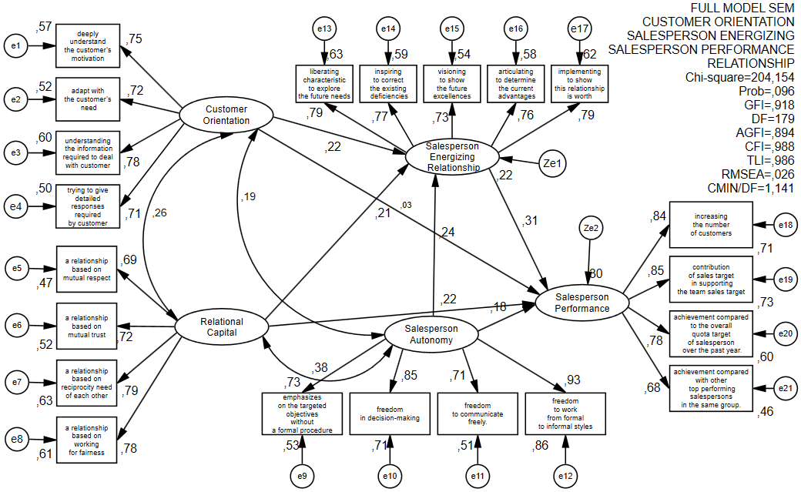

The full structural model showed the acceptable fit indices (χ² = 204,154; (p=0,096); CFI = 0,988; TLI = 0,986, GFI = 0,918; RMSEA = 0,026 dan CMIN/DF = 1,141).
The figure above shows the relation among variables and it can be formulated to the table below:

Table 1. Regression Weight Structural Equation Model
 |  |  | Estimate | S.E. | C.R. | P | Label
CO |  | SER | ,189 | ,069 | 2,736 | ,006 | par_14
RC |  | SER | ,220 | ,091 | 2,418 | ,016 | par_15
SA |  | SER | ,238 | ,081 | 2,941 | ,003 | par_19
SER |  | SP | ,405 | ,109 | 3,703 | *** | par_16
SA |  | SP | ,237 | ,105 | 2,265 | ,024 | par_17
RC |  | SP | ,307 | ,119 | 2,588 | ,010 | par_18
CO |  | SP | ,034 | ,088 | ,381 | ,703 | par_26
Explanation:
CO : Customer Orientation
SER : Salesperson Energizing Relationship
SA : Salesperson Autonomy
RC : Relational Capital
SP : Salesperson Performance

Table 1 showed that from seven hypotheses, there were six hypotheses accepted while the other one hypothesis that was the relation of customer orientation to salesperson’s performance was rejected. For the customer orientation variable, it significantly affects the salesperson performance through salesperson energizing relationship, whereas the relational capital and job autonomy are able to directly affect the salesperson performance and through salesperson energizing relationship as well.

6. Conclusion and Future Research
The results of this study reiterated that customer orientation remains the core of marketing strategy implementation aimed to maintain, bind, and establish relationships for the long term when supported with other variables that are capable in mediating the customer orientation on salesperson performance. In line with the previous studies, these findings supported the results of customer orientation’s direct effect inconsistencies on salesperson performance (Franke & Park, 2006; Jaramillo & Grisaffe, 2009; Singh & Venugopal, 2015). Therefore, a critical review in the marketing literature on this customer orientation which, in fact, cannot directly affect the salesperson job outcome is required. This study provides an extended alternative to bridge the problem, in this case through salesperson energizing relationship.
While some literature is still asking the question on how customer orientation works in strengthening salesperson’s job outcome, the finding of this study provide insights into how customer orientation could work. The energizing interaction power which is covered into five dimensions, i.e. (1) relationship with liberating characteristic which can explore the future needs, (2) relationship with inspiring characteristic which can explore and correct the existing deficiencies, (3) relationship with visioning characteristic which can show the future advantages, (4) relationship with articulating characteristic which can determine the current advantages, and (5) relationship with implementing characteristic which can show that this relationship is worth-continuing and believed to strengthen and potentially enhance the salesperson performance.
The results of this study have also confirmed that the relational capital power inside the salesperson will enable the interaction strength based on mutual trust between the two interacting parties. It becomes the basis for establishing a long-term relationship and maintaining loyalty. In addition to trust, the aspects of relational capital power which include benevolence, mutual respect, competency, and honesty have also become the basic dimensions in supplier-customer interactions that will directly help strengthen the salesperson performance and also the salesperson energizing relationship.
Likewise, job autonomy will also directly strengthen the salesperson energizing relationship power as well as enhance the salesperson performance. It indicates that the dimensions of job autonomy relating to freedom in the management practice style and independence in making decisions based on the expertise even without the need of an absolute authority in the organization, and also the ability to access and manage information to make decisions will ensure the expectations of salesperson performance improvement. This is consistent with the previous research that pay attention to the direct effects (Bonney & Wolliams, 2009; He & Li, 2010), although the setting is a developing country like Indonesia. It is fair for the salesperson to receive trust to manage the responsibility of his job, considering that this kind of job in pharmaceutical world as in this study requires salespersons with independency in making fast and agile decisions.
This study expands the literature on sales about the role of customer orientation on the salesperson performance by providing an alternative mediator namely the interaction power with energy or so-called salesperson energizing relationship. It is also to answer the findings of Plouffe et al. (2009) who are still questioning how customer orientation works and proceeds in order to improve the salesperson performance. This study also responds the opinion from Kaynak et al. (2016) and Singh and Venugopal (2015) about the importance of an expanding study in developing countries outside the Western countries that in fact have completely different contingency situations (political, cultural, and economic aspects)
The result of this study confirms that customer orientation is not a direct antecedent of salesperson performance, and it can only strengthen job outcome when aided with the next stage, in this case, it is with alternative offers of strengthening the energizing interactions of a salesperson. Intervening variables are required to bridge the effects of customer orientation on salesperson performance.
This study re-emphasizes the important role of salespersons who stand at the vanguard of interaction with customers. Their critical role is not only in their ability to understand the customers and collect information needed to respond to the customers’ questions in detail as widely understood within the customer orientation concept. Beyond that, this study reminds the salespersons’ managers to always encourage the sales force to own high affect ability and an entrepreneur-like attitude in the dynamics of interactions and relations with customers. These demands can be responded through the ability to interact with energy, capable of being a mesmerizing driving force, and keep their spirit in winning the customers’ hearts and choices. A special training that focuses on keeping the energy and stamina during interactions is necessary to maintain the energy poured in sustaining relations with customers.
In addition to trainings that can raise and maintain salesperson’s energy, the company should also consider sales outcome beyond volume or profit alone, as they have done so far. Rather, it is also wise to consider from other’s perspectives such as customer feedback, customer satisfaction, and customer engagement, customer loyalty which are also related to the goals of salesperson performance.
This study only measure the salespersons at go-public companies. Futher studies can be applied in a wider setting like in pharmaceutical companies in general either go public or owned by a family, which of course might have more dynamic culture and policy so that research generalization can be expanded. Another consideration for future research is the different body of industries that uses salespersons as the vanguard of their industry such as finance, retail, telecommunications, or insurance so that more comprehensive results can be obtained on the effects of customer orientation on the salesperson performance. This study is considered as merely cross-sectional, hence the performance measurement results cannot yet be measured more objectively. The next studies may consider longitudinal setting to improve the results of the occuring effects.

FINAL REFEREEING DECISION IJSEM_196529: MANUSCRIPT ACCEPTANCE
October 5, 2018
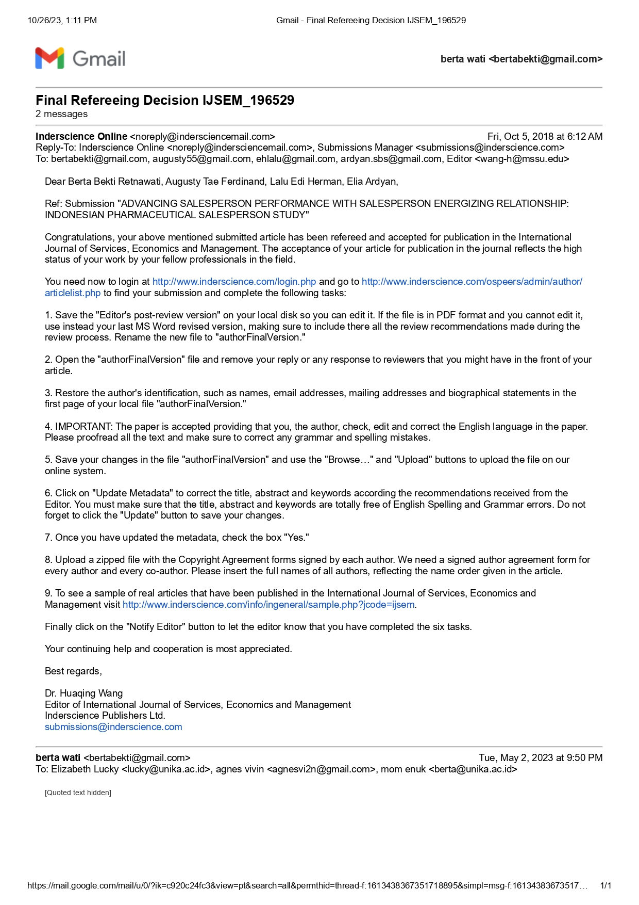

- Refereeing Process: Editor comments IJSEM-196529 (to upload author’s final version)
October 9, 2018
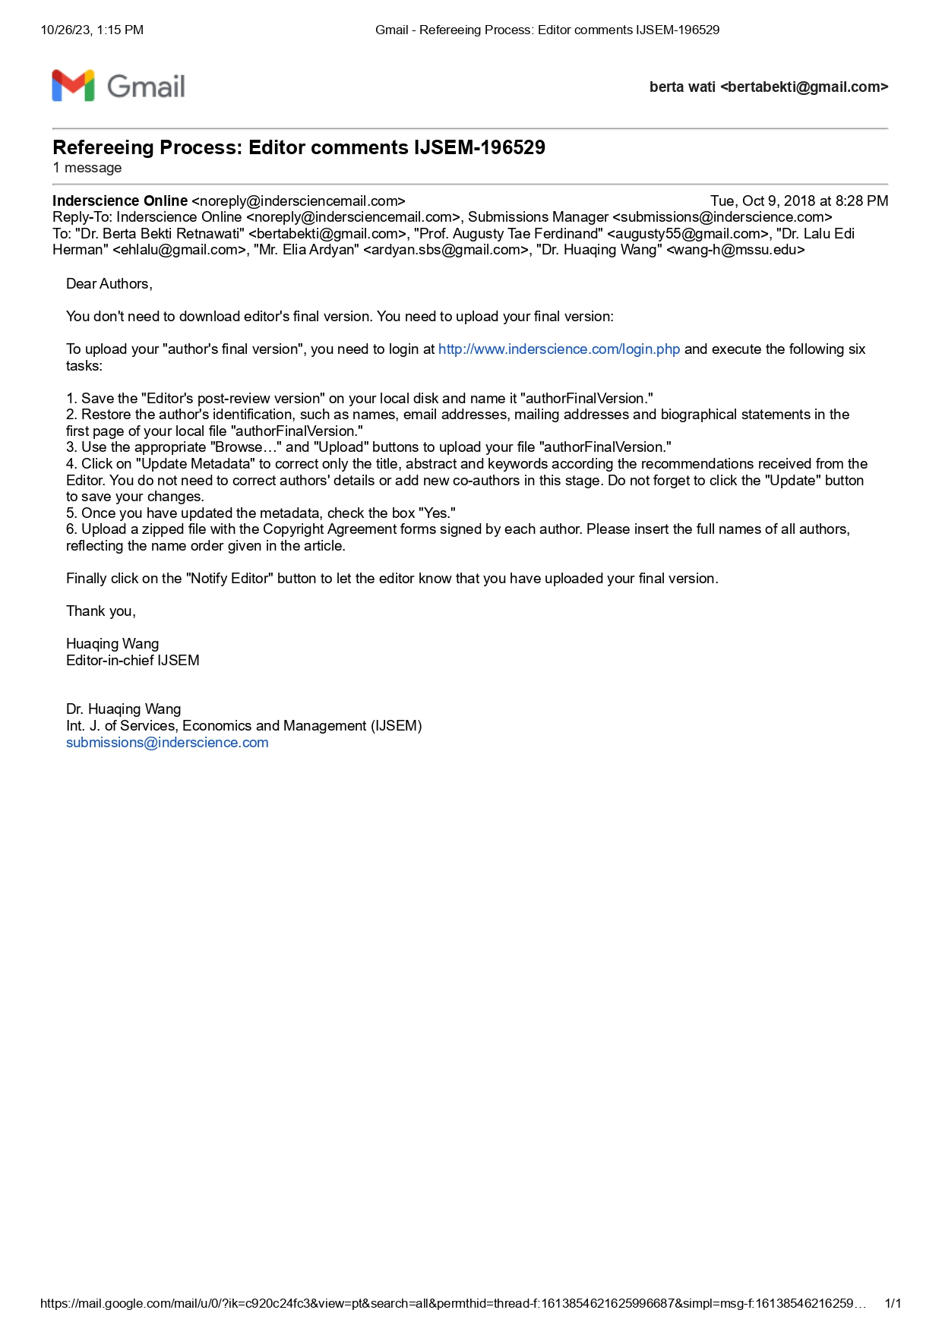

IJSEM-196529 - author agreement
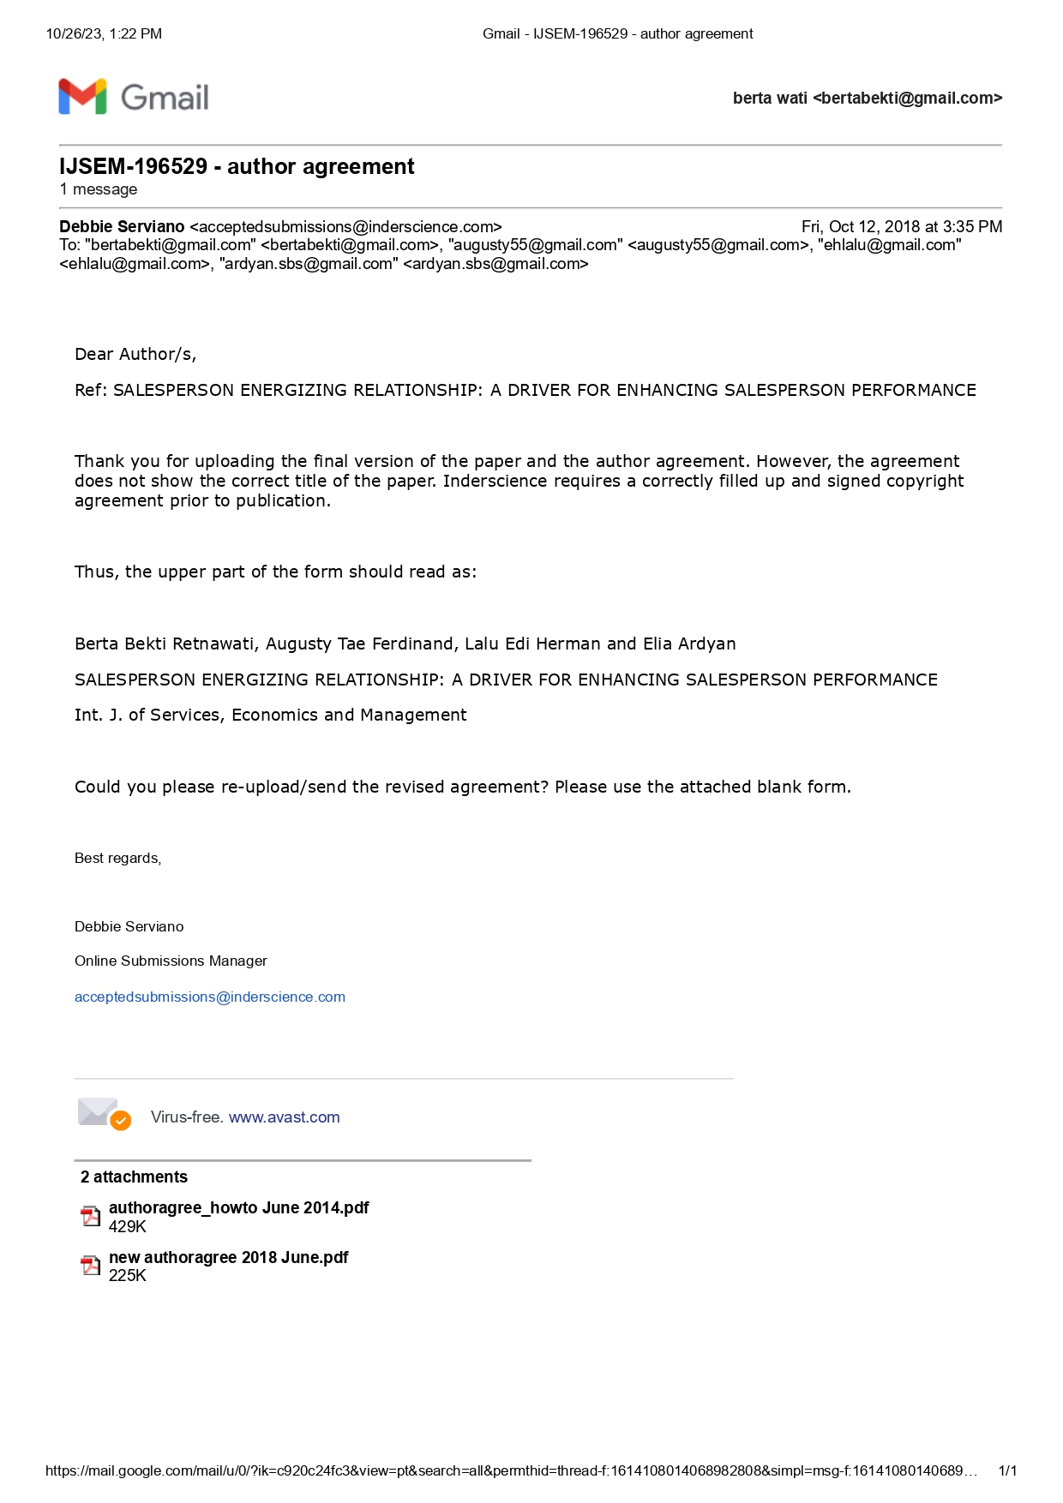
October 12, 2018

EDITOR IJSEM: PROOF OF PAPER FOR CHECKING
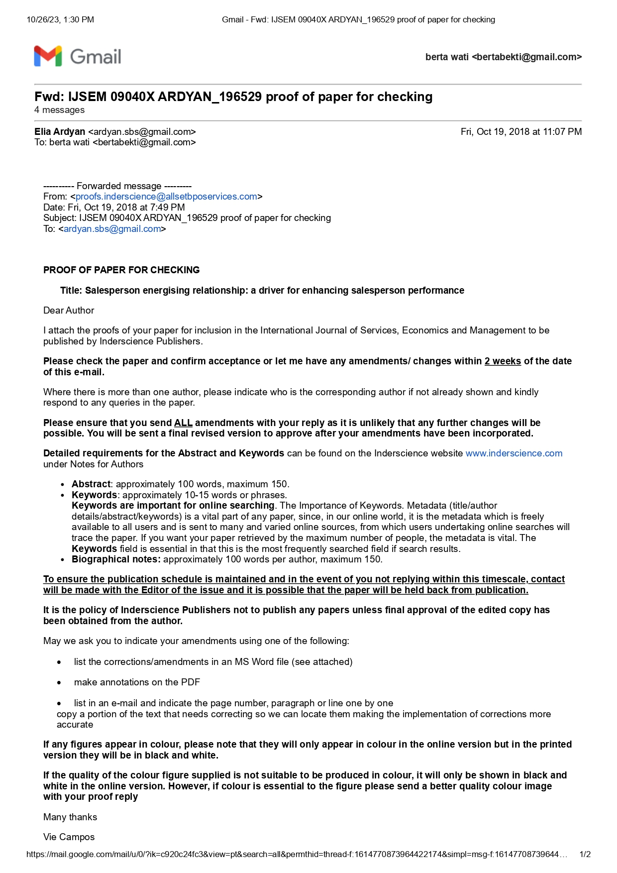
October 19, 2018

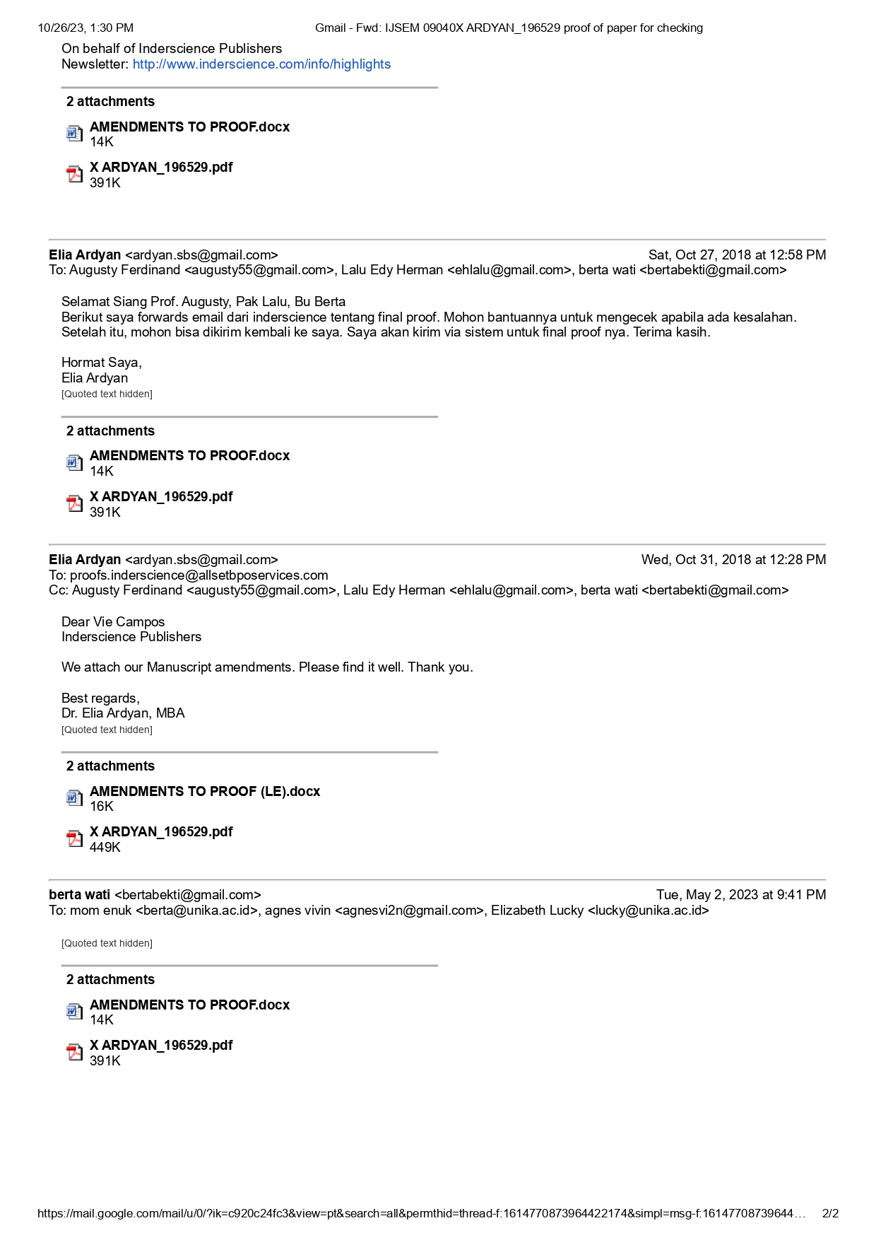
IX.MANUSCRIPT AMENDMENTS
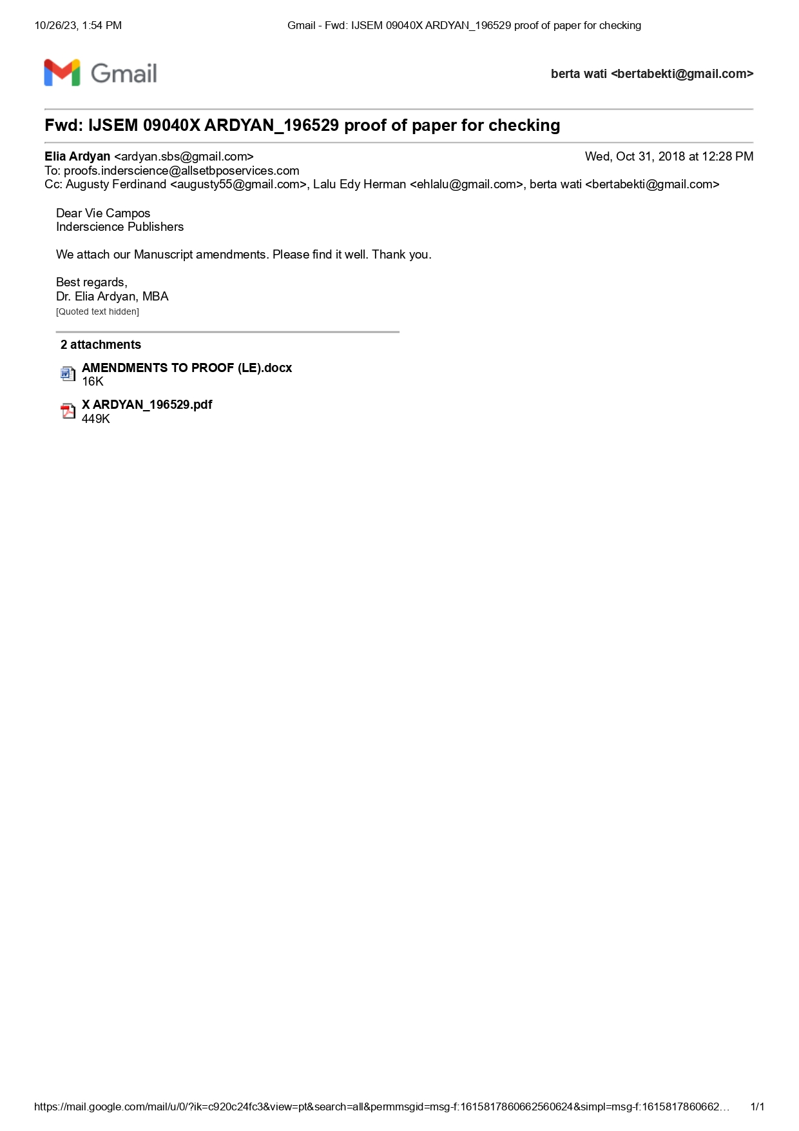
October 31, 2018

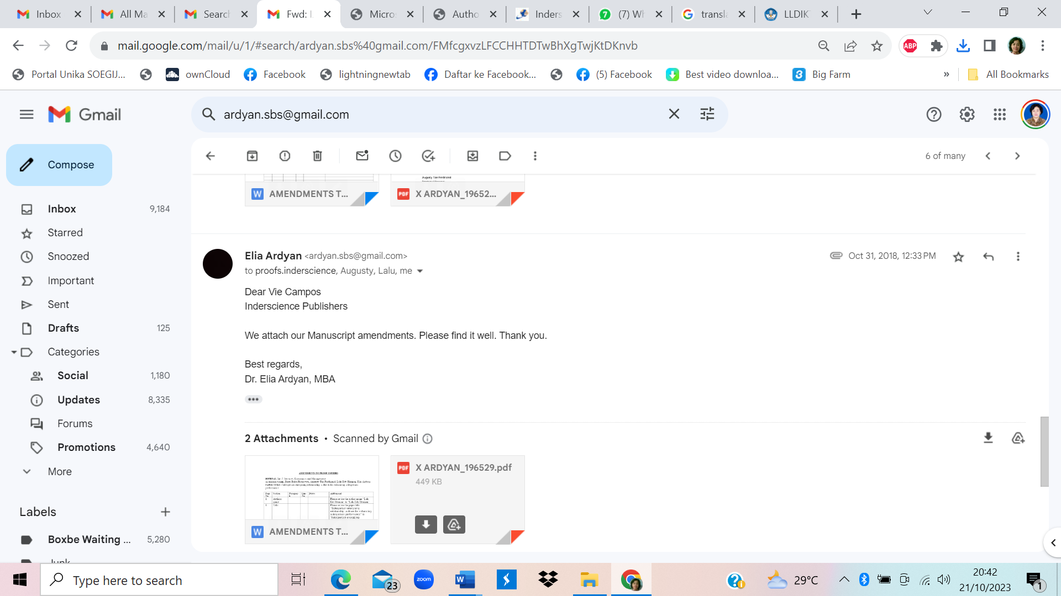
AMENDMENTS TO PROOF OSPEERS

JOURNAL: Int. J. Services, Economics and Management
AUTHORS NAME: Berta Bekti Retnawati, Augusty Tae Ferdinand, Lalu Edy Herman, Elia Ardyan
PAPER TITLE : Salesperson energising relationship: a driver for enhancing salesperson performance

Page No. | Section | Paragraph | Line No. | Delete | Add/amend
1 | Authors name |  |  |  | Please revise the author name “Lalu Edi Herman” to “Lalu Edy Herman”
1 | Title |  |  |  | Please revise the paper title “Salesperson energising relationship: a driver for enhancing salesperson performance” to “Salesperson energizing relationship: a driver for enhancing salesperson performance”
1-19 | all section |  |  |  | Please revise all of the word “energising” to energizing.
4,7 |  |  |  |  | Please revise all of the word “energised” to “energized”
2 |  |  |  | Please delete “This paper is a revised and expanded version of a paper entitled (title) presented at (name, loation, and date of conference)”
3 | Literature Review  2.1. Salesperson Energizing Relationship | 1 |  |  | Please revise “Another testing variable is required that can bridge the role of customer orientation there is sales person performance” to “Another variable is required for bridging the relationship of customer orientation and salesperson performance”
4 | Literature Review  2.1. Salesperson Energizing Relationship | 1 |  |  | Please revise “framework model” to “model framework”
14 | Result | Table 1 |  | Please delete: ***
17 | References |  |  |  | Revise Comment (Y3):  Vol. 5, No. 9, pp.89-109
17 | References |  |  |  | Revise Comment (Y4):  Vol. 53, No. 3, pp.68-81
17 | References |  |  |  | Revised Comment (Y5)  Multivariate Data Analysis (7 ed.). New York: A Global Perspective.
19 | References |  |  |  | Revise Comment (Y6):  United Kingdon: Emerald Group Publishing Limited.
20 | References |  |  |  | Revised Comment (Y7)  Vol. 71, No. 3, pp.1-17

X.EDITOR IJSEM: PROOF OF PAPER FOR APPROVAL
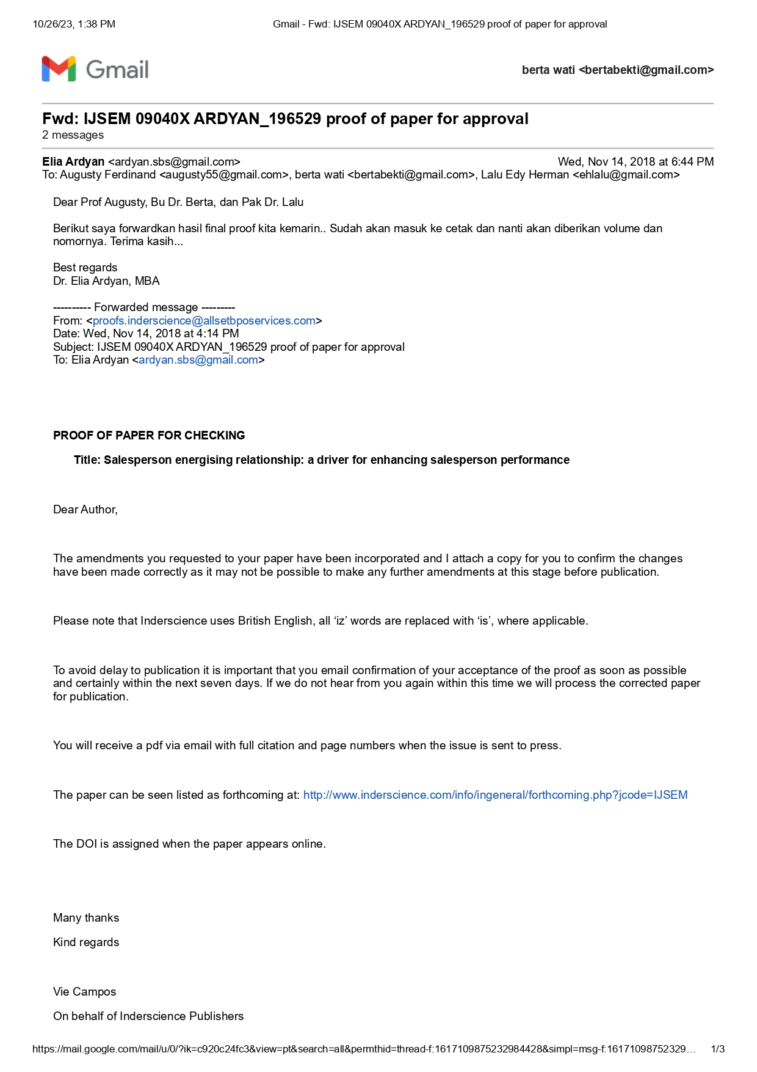
November 14, 2018

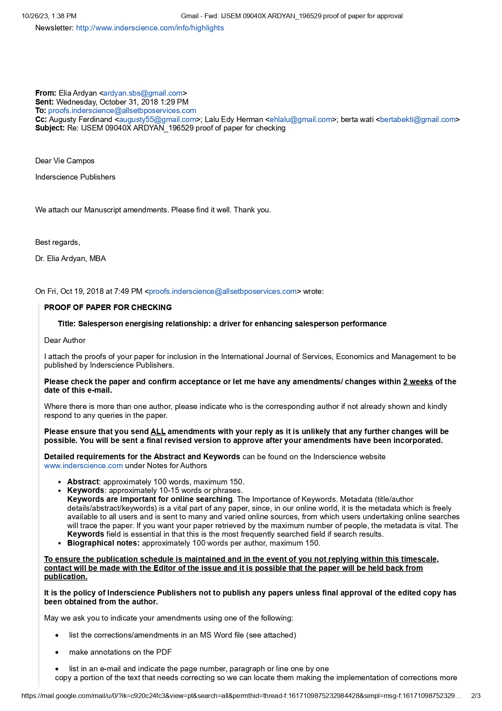
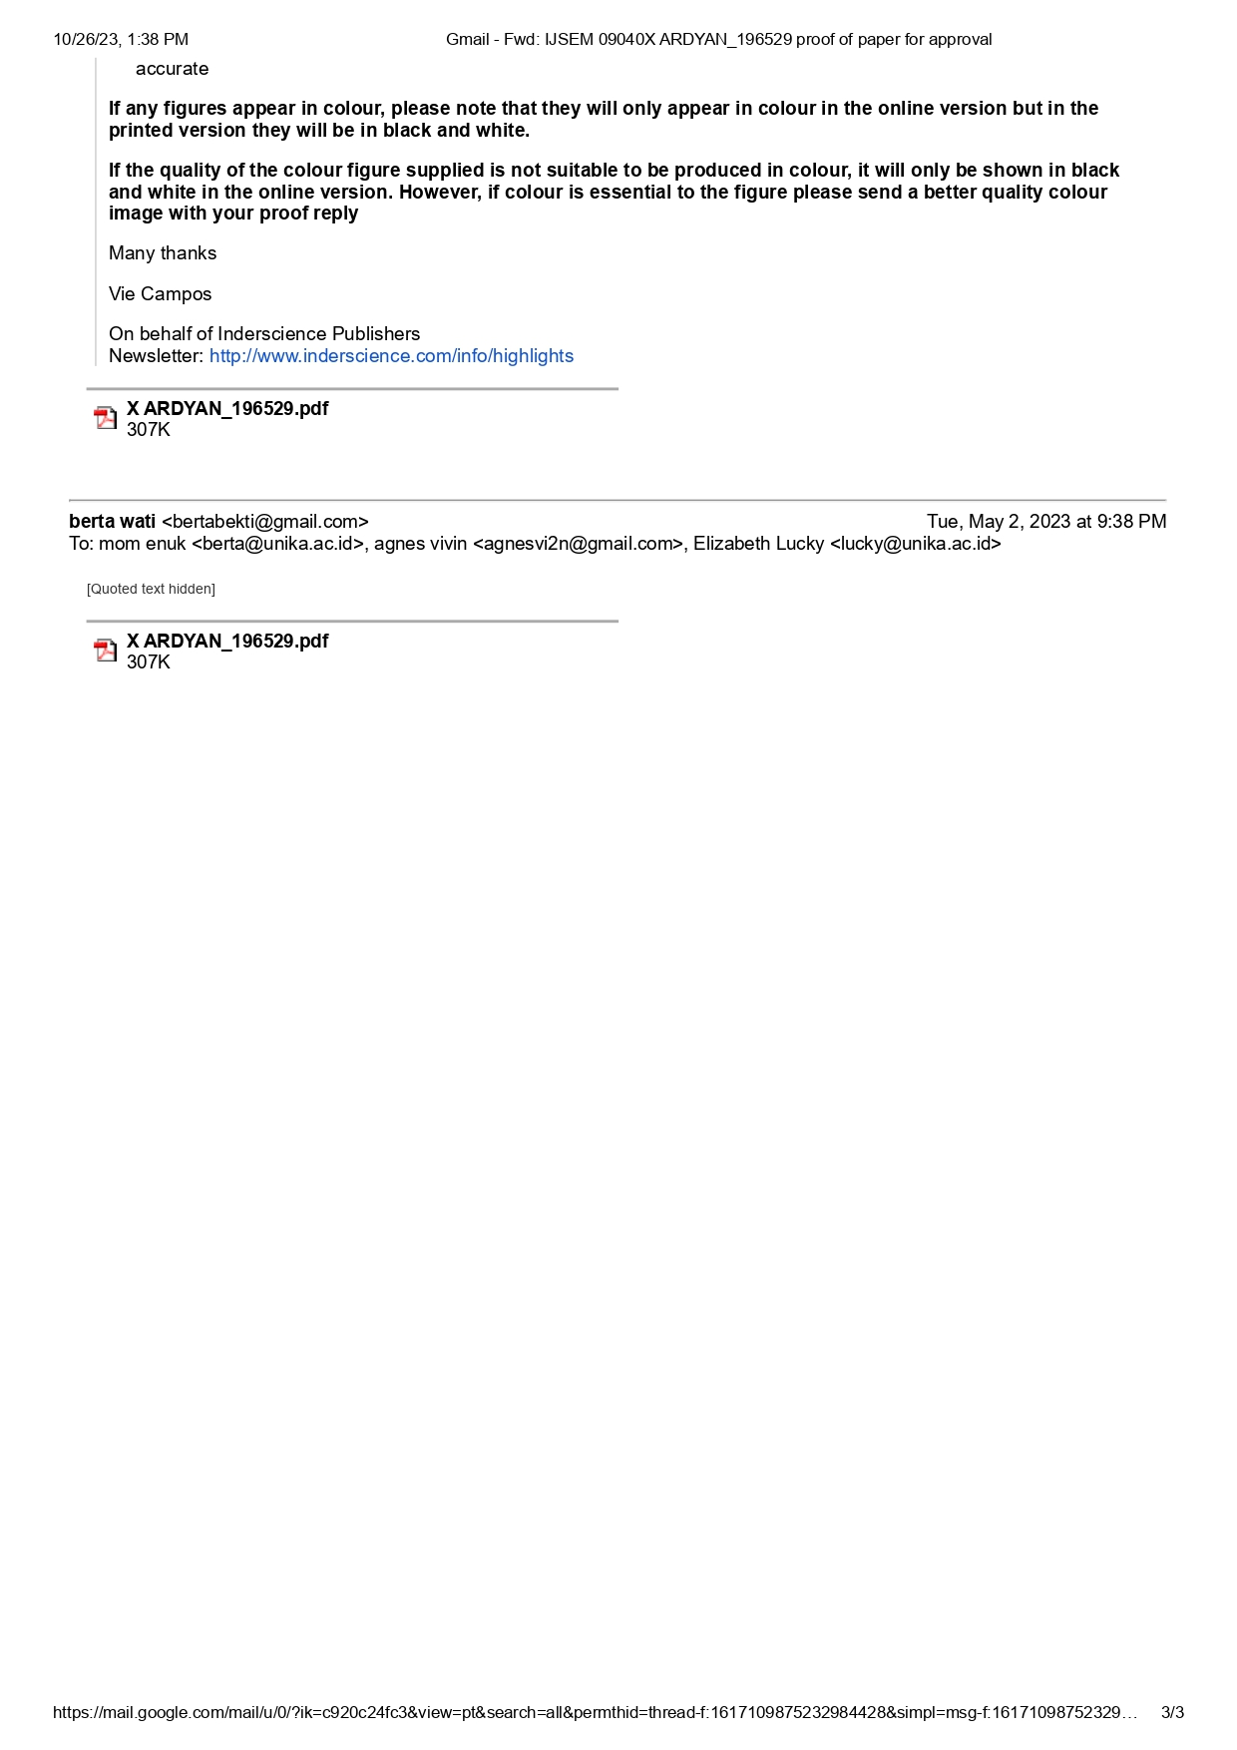
XI.INFORMATION ABOUT FINAL VERSION OF PAPER
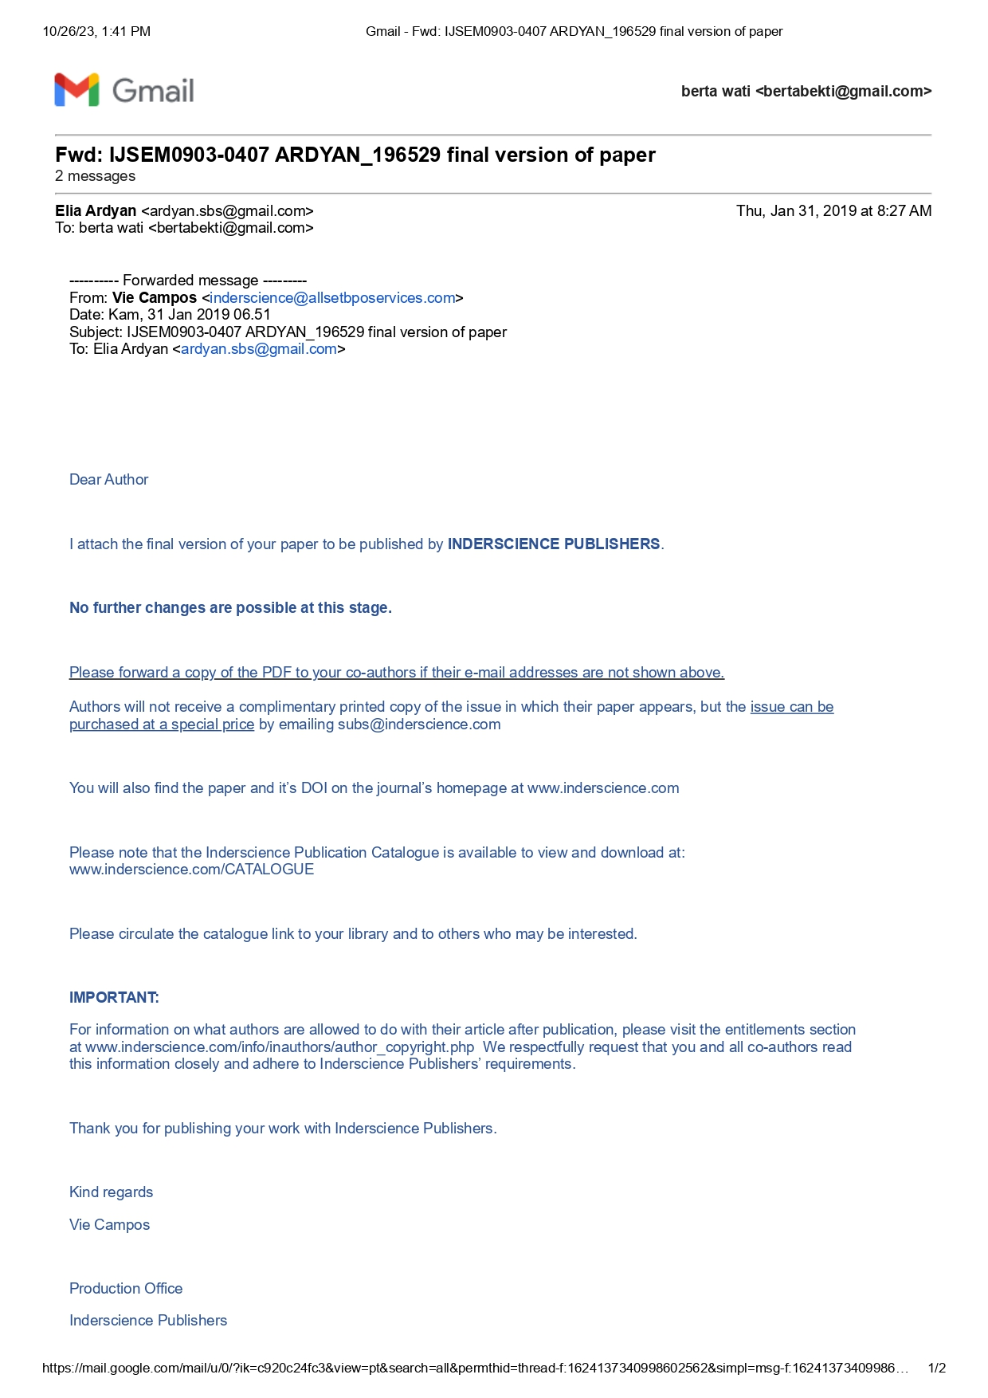
January 31, 2019

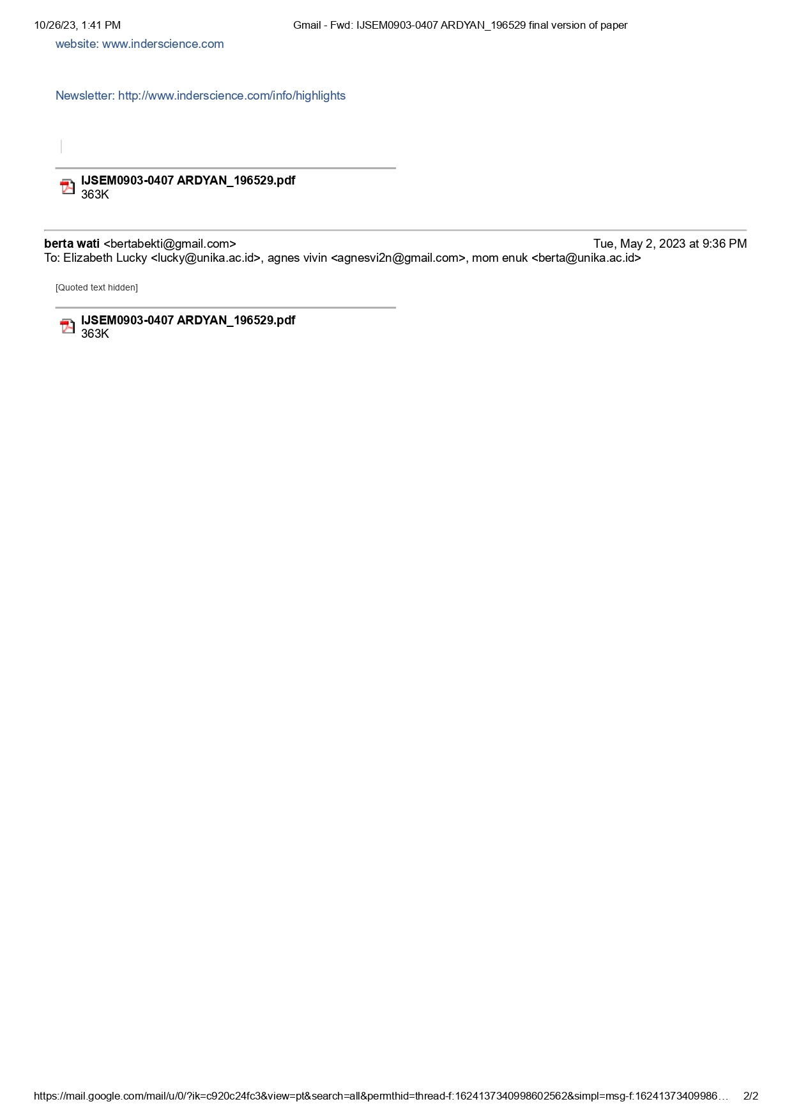

XII. SCREEN SHOOT EMAIL FROM EDITOR IJSEM
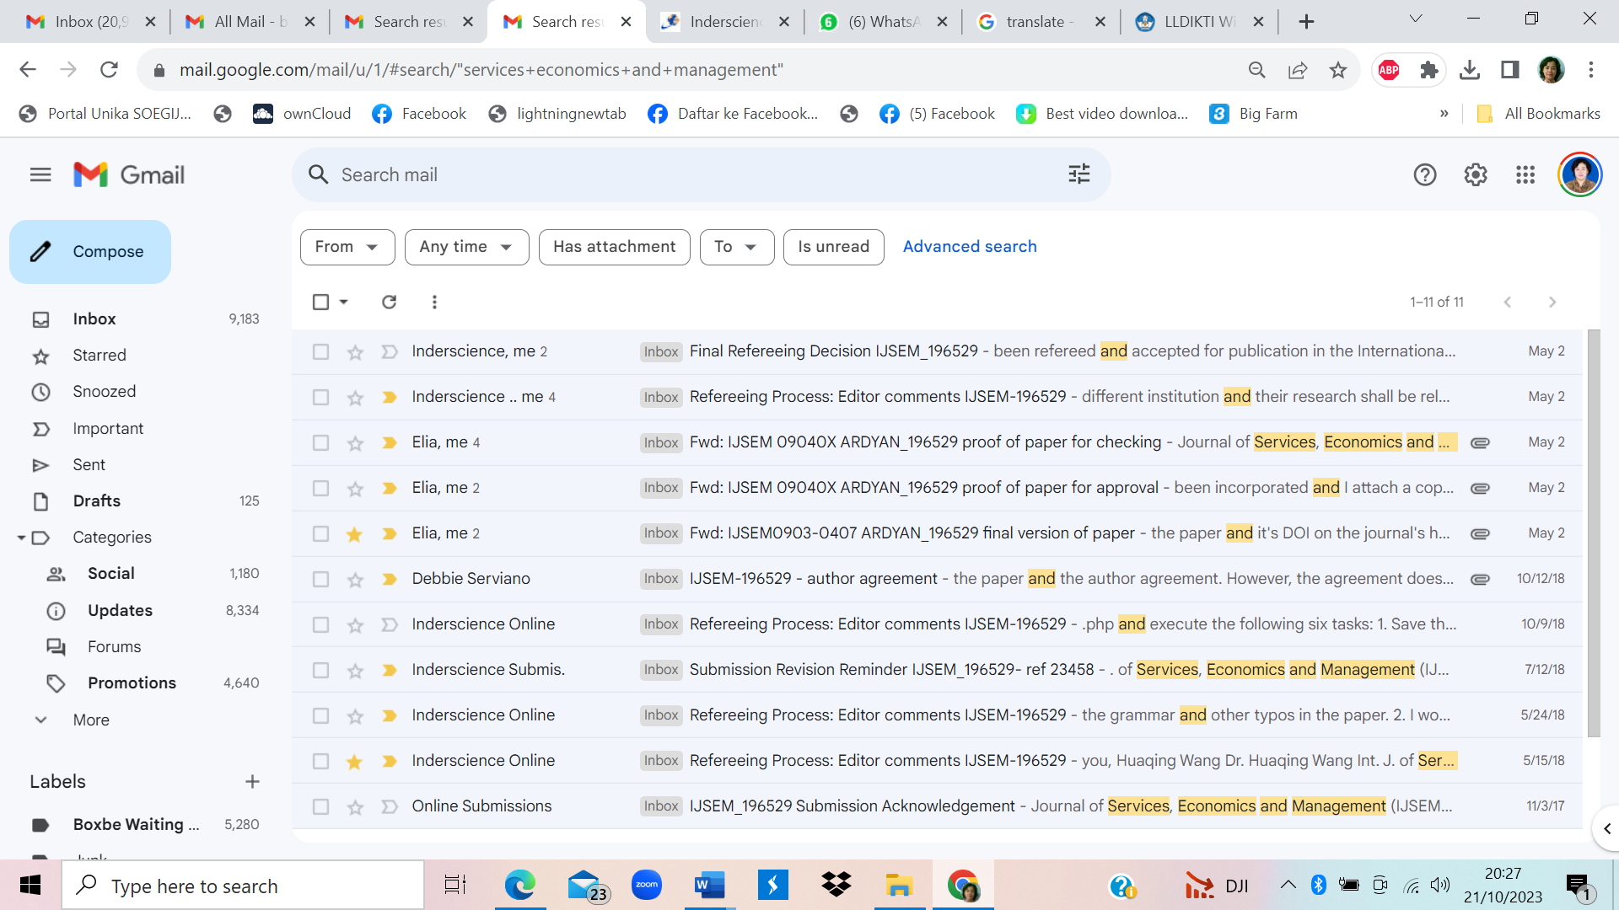

- FULL ARTICLE (PUBLISHED)

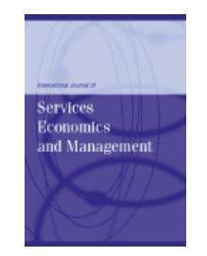

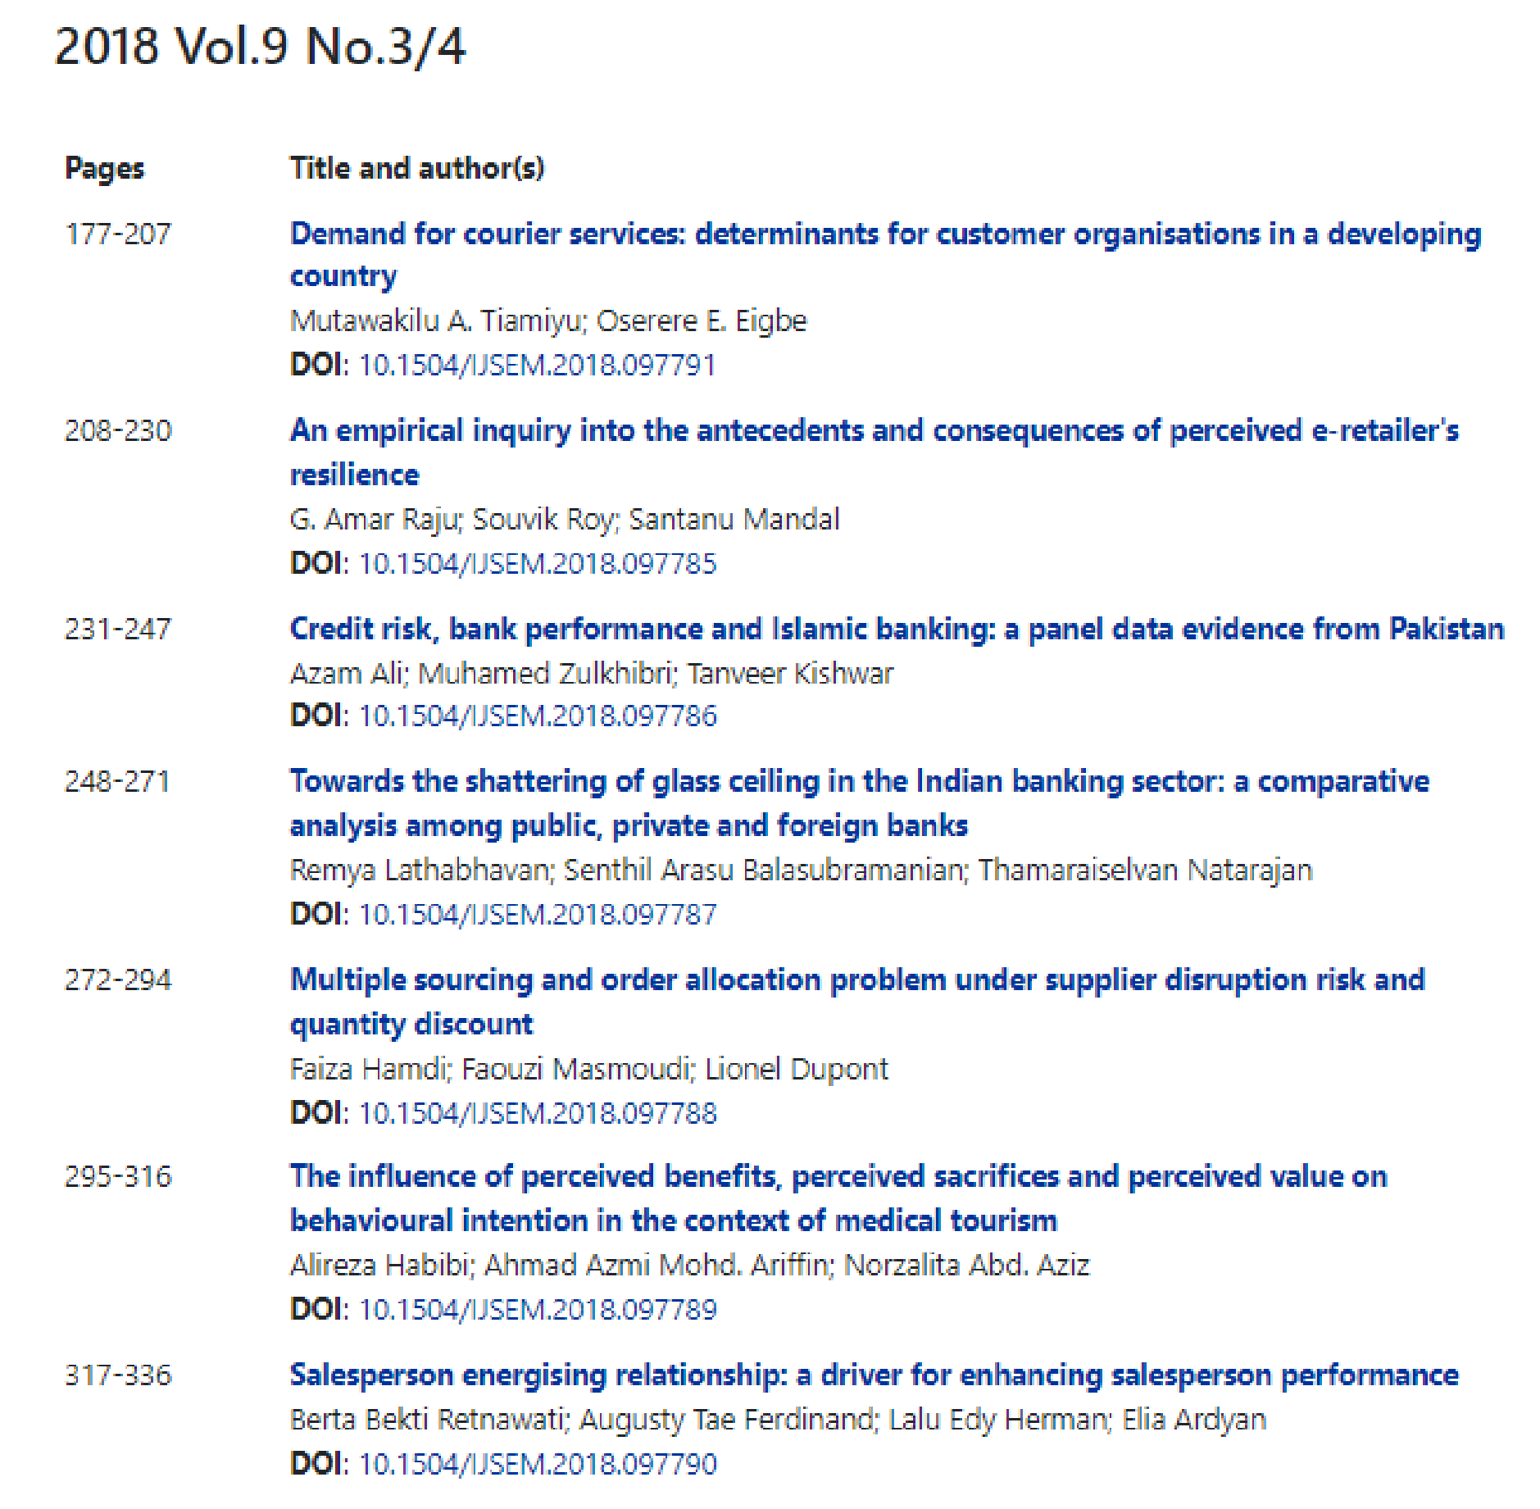

Int. J. Services, Economics and Management, Vol. 9, Nos. 3/4, 2018

Salesperson energising relationship: a driver for enhancing salesperson performance

Berta Bekti Retnawati
Department of Management,
Faculty of Economics and Business,
Soegijapranata Catholic University,
Pawiyatan Luhur IV/1 Bendan Duwur, Semarang 50234, Indonesia Email: bertabekti@gmail.com
Augusty Tae Ferdinand
Department of Management,
Faculty of Economics and Business,
Diponegoro University,
Erlangga Tengah Street, Semarang 50241, Indonesia Email: augusty55@gmail.com
Lalu Edy Herman
Department of Management,
Faculty of Economics,
Mataram University,
Majapahit Street, Mataram 33125, Indonesia Email: ehlalu@gmail.com
Elia Ardyan*
Department of Management,
Sekolah Tinggi Ilmu Ekonomi Surakarta, Indonesia
Email: ardyan.sbs@gmail.com *Corresponding author
Abstract: The current study aims at developing and testing a conceptual model on how to manage the salesperson’s customer orientation for enhancing salesperson performance, by introducing the concept of salesperson energising relationship as a novelty in the sales management study. The research context is in the pharmaceutical industry in Indonesia, which holds a promising pharmaceutical market to the global market place. The structural equation model analysis is employed to test the hypotheses. The finding of this study demonstrates the pivotal role of salesperson energising relationship in mediating the customer orientation and salesperson performance as well as the role of salesperson autonomy and relational capital in influencing salesperson performance. The originality of this study is in the important role of salesperson energising relationship that contributing to enrich the sales management literature.
Copyright © 2018 Inderscience Enterprises Ltd.

Keywords: customer orientation; salesperson energising relationship; relational capital; salesperson autonomy; salesperson performance.
Reference to this paper should be made as follows: Retnawati, B.B., Ferdinand, A.T., Herman, L.E. and Ardyan, E. (2018) ‘Salesperson energising relationship: a driver for enhancing salesperson performance’, Int. J. Services, Economics and Management, Vol. 9, Nos. 3/4, pp.317–336.
Biographical notes: Berta Bekti Retnawati is a Lecturer from the Department of Management, Faculty of Economics and Business, Soegijapranata Catholic University, Indonesia. She received her PhD from the Diponegoro University in 2016. Her research focuses on salesperson performance, green marketing, and entrepreneurial marketing. Her studies have been published in journals such as Asia Pacific Management Review, International Journal of Innovation Digital Economy, International Review of Management and Marketing, and Journal Information.
Augusty Tae Ferdinand is a Professor of Marketing from the Diponegoro University Indonesia. He received his DBA in Strategic Marketing from the Southern Cross University, Australia. His recent position is being the Head of Marketing Science Laboratory, Faculty of Economics and Business, Diponegoro University. His research interest is in marketing model, sales management, entrepreneurial marketing, innovation marketing, human capital, critical moment of work in sales and marketing. He is the President of Indonesian Marketing Academy (IMARC).
Lalu Edy Herman is a Lecturer from the Department of Management, Faculty of Economics, Mataram University, Indonesia. He is a PhD candidate of the Diponegoro University. His research focuses on salesperson performance, green marketing, entrepreneurial marketing and branding.
Elia Ardyan is a Lecturer and Researcher from the Sekolah Tinggi Ilmu Ekonomi Surakarta, Central Java, Indonesia. His research areas are entrepreneurship, small medium enterprises, and marketing. His studies are published in International Journal of Innovation Digital Economy (2015), Market/Tržište (2015), DLSU Business & Economics Review (2016 and 2017), International Review of Management and Marketing (2016), International Journal of Sociotechnology and Knowledge Development (2016), International Journal of Social Ecology and Sustainable Development (2017), International Journal of Electronic Customer Relationship Management (2018),
International Journal of Business and Society (2018), International Journal of Asian Business and Information Management (2018), Journal of Business and Retail Management Research (2018), and Asia Pacific Management Review (2018).

Introduction
Salespersons play an important role in business competition, especially in making ways for improving the sales performance. Salesperson performance improvement could be influenced by many factors such as competitive advantage. Sales person should strive for getting a level of competitive advantage as a basis for enhancing performance, particularly in building relationship with customers. Our literature study demonstrated the important role of customer orientation and adaptive-selling approach in leveraging the performance improvement (Franke and Park, 2006; Jaramillo and Grisaffe, 2009; Kaynak et al., 2016; Singh and Venugopal, 2015). Any salesperson with adaptive capability will be able to adjust and change the sales approach to match their customers. Salesperson should also have the ability to serve customers, to fulfil customer needs (Crosby et al., 1990), to create added values (Singh and Koshy, 2011), and to provide solutions for customers (Bonney and Wolliams, 2009; Sawhney, 2006; Tuli et al., 2007).
Studies on the role of customer orientation in enhancing sales person performance has been conducted instensively and come out with a mix results. Some scholars demonstrate the significant influence of customer orientation to salesperson performance (Boles et al., 2001; Homburg et al., 2011; Kara et al., 2013; Keillor and Parker, 2000). Homburg et al. (2011) proves the curvilinear influence of customer orientation on salesperson individual performance. Meanwhile, Franke and Park (2006) find that customer orientation is not significantly influence salesperson performance in their cross-sectional study. Customer orientation, however, has a significant influence in a longitudinal study method (Franke and Park, 2006). Another study of Jaramillo and Grisaffe (2009) indicates no direct influence of customer orientation to salesperson performance but fully mediated by adaptive selling to improve salesperson performance. The fact that customer orientation cannot directly influence salesperson performance and requires salesmanship skills and salesperson’s ability in managing their emotion are found in a study in India setting (Singh and Venugopal, 2015). Therefore, it is reasonable to include an intervening variable for mediating the relationship between customer orientation and salesperson performance.
The purpose of this study is to build and test a conceptual model on how to manage the salesperson’s customer orientation for enhancing salesperson performance. To do so, we insert into the model our a new concept of salesperson energising relationship, together with relational capital and salesperson autonomy, then test the model in the pharmaceutical industry in Indonesia.

Literature review

Salesperson energising relationship
Previous research has shown inconsistencies in the influence of customer orientation on salesperson performance. Another variable is required for bridging the relationship of customer orientation and salesperson performance (Jaramillo and Grisaffe, 2009; Schwepker and Good, 2012). This study provides a model framework by adding the concept of salesperson energising relationship which is going to emphasise that the customer orientation will be more powerful in influencing the salesperson performance by passing through the mediating variable.
The energy in relationship refers to salesperson task to be able to manage and bind customers for a long-term period (Medhurst and Albrecht, 2016). Work engagement becomes one that gives strong influence on individual factor besides other factor that is role ambiguity, ready for adaptiveness, cognitive aptitude, and selling-related knowledge that can give a direct influence on salesperson performance (Dong et al., 2015; Medhurst and Albrecht, 2016). Employee engagement or work engagement enables salespeople to have organisational commitment and awareness to achieve optimal performance (Di Mascio, 2010; Medhurst and Albrecht, 2016). Di Mascio (2010) and Medhurst and Albrecht (2016) also explained that the dimension of affection in work engagement is energy. Affection engagement is defined as an experience that actively describes a sense of enthusiasm, energy and positive stimulation. This energised dimension provides a person with a high degree of focus, attention, and concentration.
The energising relationship can also be illustrated through a concept from Anderson et al. (2010) who has identified and analysed the practice of networking that can run well within the existing entrepreneurial growth by applying span of networking growth concept. The Pierre Bourdieu’s habitus concept becomes the platform/basis of one’s mental or cognitive structure in encountering the dynamic environment. Habitus itself is a cognitive thinking where someone is trying to do what and how something is formed. There are five spans in either networking growth or relation that are formed from the interaction of the two sides, which are relation characterised by liberating that is able to explore future needs, relation with inspiring characteristic that is able to explore and correct the existing deficiencies, relation with visioning characteristic that is able to show the future superiority, relation with articulating characteristic that is able to determine the current advantages, and relation which is characterised by implementing that is able to demonstrate that this relationship deserves to be continued. Based on those concepts of work engagement and entrepreneurial networking, here, the researcher provides a definition for salesperson energising relationship as the salesperson’s ability in binding customers to make a long-term relation characterised with liberating, inspiring, visioning, articulating, and implementing relationships. This salesperson energising relationship has the potential to become a mediator between customer orientation to maximally support the achievement of sales force performance.

Customer orientation
Customer orientation has long been extensively studied in the sales force management literature, since the first SOCO coined by Saxe and Weitz (1982). Customer orientation which is owned by the salesperson during the interaction with customers provides a positive effect in strengthening satisfaction and establishing customers’ trust on the company and the salesperson (Arndt and Karande, 2012; Homburg et al., 2011; Kaynak et al., 2016). Customer orientation in various researches in marketing management is described as “The practice of marketing concept at the level of individual salesperson and customer” (Saxe and Weitz, 1982). The definition of customer orientation is expressed as a marketing management implementation where a salesperson tries to ascertain the needs and tries to satisfy the customers. The effort in customer satisfaction requires a mastery of as much information about customers to know the needs, desires, behaviours, and styles of communication needed to interact with the customers (Homburg et al., 2011; Singh and Venugopal, 2015; Stock, 2016). In carrying out the role to implement the customer orientation, salesperson is required to be a consultant for the customer or as a customer advocate to be able to provide services that delight the customer in not only a moment interaction but the long run (Kaynak et al., 2016; Pousa and Mathieu, 2013). It is hoped that the customer orientation will enable the salesperson performance to increase along with the customer acceptance to the interaction satisfactions that occur between them.

Relational capital
Study on relational capital is rooted in the conception of invisible assets by Hiroyuki Itami in Japanese, 1980 (Sullivan, 2000), social capital and intellectual capital as framed in the management research intensively (Bontis, 2004; Chia-Yi and Chang, 2015; Falcone and Castelfranchi, 2011; Mubarik et al., 2016; Sullivan, 2000; Welbourne and Padrdo-del-val, 2009) demonstrated the essence, support, function, and key role of intellectual capital in enhancing human capital effectiveness in terms of worker’s performance, organisational performance. Discussion of relational capital in this study is rooted in the theory of intellectual capital as appeared in the study of Bontis (2004), in which they pinpointed three main elements of intellectual capital as human capital, structural capital, relational capital in a format that human capital and structural capital are driver for enhancing relational capital and ultimately relational capital is key determinant for human capital effectiveness. Another root is in social capital theory as appeared in the study Tata and Prasad (2015) that classified social capital as structural social capital and relational social capital.
Study on salesforce management is rooted in the human intellectual capital theory as indicated human capital as a key anchor for driving, leveraging and enhance performance. How important human intellectual capital in sales organisation is seen in the practices that most of sales managers devote considerable efforts for enhancing salesperson hard-competence and ultimately soft-competence in building social relationship (Chia-Yi and Chang, 2015), those org-ware is believed as a determinant for enhancing human capital effectiveness. On the basis of human intellectual theory, our way to understand relational capital is to understand the essence of human capital, at the first side is understanding the hard type of intellectual capital, named as structural capital indicated by the quantity of workforce such as salesman, sales supervisor, quantity of network, number of member of distribution channel, structure of relationship such as contracted relationship or voluntary relationship, pattern of transactional involvement within network relationship (Bontis and Fitz-ens, 2002; Chia-Yi and Chang, 2015) such as by contract involvement or voluntary involvement. At the second side is soft type of intellectual capital, named as relational capital, indicated by quality of relationship, the developed and embedded trustworthiness between members of relationship, professional and social obligation attached to the formation of relationship, commitment consensus in strengthening attributes for a mutually benefit relationship (Falcone and Castelfranchi, 2011; Mubarik et al., 2016; Terawatanavong et al., 2007; Welbourne and Padrdo-del-val, 2009).
Relational capital in this study is defined as portfolio of soft attributes developed and embedded in cultivating a network in three aspects:
- interdependency with respect on autonomy in each party
- relational strength for creating value
- value creating in benefit and justice.
Relational capital could be seen mainly as quality of relationship that even though several parties or individual are committed in a relationship, but what is more important in that committed bond is each parties are high respect on autonomy of individual in interdependence and trust (Terawatanavong et al., 2007) and mutual respect within parties (Miocevic, 2016). A relational capital is cultivated in a manner that it has a specific quality that adding value for both parties as a basis for strengthening the added value relationship. This means that any relationship to be developed between parties should be a value creation chain that gain access to value-added information and knowledge needed for generating an added value performance (Johansson, 2007). A relational between parties is recognised as capital if the relationship has potential for creating reciprocal benefit and justice for a long-term bond between partier characterised by mutual respect, mutual trust, reciprocity and friendship (Miocevic, 2016) as a basis for creating and enhancing performance.

Salesperson autonomy
Today, the term autonomy is one of the hottest topics that is always interesting to study further of its effects in the workplace. Basically, every employee wants to have the freedom to work and be in an environment that respects the work outputs of more than targeted. Autonomy at work is described by the empowerment of the employees in making their own decisions, having goals and targets of their works, and deadlines, and also working on their own ways. A salesperson is a spearhead of a company to carry out marketing activities of products. A salesperson is required to possess the ability to sell high in order to convince the potential buyers to willingly buy the product offered. Creativities of a salesperson in marketing activities has become a very necessary thing and is believed to give contributions on innovation, effectiveness, and company’s performance (Shalley et al., 2004).
Job autonomy shows a confidence from the principal or supervisor in the ability and responsibility of a salesperson. Salesperson autonomy is an ability of a salesperson to understand the main job or problem encountered followed by actions to tackle them (Wang and Netemeyer, 2002). In this case, salesperson autonomy demonstrates the salesperson’s creativity in carrying out his work freely and responsibly based on the corridors specified by the company. Creativity is believed to be able to build the company’s competitive ability in adjusting itself to the changes in the competitive landscape to build competitive excellence (Shalley et al., 2004).
Granting an autonomy to the salesperson to do the job will help to create a good climate in the sales working group, in which the salesperson will be able to work based on the rules and concepts made by himself according to the conditions of market realities. The availability of empowerment and salesperson autonomy will stimulate the emergence of creative ideas that are expected to be able to apply in their work, develop, and further spread the ideas to the team. The salesperson’s involvement in the decision-making and autonomy perceptions acquired is an important prerequisite for creative results (Amabile et al., 2004).

Salesperson performance
The discussion on salesperson performance is extremely important in salesforce management (Piercy et al., 1998). A salesperson’s sales performance measurement has now been quite long based on sales quota achievement, and the salesperson’s comparative performance in the previous unit (Babakus et al., 1996). Salesperson performance is evaluation on his/her behaviour, whether or not his/her behaviour contribute to the accomplishment of company’s goals (Churchill et al., 1993). Many factors should be considered to improve salesperson performance. Firstly, the factors come from inside the company. These factors from the inside can take such forms as managers asking the salesperson to be involved in the effort of team-based sales (Piercy et al., 1998), salespersons who are always oriented to learning (Nguyen et al., 2006; Paparoidamis, 2005; Sujan et al., 1994), salespersons having high emotional intelligence (Kadic-Maglic et al., 2016; Pettijohn et al., 2010), salespersons having presentation skills (Johlke, 2006), salespersons oriented to customers (Cross et al., 2007; Singh and Das, 2013; Singh and Venugopal, 2015), and so on. Secondly, the factors come from outside the company. These factors coming from the outside can be market potential (Churchill et al., 1993) and social value (Swenson and Herche, 1994).

Model development and hypotheses

Customer orientation, salesperson energising relationship and salesperson performance: mediating effects of salesperson energising relationship
However, in addition to the results that have not been inclusive yet to directly influence the customer orientation on the salesperson performance that is characterised by the literature gap still available questioning how customer orientation process is able to strengthen the sales performance (Jaramillo and Grisaffe, 2009; Singh and Venugopal, 2015). The same thing was also questioned by Plouffe et al. (2009), how orientation works in influencing the salesperson performance. Responding to the questions Singh and Venugopal (2015) offers a mediation with the salesmanship skills where there contain several dimensions to strengthen the salesperson performance, they are the ability of prospecting potential customers, delivering messages, and closing the sale, however, it has not looked specifically on the persuasive power that enables the salesperson in winning the customers’ hearts.
In this study, the impetus that begins with customer orientation is forwarded by strengthening the salesperson energising relationship which will potentially enhance the final output, the salesperson performance. Strengthening the findings from Singh and Venugopal (2015) which confirmed the importance of managing salesperson’s emotions in interacting with customers requires support of forces in the interaction with the customers, i.e., the energy in the relationship itself. Energised that becomes a part of complex cognitive process illustrates a mental state characterised by the high levels of focus, attention, and concentration (Medhurst and Albrecht, 2016). Mentally, energised also illustrates the condition of someone who is active, alert, and quickly understand (receptive), and responsive to changes in information and stimuli. In relation to the process of interaction with customers by accommodating the entrepreneur behaviours, energised can be applied in various conditions of interactions. A salesperson with an energetic interaction capability is expected to strengthen the ability in achieving the maximum salesperson performance.
Based on those previous literature review and explanations, this research presents hypotheses that deal with the influence of customer orientation, salesperson energising relationship, and sales force performance as follows:
H1 Salesperson with high level of customer orientation will lead to high level of salesperson energising relationship.
H2 Salesperson with high level of customer orientation will lead to high level of salesperson performance.
H3 Salesperson with high level salesperson energising relationship will have increased level of salesperson performance.

Relational capital and energising relationship
Relational capital which clearly appeared in network research has attracted scholars interest for its ability to create performance, especially its ability to enhance human capital effectiveness (Bontis and Fitz-ens, 2002) in a sense that interconnectedness between persons based on mutual respect, mutual trust, friendship and reciprocity (Miocevic, 2016) are expected to form a basis for exploring future possibilities such as need, challenge, prospect for growth in the future (Anderson et al., 2010). Relationship quality by nature is indicated by closeness’ connectedness that is potential for creating happiness in work and life (Capaldi et al., 2014) as a basis for human capital involvement in energising their relationship. Relational capital based on its core value of relationship quality is a platform for creating values in a form that value creation is a result of resource sets when they are linked, joined and interfaced for producing value both for seller and buyer (Haas et al., 2012)
Relational capital is proved to serve as a leverage for job satisfaction (Nguyen and Nguyen, 2011) for those involved in marketing activities in inspiring, visioning, articulating, and implementing value creation process in the relationship, in turn to enhance human capital effectiveness. In the spirit of relationship marketing, a relationship is only beneficially built if the parties involved in the relationship can fulfil their promises (Hunt, 1997) as a driver for human capital effectiveness in term of value creation success for all parties in the relationship circle. Therefore the following hypothesis is proposed.
H4 Relational capital has a positive impact on salesperson’s energising relationship.

Relational capital and salesperson performance
A popular idiom in marketing world “Your network is your net worth” demonstrates the importance of relationship, especially network in creating performance both individually and organisationally. This is one of the essences of this study; that building relationship that energises the involvement of parties in relational capital is pivotal for value creation. A strong tie in relationship which is mirrored in meeting customer needs in a manner that shows that the salespersons are knowledgeable, the salesperson’s knowledge of products is beneficial to customer and it is irreplaceable (Choi et al., 2015). Feeling of justice fulfilment in a relational capital setting is potential for affecting salesperson’s commitment to providing superior customer value (Schwepker, 2016) in the sales encountering process. Therefore the following hypothesis is proposed.
H5 Relational capital has a positive impact on Salesperson performance.

Salesperson autonomy, salesperson energising relationship and salesperson performance
Salesperson is one of a company’s human resources who can give great contribution to the achievement of the company’s goals. However, salespersons are frequently in dilemma because they are responsible for two main duties, i.e., sales productivity and customer satisfaction. The greater autonomy level in their job will be found by salespersons as a freedom in interacting with customers (Pettijohn et al., 2010). When salesperson’s freedom is limited in making decisions in their job, they will be less capable of offering customer-oriented solutions, because they can only share the standard solutions as instructed by the company.
Autonomy is one basic characteristics of a profession, as a form of freedom for professionals to perform their professional activities based on individual assessment for the implementation of their knowledge. Giving greater yet controlled job autonomy to salesperson becomes something highly crucial nowadays. A leader can provide supports to salespersons, including assigning job with substantial freedom, independence, and flexibility in their jobs, as well as the procedures they should use. A well-developed salesperson autonomy will have core characteristics such as varied expertises developing, task identity, task significance and feedback from job.
Figure 1 Empirical model
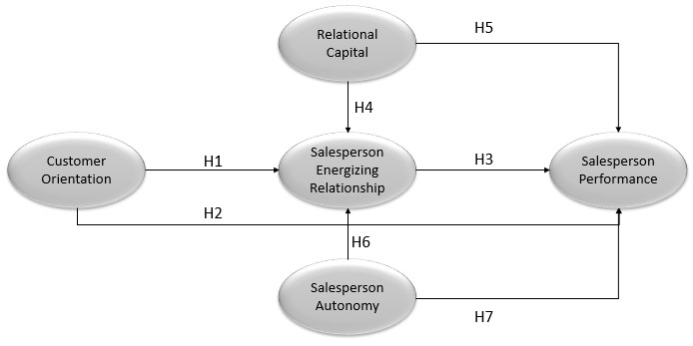
Salesperson performance is intended to be sales productivity, and it deals only with the factors directly controlled by the salesperson. Salesperson performance is measured by how great is the sales output being produced (Churchill et al., 1985). Challagalla and Shervani (1996) suggest that salesperson performance is a level at which salesperson can achieve the sales target set to themselves. The salesperson profession is a challenging one, in which one should have high creativity in meeting the set output target and should be customer-oriented to create satisfaction in the customers. The job autonomy given to salesperson will affect their competence and creativity (Kauffed, 2006) and improve performance. Job autonomy can improve salesperson performance since they think themselves capable and more confident in performing their duties (Gellatly and Irving, 2001; Langfred and Moye, 2005).
H6 The higher salesperson autonomy, the higher salesperson energising relationship.
H7 The higher salesperson autonomy, the higher salesperson performance.

Method

Sample
The setting of sampling in this study followed the advices from Saxe and Weitz (1982) suggestion where the measurement of customer orientation is expected to follow several required conditions:
- salesperson has a set of alternative approaches when they interact with customers
- customer is under complex purchase situation, requires some considerations and thoughts prior to making purchase decision
- there is an interactive relationship between salesperson and customers
- repeat sales and referrals become important sources in the interaction between salesperson and customer.
The sample in this research is taken from salespersons within pharmaceutical industry in Indonesia, a developing country with promising pharmaceutical industry prospect at both Asia and global levels. The data are collected from pharmaceutical companies which have been go public in Indonesia. The reason for choosing companies which have been go public is due to the researchers’ belief that these companies are more transparent and they have good corporate governance (GCG). The term salesperson in this research means the company’s ambassador/detailer entrusted to represent the company to promote their products professionally and credibly and full of integrity to doctors in such a way that these doctors are convinced and prescribe the company’s products to their patients.
The sampling techniques used in this research are purposive sampling and convenience sampling which constitute non-probability sampling techniques. The sampling techniques apply certain criteria, i.e., the respondent should be pharmaceutical salespersons who have worked for the current companies during the data collection for two years or more, assuming that these persons have performed many sales activities and interacted with customers.
It is necessary to do data screening and trimming as an effort of ensuring the data feasibility for the next testing stage. The data screening is performed by testing the response consistency of each respondent, by judging the extreme standard deviation. Meanwhile, the data trimming is done by judging the consistency between closed and open responses fulfilled by the respondents. In total, responses are given by 350 respondents and the number of returned questionnaires is 295 (response rate 84%), with 16 data (cases) failing to qualify for such reasons as having less than a year experience and 27 data (cases) failing to complete the questionnaire consistently, thus these data are disposed of. The remaining data come from 252 respondents. The outlier of the remaining data is 47 data (cases), leaving 205 questionnaire data feasible for further testing.
The description of these 205 respondents are as follows: the number of male and female salespersons is quite balanced, i.e., 59% and 41%, while their age ranges from 25 to 50 years old, most of them are married (82%), and most of them have worked for
10 to 15 years for their companies (26%) and followed by those who have worked for 3 to 5 years for their company (21%). Finally, in regard to the number of teammates in a work team, the most range is 2–5 people (70%).

Measurement
In measuring all variables, this research uses self-reported measuring instruments which have been validated in previous studies, and have been standardised in many studies in marketing management literature for both customer orientation, salesperson autonomy, relational capital, salesperson performance, and salesperson energising relationship (Anderson et al., 2010; Cross et al., 2007; Hughes et al., 2012; Kang et al., 2014; Killic and Dursun, 2008). All research variables are measured in ten-point range scale (a tenth-range scale) from score 1: strongly disagree to score 10: strongly agree with the provided statements.

Customer orientation
The self-measurement of customer orientation instrument (SOCO) from (Saxe and Weitz, 1982) has long and widely been applied in various sales management research literature, however, many criticisms sent to this measure on the number of question items that must be responded by the respondents (24 indicator items). Hence, many of the next researchers reduced the number of questions on the customer orientation measurement without reducing the meaning of concept being explored (Jaramillo and Grisaffe, 2009; Singh and Venugopal, 2015). One modification, and used in this study, was developed by Hughes et al. (2012) which covers four statements, one example is “The salesperson’s in depth efforts in trying to understand the customer’s motivation.”

Salesperson energising relationship
Self-measurement (self-report) on energising salesperson relationship refers to the statement used in measuring the level of affection in binding customers from Medhurst and Albrecht (2016) and also the level of entrepreneurial growth from Anderson et al. (2010), there are five items of statements to measure the salesperson’s ability in making a strong and energetic interaction with customers, one example is “The relationship with liberating characteristic is able to explore the future needs.”

Salesperson autonomy
There are four items relating to the self-report measurement of salesperson autonomy, with reference to the research development done by Das and Joshi (2007), autonomy is related to freedom in the styles of management practices, and independency in making decisions based on the expertise, without the need of absolute authority in the organisation, and also the ability to access and manage information for decision making.
This research developed the questionnaire items to measure self-report with regard to the salesperson autonomy in relation to their opinions on the company’s policy. One example of statement items is “the salesperson’s opinion on the company’s policy in giving freedom to the salesperson from a formal style towards the informal style.”

Relational capital
The self-reported measurement regarding relational capital adopts the measuring instrument used by Kohtamaki et al. (2013), which gives an emphasis on how is the power of interaction which is based on mutual trust between the two interacting parties which becomes the basis for the construction of long-term relationship and loyalty continuously maintained. In addition to trust, the relational capital power aspects which include benevolence, mutual respect, competence, and honesty also become the basic dimensions in making the supplier-customer interaction (Hughes et al., 2013). An example of statements in relational capital is “The awareness that relationship with customer is based on mutual respect”

Salesperson performance
The self-reported measuring instrument on salesperson performance has extensively been used in many sales management studies. Basically, the measurement statement explores the output of self-achievement in many sales goals, such as comparison with partners in the same team, real achievement as compared to annual targets, and comparison of performance to the previous year, and number of new customers (Babakus et al., 1996; Cross et al., 2007; Jaramillo and Grisaffe, 2009). This research uses self-reported measuring instrument from these researchers, for example “Total achievement of sales target as compared to other top performing salespersons in the same group”.

Result
The non-response bias testing is intended to figure out whether or not there is a significant difference in the questionnaire responses for the sample groups being studied. In this research, the sample groups are distinguished between the groups during initial data collection and the one at the end of data collection. This research uses Levene statistics test with independent sample t test to test the non-response bias. If the probability of Levene test < 0.05 or significant, it is then concluded that there is a difference in the questionnaire responses for the sample groups being studied. On the contrary, if the probability of Levene test > 0.05 or insignificant, then it is concluded that there is no difference in the questionnaire responses for the sample groups being studied. The scores of probability of Levene test for all research indicators are > 0.05 or insignificant. The further analysis testing uses mean score produced by each sample group being studied. Both of these significant indicators are found to have not-too-great mean score difference (< 1.00). It means each sample group is the same based on the result of non-response bias testing using Levene test. It can then be concluded that there is insignificant difference in the responses of the two sample groups being studied. Afterwards, this result can be used in the further stage, i.e., dimensionality of measure and discriminant validity.
Figure 2 Fit structural equation model
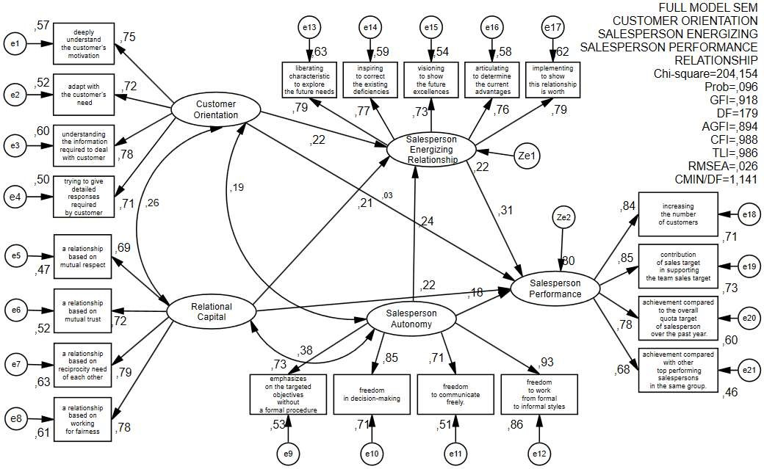
The construct reliability test in this research uses Cronbach alpha which is recommended at > 0.70 (Hair et al., 2010). The reliability test results for all constructs in this study for customer orientation, relational capital, job autonomy, salesperson energising relationship, and salesperson performance were above > 0.70. For the unidimensionality test, confirmatory factor analysis model was conducted. Average variance extracted (AVE) of each construct is expected to be bigger that squared correlation for each pair of constructs. It indicates a good discriminate validity (Singh and Venugopal, 2015).
The next stage is fit structural equation model to test the hypotheses (Figure 2).
The full structural model showed the acceptable fit indices [χ² = 204.154; (p = 0.096); CFI = 0.988; TLI = 0.986, GFI = 0.918; RMSEA = 0.026 and CMIN/DF = 1.141).
Figure 2 shows the relation among variables and it can be formulated in Table 1.
Table 1 Regression weight structural equation model
 |  |  | Estimate | S.E. | C.R. | P | Label
CO | → | SER | .189 | .069 | 2.736 | .006 | par_14
RC | → | SER | .220 | .091 | 2.418 | .016 | par_15
SA | → | SER | .238 | .081 | 2.941 | .003 | par_19
SER | → | SP | .405 | .109 | 3.703 |  | par_16
SA | → | SP | .237 | .105 | 2.265 | .024 | par_17
RC | → | SP | .307 | .119 | 2.588 | .010 | par_18
CO | → | SP | .034 | .088 | .381 | .703 | par_26
Notes: CO: customer orientation.
SER: salesperson energising relationship.
SA: salesperson autonomy.
RC: relational capital.
SP: salesperson performance.
Table 1 showed that from seven hypotheses, there were six hypotheses accepted while the other one hypothesis that was the relation of customer orientation to salesperson’s performance was rejected. For the customer orientation variable, it significantly affects the salesperson performance through salesperson energising relationship, whereas the relational capital and job autonomy are able to directly affect the salesperson performance and through salesperson energising relationship as well.

Conclusions and future research
The results of this study reiterated that customer orientation remains the core of marketing strategy implementation aimed to maintain, bind, and establish relationships for the long-term when supported with other variables that are capable in mediating the customer orientation on salesperson performance. In line with the previous studies, these findings supported the results of customer orientation’s direct effect inconsistencies on salesperson performance (Franke and Park, 2006; Jaramillo and Grisaffe, 2009; Singh and Venugopal, 2015). Therefore, a critical review in the marketing literature on this customer orientation which, in fact, cannot directly affect the salesperson job outcome is required. This study provides an extended alternative to bridge the problem, in this case through salesperson energising relationship.
While some literature is still asking the question on how customer orientation works in strengthening salesperson’s job outcome, the finding of this study provide insights into how customer orientation could work. The energising interaction power which is covered into five dimensions, i.e.:
- relationship with liberating characteristic which can explore the future needs
- relationship with inspiring characteristic which can explore and correct the existing deficiencies
- relationship with visioning characteristic which can show the future advantages
- relationship with articulating characteristic which can determine the current advantages
- relationship with implementing characteristic which can show that this relationship is worth-continuing and believed to strengthen and potentially enhance the salesperson performance.
The results of this study have also confirmed that the relational capital power inside the salesperson will enable the interaction strength based on mutual trust between the two interacting parties. It becomes the basis for establishing a long-term relationship and maintaining loyalty. In addition to trust, the aspects of relational capital power which include benevolence, mutual respect, competency, and honesty have also become the basic dimensions in supplier-customer interactions that will directly help strengthen the salesperson performance and also the salesperson energising relationship.
Likewise, job autonomy will also directly strengthen the salesperson energising relationship power as well as enhance the salesperson performance. It indicates that the dimensions of job autonomy relating to freedom in the management practice style and independence in making decisions based on the expertise even without the need of an absolute authority in the organisation, and also the ability to access and manage information to make decisions will ensure the expectations of salesperson performance improvement. This is consistent with the previous research that pay attention to the direct effects (Bonney and Wolliams, 2009; He and Li, 2010), although the setting is a developing country like Indonesia. It is fair for the salesperson to receive trust to manage the responsibility of his job, considering that this kind of job in pharmaceutical world as in this study requires salespersons with independency in making fast and agile decisions.
This study expands the literature on sales about the role of customer orientation on the salesperson performance by providing an alternative mediator namely the interaction power with energy or so-called salesperson energising relationship. It is also to answer the findings of Plouffe et al. (2009) who are still questioning how customer orientation works and proceeds in order to improve the salesperson performance. This study also responds the opinion from Kaynak et al. (2016) and Singh and Venugopal (2015) about the importance of an expanding study in developing countries outside the Western countries that in fact have completely different contingency situations (political, cultural, and economic aspects)
The result of this study confirms that customer orientation is not a direct antecedent of salesperson performance, and it can only strengthen job outcome when aided with the next stage, in this case, it is with alternative offers of strengthening the energising interactions of a salesperson. Intervening variables are required to bridge the effects of customer orientation on salesperson performance.
This study re-emphasises the important role of salespersons who stand at the vanguard of interaction with customers. Their critical role is not only in their ability to understand the customers and collect information needed to respond to the customers’ questions in detail as widely understood within the customer orientation concept. Beyond that, this study reminds the salespersons’ managers to always encourage the sales force to own high affect ability and an entrepreneur-like attitude in the dynamics of interactions and relations with customers. These demands can be responded through the ability to interact with energy, capable of being a mesmerising driving force, and keep their spirit in winning the customers’ hearts and choices. A special training that focuses on keeping the energy and stamina during interactions is necessary to maintain the energy poured in sustaining relations with customers.
In addition to trainings that can raise and maintain salesperson’s energy, the company should also consider sales outcome beyond volume or profit alone, as they have done so far. Rather, it is also wise to consider from other’s perspectives such as customer feedback, customer satisfaction, and customer engagement, customer loyalty which are also related to the goals of salesperson performance.
This study only measures the salespersons at go-public companies. Further studies can be applied in a wider setting like in pharmaceutical companies in general either go public or owned by a family, which of course might have more dynamic culture and policy so that research generalisation can be expanded. Another consideration for future research is the different body of industries that uses salespersons as the vanguard of their industry such as finance, retail, telecommunications, or insurance so that more comprehensive results can be obtained on the effects of customer orientation on the salesperson performance. This study is considered as merely cross-sectional, hence the performance measurement results cannot yet be measured more objectively. The next studies may consider longitudinal setting to improve the results of the occurring effects.

References
Amabile, T.M., Schatzel, E.A., Moneta, G.B. and Kramer, S.J. (2004) ‘Leader behaviours and the work environment for creativity: perceived leader support’, The Leadership Quarterly, Vol. 14, No. 1, pp.5–32.
Anderson, A.S., Dodd, S.D. and Jack, S. (2010) ‘Network practices and entrepreneurial growth’, Scandinavian Journal of Management, Vol. 26, No. 2, pp.121–133.
Arndt, A. and Karande, K. (2012) ‘Is it better for salespeople to have the highest customer orientation or a strong fit with their group’s customer orientation? Findings from automobile dealerships’, Journal of Retailing and Consumer Service, Vol. 19, No. 3, pp.353–359.
Babakus, E., Cravens, D.W., Grant, K., Ingram, T.N. and LaForge, R.W. (1996) ‘Investigating the relationships among sales, management control, sales territory design, salesperson performance, and sales organization effectiveness’, International Journal of Research in Marketing, Vol. 13, No. 4, pp.345–363.
Boles, J.S., Babin, B.J. and Brashear, T.G. (2001) ‘An examination of the relationships between retail work environments, salesperson selling orientation customer orientation and job performance’, Journal of Marketing Theory and Practice, Vol. 9, No. 3, pp.1–13.
Bonney, F.L. and Wolliams, B.C. (2009) ‘From products to solutions: the role of salesperson opportunity recognition’, European Journal of Marketing, Vol. 43, Nos. 7/8, pp.1032–1052.
Bontis, N. (2004) ‘National intellectual capital index: a United Nations initiative for the Arab region’, Journal of Intellectual Capital, Vol. 5, No. 1, pp.13–39.
Bontis, N. and Fitz-ens, J. (2002) Intellectual capital ROI: A causal map of human capital antecedents and consequents’, Journal of Intellectual Capital, Vol. 3, No. 3, pp.223–247.
Capaldi, C.A., Dopko, R.L. and Zelenski, J.M. (2014) ‘The relationship between nature connectedness and happiness: a meta-analysis’, Frontiers in Psychology, Vol. 5, No. 9, pp.89–109.
Challagalla, G.N. and Shervani, T.A. (1996) ‘Dimensions and types of supervisory control: effects on salesperson performance and satisfaction’, Journal of Marketing, Vol. 60, No. 1, pp.89–105.
Chia-Yi, C. and Chang, J-J. (2015) ‘Does network building improve sales performance? The stabilizing role of job embeddedness’, Journal of Organizational Effectiveness: People and Performance, Vol. 2, No. 2, pp.110–133.
Choi, Y., Huang, Y. and Sternquist, B. (2015) ‘The effects of the salesperson’s characteristics on buyer-seller relationships’, Journal of Business & Industrial Marketing, Vol. 30, No. 5, pp.616–625.
Churchill, G.A., Ford, N.M. and Walker, O.C. (1993) Sales Force Management, R.D. Irwin, Homewood, IL.
Churchill, G.A., Ford, N.M., Hartley, S.W. and Walker, O.C. (1985) ‘The determinants of salesperson performance: a meta-analysis’, Journal of Marketing Research, Vol. 22, No. 2, pp.103–118.
Crosby, L.A., Evans, K.R. and Cowles, D. (1990) ‘Relationship quality in services selling: an interpersonal influence perspective’, Journal of Marketing, Vol. 53, No. 3, pp.68–81.
Cross, M.E., Brashear, T.G., Rigdon, E.E. and Bellenger, D.N. (2007) ‘Customer orientation and salesperson performance’, European Journal of Marketing, Vol. 41, Nos. 7/8, pp.821–835.
Das, S.R. and Joshi, M.P. (2007) ‘Process innovativeness in technology services organizations: roles of differentiation strategy, operational autonomy and risk-taking propensity’, Journal of Operations Management, Vol. 25, No. 3, pp.643–660, DOI: 10.1016/j.jom.2006.05.011.
Di Mascio, R. (2010) ‘The service models of frontline employees’, Journal of Marketing, Vol. 74, No. 4, pp.63–80.
Dong, Y., Liao, H., Chuang, A., Zhou, J. and Campbell, E.M. (2015) ‘Fostering employee service creativity: joint effects of customer empowering behaviors and supervisory empowering leadership’, Journal of Applied Psychology, Vol. 100, No. 5, pp.1364–1380.
Falcone, R. and Castelfranchi, C. (2011) ‘Trust and relational capital’, Computational and Mathematical Organization Theory, Vol. 17, No. 2, pp.179–195.
Franke, G.R. and Park, J.E. (2006) ‘Salesperson adaptive selling behavior and customer orientation: a meta-analysis’, Journal of Marketing Research, Vol. 43, No. 4, pp.693–702.
Gellatly, I.R. and Irving, P.G. (2001) ‘Personality, autonomy and contextual performance of manager’, Human Performance, Vol. 14, No. 3, pp.231–245.
Haas, A., Snehota, I. and Corsaro, D. (2012) ‘Creating value in business relationships: the role of sales’, Industrial marketing Management, Vol. 41, No. 1, pp.94–105.
Hair, J.F., Black, W.C., Babin, B.J. and Anderson, R.E. (2010) Multivariate Data Analysis, 7th ed., A Global Perspective, New York.
He, H. and Li, Y. (2010) ‘Key service drivers for high-tech service brand equity: the mediating role of overall service quality and perceived value’, Journal of Marketing Management, Vol. 27, Nos. 1-2, pp.77–99.
Homburg, C., Muller, M. and Klarmann, M. (2011) ‘When does salespeople’s customer orientation lead to customer loyalty? The differential effects of relational and functional customer orientation’, Journal of the Academy of Marketing Science, Vol. 39, No. 6, pp.795–812.
Hughes, D.E., Bon, J.L. and Malshe, A. (2012) ‘The marketing–sales interface at the interface: creating market-based capabilities through organizational synergy’, Journal of Personal Selling and Sales Management, Vol. 32, No. 1, pp.57–72.
Hughes, D.E., Le Bon, J. and Rapp, A. (2013) ‘Gaining and leveraging customer-based competitive intelligence: the pivotal role of social capital and salesperson adaptive selling skills’, Journal of the Academy of Marketing Science, Vol. 41, No. 1, pp.91–110.
Hunt, S.D. (1997) ‘Competing through relationships: grounding relationship marketing in resource-advantage theory’, Journal of Marketing Management, Vol. 13, No. 5, pp.431–445.
Jaramillo, F. and Grisaffe, D.B. (2009) ‘Does customer orientation impact objective sales performance? Insight from a longitudinal model in direct selling’, Journal of Personal Selling and Sales Management, Vol. 29, No. 2, pp.167–178.
Johansson, J. (2007) Sell-side analysts’ creation of value – key roles and relational capital’, Journal of Human Resource Costing and Accounting, Vol. 11, No. 1, pp.30–52.
Johlke, M.C. (2006) ‘Sales presentation skills and salesperson job performance’, Journal of Business & Industrial Marketing, Vol. 21, No. 5, pp.311–319.
Kadic-Maglic, S., Vida, I., Obadia, C. and Plank, R. (2016) ‘Clarifying the influence of emotional intelligence on salesperson performance’, Journal of Business & Industrial Marketing, Vol. 31, No. 7, pp.877–888.
Kang, B., Oh, S. and Sivadas, E. (2014) ‘Beyong relationship quality: examining relationship management effectiveness’, Journal of Marketing Theory and Practice, Vol. 21, No. 3, pp.273–288.
Kara, A., Andaleeb, S.S., Turan, M. and Cabuk, S. (2013) ‘An examination of the effects of adaptive selling behavior and customer orientation on performance of pharmaceutical salespeople in an emerging market’, Journal of Medical Marketing: Device, Diagnostic, and Pharmaceutical Marketing, Vol. 13, No. 2, pp.102–114.
Kauffed, S. (2006) ‘Self-directed work groups and team competence’, Journal of Occupational and Organizational Psychology, Vol. 79, No. 1, pp.1–21.
Kaynak, E., Kara, A., Chow, C.S.F. and Laukkanen, T. (2016) ‘Role of adaptive selling and customer orientation on salesperson performance: evidence from two distinct markets of Europe and Asia’, Journal of Transnational Management, Vol. 21, No. 2, pp.62–83.
Keillor, D.B. and Parker, R.S. (2000) ‘Relationship-oriented characteristics and individual salesperson performance’, Journal of Business & Industrial Marketing, Vol. 15, No. 1, pp.7–22.
Killic, C. and Dursun, T. (2008) ‘Job-related antecedents and performance outcomes of individual: level customer orientation’, The Business Review, Vol. 10, No. 1, pp.39–46.
Kohtamaki, M., Partanen, J. and Moller, K. (2013) ‘Making a profit with R&D services: the critical role of relational capital’, Industrial Marketing Management, Vol. 14, No. 8, pp.847–877.
Langfred, C.W. and Moye, N.A. (2005) ‘Effects of task autonomy on performance: an extended model considering motivational, informational, and structural mechanisms’, Journal of Applied Psychology, Vol. 89, No. 6, pp.934–945.
Medhurst, A.R. and Albrecht, S. (2016) ‘Salesperson work engagement and flow: a qualitative exploration of their antecedents and relationship’, Qualitative Research in Organizations and Management: An International Journal, Vol. 11, No. 1, pp.22–45.
Miocevic, D. (2016) ‘The antecedents of relational capital in key exporter-importer relationships: an institutional perspective’, International Marketing Review, Vol. 33, No. 2, pp.196–218.
Mubarik, S., Chandran, V. and Devadason, E.S. (2016) ‘Relational capital quality and client loyalty: firm-level evidence from pharmaceuticals, Pakistan’, The Learning Organization, Vol. 23, No. 1, pp.43–60.
Nguyen, T.D. and Nguyen, T.T.M. (2011) Firm-specific marketing capital and job satisfaction of marketers: evidence from Vietnam’, The Learning Organization, Vol. 18, No. 3, pp.251–263.

Nguyen, T.T.M., Barrett, N.J. and Nguyen, T.D. (2006) The Role of Market and Learning Orientations in Relationship Quality: Evidence from Vietnamese Exporters and their Foreign Importers International Marketing Research, Vol. 17, pp.107–133, Emerald Group Publishing Limited, UK.
Paparoidamis, N.G. (2005) ‘Learning orientation and leadership quality: their impact on salespersons’ performance’, Management Decision, Vol. 43, Nos. 7/8, pp.1054–1063.
Pettijohn, C.E., Rozell, E.J. and Newman, A. (2010) ‘The relationship between emotional intelligence and customer orientation for pharmaceutical salespeople: a UK perspective’, International Journal of Pharmaceutical and Healthcare Marketing, Vol. 4, No. 1, pp.21–39.
Piercy, N.F., Cravens, D.W. and Morgan, N.A. (1998) ‘Salesforce performance and behavior-based management processes in business to business sales organizations’, European Journal of Marketing, Vol. 32, Nos. 1/2, pp.79–100.
Plouffe, C.R., Hulland, J. and Wachner, T. (2009) ‘Customer-directed selling behaviors and performance: a comparison of existing perspectives’, Journal of the Academy of Marketing Science, Vol. 37, No. 4, pp.422–439.
Pousa, C. and Mathieu, A. (2013) ‘Boosting customer orientation through coaching: a Canadian study’, International Journal of Banking Marketing, Vol. 32, No. 1, pp.60–81.
Sawhney, M. (2006) ‘Going beyond the product, defining, designing, and delivering customer solutions’, in Lusch, R.F. and Vargo, S.L. (Eds.): The Service-Dominant Logic of Marketing: Dialog, Debate, and Directions, pp.365–380, M. E. Sharpe, New York.
Saxe, R. and Weitz, B.A. (1982) ‘The SOCO scale: a measure of the customer orientation of salespeople’, Journal of Marketing Research, Vol. 19, No. 3, pp.343–351.
Schwepker, C.H. (2016) ‘Servant leadership, distributive justice and commitment to customer value in the salesforce’, Journal of Business & Industrial Marketing, Vol. 31, No. 1, pp.70–82.
Schwepker, C.H. and Good, D.J. (2012) ‘Sales quotas: unintended consequences on trust in organization, customer-oriented selling, and sales performance’, Journal of Marketing Theory and Practice, Vol. 20, No. 4, pp.437–452.
Shalley, C.E., Zhou, J. and Oldham, G.R. (2004) ‘The effects of personal and contextual characteristics on creativity: where should we go from here?’, Journal of Management, Vol. 30, No. 6, pp.933–958.
Singh, R. and Das, G. (2013) ‘The impact of job satisfaction, adaptive selling behaviors and customer orientation on salesperson’s performance: Exploring the moderating role of selling experience’, Journal of Business & Industrial Marketing, Vol. 28, No. 7, pp.554–564.
Singh, R. and Koshy, A. (2011) ‘Does salesperson’s customer orientation create value in B2B relationships? Empirical evidence from India’, Industrial marketing Management, Vol. 40, No. 1, pp.78–85.
Singh, R. and Venugopal, P. (2015) ‘The impact of salesperson customer orientation on sales performance via mediating mechanism’, Journal of Business & Industrial Marketing, Vol. 30, No. 5, pp.594–607.
Stock, R.M. (2016) ‘Understanding the relationship between frontline employee boreout and customer orientation’, Journal of Business Research, Vol. 69, No. 10, pp.4259–4268.
Sujan, H., Weitz, B.A. and Kumar, N. (1994) ‘Learning orientation, working smart, and effective selling’, Journal of Marketing, Vol. 58, No. 3, pp.39–52.
Sullivan, P.H. (2000) Value-driven Intellectual Capital; How to convert Intangible Corporate Assets into Market Value, John Wiley & Son, Inc., USA.
Swenson, M.J. and Herche, J. (1994) ‘Social values and salesperson performance: and empirical examination’, Journal of Academy of Marketing Science, Vol. 22, No. 3, pp.283–289.
Tata, J. and Prasad, S. (2015) ‘Immigrant family businesses: social capital, network benefits and business performance’, International Journal of Entrepreneurial Behavior & Research, Vol. 21, No. 6, pp.842–866.
Terawatanavong, C., Whitwell, G.J. and Widing, R.E. (2007) ‘Buyer satisfaction with relational exchange across the relationship lifecycle’, European Journal of Marketing, Vol. 41, Nos. 7/8, pp.915–398.
Tuli, K.R., Kohli, A.K. and Bharadwaj, S.B. (2007) ‘Rethinking customer solutions: from product bundles to relational processes’, Journal of Marketing, July, Vol. 71, No. 3, pp.1–17.
Wang, G. and Netemeyer, R.G. (2002) ‘The effects of job autonomy, customer demandingness, and trait competitiveness on salesperson learning, self-efficacy, and performance’, Journal of the Academy of Marketing Science, Vol. 30, No. 3, pp.217–228.
Welbourne, T. and Padrdo-del-val, M. (2009) ‘Relational capital: strategic advantage for small and medium-size enterprises (SMEs) through negotiation and collaboration’, Group Decision and Negotiation, Vol. 18, No. 5, pp.483–497.

