The influence of Gender towards Purchase Intentions at Shopee: Moderating Role of Brand Image and Marketing Content
Sthefani Hana Aretha
Department of Management, Faculty of Economics and Business, Soegijapranata Catholic University, Indonesia
Email: 20D10233@student.unika.ac.id

MG Westri Kekalih Susilowati
Department of Management, Faculty of Economics and Business, Soegijapranata Catholic University, Indonesia
Email: westrie@unika.ac.id

Abstract
This research aims to examine whether brand image and content marketing positively influence the purchase intention of Shopee users among university students in Semarang. The study adopts a path analysis approach. By maximizing content marketing strategies and strengthening its brand image, Shopee can attract a more extensive consumer base and enhance its market share. This research contributes to developing theories and concepts related to gender, content marketing perceptions, brand image, and consumer purchase intention. The research sample comprises 90 university students who are Shopee users in Semarang. The findings reveal that gender significantly influences perceptions of content marketing and brand image, but it does not affect purchase intention. Furthermore, perceptions of brand image and purchase intention on the Shopee platform have a positive and significant influence. However, content marketing has no significant influence on the purchase intention of the Shopee platform.

Keywords: content marketing, brand image, purchasing intention, consumer behavior.

INTRODUCTION

ABSTRACT
This research aims to examine whether brand image and content marketing positively influence the purchase intention of Shopee users among university students in Semarang. The study adopts a path analysis approach. By maximizing content marketing strategies and strengthening its brand image, Shopee can attract a more extensive consumer base and enhance its market share. This research contributes to developing theories and concepts related to gender, content marketing perceptions, brand image, and consumer purchase intention. The research sample comprises 90 university students who are Shopee users in Semarang. The findings reveal that gender significantly influences perceptions of content marketing and brand image, but it does not affect purchase intention. Furthermore, perceptions of brand image and purchase intention on the Shopee platform have a positive and significant influence. However, content marketing has no significant influence on the purchase intention of the Shopee platform.

Keywords: gender, content marketing perception, brand image perception, purchasing intention.

INTRODUCTION
Business competition is getting tougher with the presence of technology, especially digital information technology, which has changed the economic context. The economy enters an era known as the digital economy, an economy based on science and technology. Entering the era of the industrial revolution 4.0, digital technology is one of the principal capital industry players need to develop their business lines. Indonesia is a country that has great potential for the development of the digital economy. Indonesia's Gross Merchandise Value (GMV) is predicted to increase to USD 146 Billion in 2025 from USD 70 Billion in 2021. This figure is quite fantastic and exceeds the GMV of neighbouring countries in Southeast Asia (Figure 1). The development of the digital economy is also driven by changes in people's behavior that tend to use digital platforms. Technological changes change not only industrial behavior but also consumer behavior. Consumers are faced with many product offers, distribution channels, payment methods, etc. Business entities must be responsive to various changes triggered by these technological changes. They must encapsulate consumer behavior changes to attract to win the competition, or at least survive in the market. Technological advancements have become one of the primary factors shaping changes in consumer lifestyles. The increasing frequency of consumer interactions in the “digital world” has led to changes in their shopping behavior. Consumers are more inclined to shop online to fulfil their needs, driven by convenience, time efficiency, and the ability to compare prices quickly (Rahmi & Amalia, 2018).

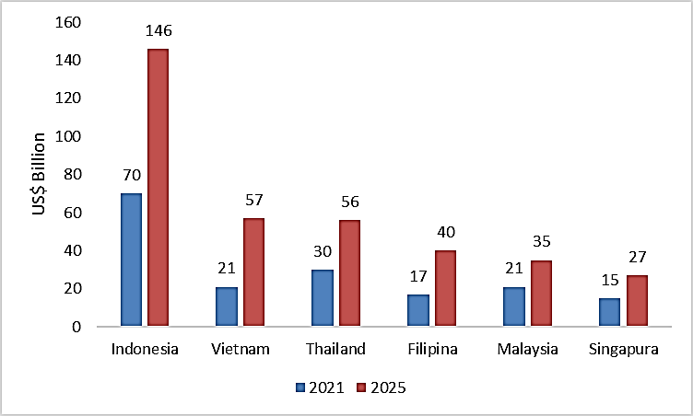
Figure 1 Southeast Asia Gross Merchandise Value (GMV) 2021 – 2025.

In marketing activities, digital technology has an extraordinary impact. Adjustment of marketing activities to digital technology is called digital marketing. Digital marketing has become increasingly crucial in today's business. It enables communication and transactions to happen anytime, anywhere and reach a broader audience. An essential aspect of digital marketing is content marketing. Content that must be presented is unique, creative, and contain helpful information. By creating compelling content, companies can build a positive relationship with consumers and enhance brand awareness (Risa Ratna, 2019). Content marketing is a marketing activity that involves creating, curating, distributing and amplifying content that is interesting, relevant and useful for specific groups in order to create talk about the content (Philip et al., 2017); it is a marketing approach that involves creating, curating distribution, and promoting content that is interesting, relevant, and useful for a clearly defined target audience that aims to create conversation about the content(Iwan Setiawan, 2016). Several studies have shown that content marketing has a significant effect on purchase intention (Abdurrahim & Sangen, 2019; Fatimah, 2023); digital content marketing has a significant impact on customer engagement and purchase intentions (Trivedi, 2022; Yaqubi & Karaduman, 2019)
Besides content marketing, brand image is also very essential. Therefore business ethics must also pay attention to brand image. Brand image is consumer perception or what consumers think or feel about the brand of a particular product which is formed from information that consumers obtain either through direct experience using the product or indirectly through hearing, seeing or learning consumers. Haitao (2022) researched the influence of Brand Image and Product Quality on Purchase Intention. The results show that both have a positive and significant effect. Other research on The Effect of Brand Image, Brand Trust, Economic Benefits, and Brand Attitude Toward Purchase Intention on iPhones also shows that Brand image is a variable that has a positive-significant effect (Maknunah & Rachmat, 2020).
Meanwhile, other studies add to the context of product halalness. This research found that product features and brand image positively affect Purchasing Decisions, with Purchase Interest as Mediating Variables (Septianti et al., 2021). A favourable brand image increases consumers' trust and triggers a purchase intention. Research by (Mangido Asi. Kennyco Jonathan, 2021) shows that brand image significantly influences consumer purchase intention.
Shopee is the leading online shopping platform in Southeast Asia and Taiwan. Launched in 2015, Shopee is a region-tailored platform that provides customers with an easy, safe and fast online shopping experience through substantial payment and logistics support. It is a company that promotes providing its users with an easy, safe, and enjoyable online shopping experience. With effective marketing strategies and a profound understanding of local consumer needs, Shopee has built a substantial market share in Southeast Asia. Through innovation in its business model, Shopee offers interactive and fun user experiences through features like Shopee Guarantee and Shopee Live. Shopee is also actively conducting attractive promotional programs and discounts like "Goyang Shopee 11.11 and 12.12," offering consumers billions of rupiahs in prizes. Such promotions are expected to boost consumer purchase intention toward products offered by Shopee, as stated by Aziky and Masreviastuti (2018).
Shopee has gained incredible popularity as one of Indonesia's most favoured online shopping platforms. Based on data from SimilarWeb, Shopee is the e-commerce site with the most website visits in Indonesia in the first quarter of 2023. During the January-March period this year, the Shopee website achieved an average of 157.9 million visits per month, far exceeding its competitors. During the same period, the Tokopedia site received an average of 117 million visits, the Lazada site 83.2 million visits, the BliBli site 25.4 million visits, and the Bukalapak site 18.1 million visits per month (Ahdiat, 2023).
Online shopping trends have become increasingly popular in Indonesia. The results of the APJII survey titled "Indonesia Internet Profile 2022" show that students and scholars dominate internet users with a percentage of 99.26%. The robust internet technology has changed students' shopping behavior, who were previously used to shopping directly at nearby markets or malls. With access to online shops through the internet, students can shop without having to go to physical stores or leave their homes. This change is a significant reason why online shopping trends are highly favoured, especially among students in Semarang.
Shopee has successfully differentiated itself from other e-commerce platforms through effective marketing strategies and a proper approach to local consumers. They continue to strive to provide added value to consumers and sellers by focusing on a positive user experience and responsive customer service. It is also essential to consider that societal gender views can influence consumer behavior in seeking and obtaining information, but the impact may vary depending on the prevailing context. All these factors are vital for companies to consider when formulating their marketing strategies to attract consumer purchase intention. In many studies, in many cases, gender influences perception. Stereotyped patterns of gender differences have been found in previous self-concept research. Men tended to rate themselves higher on self-concept measures of aptitude, strength, and immunities, and women tended to rate themselves higher on self-concept measures of likeability and morality. (Shambodo, 2020; Ujang Sumarwan, Megawati Simanjuntak, 2012). Likewise, gender affects brand image (Grohmann, 2009; Pang & Ding, 2021; Sultana, 2017). This study aims to investigate the effect of gender on Purchase Intention through its influence on content marketing perceptions and brand image perceptions as intervention or mediation variables among Shopee platform consumers, particularly students in Semarang.

METHOD
The main objective of this research is to test the hypothesis regarding the effect of gender on purchase intention in the Shopee Marketplace through its influence on perceived brand image and content marketing. Therefore, this study proposes several hypotheses as follows:
H1: Gender influences their perception of Shopee's content marketing
H2: Gender affects perceptions of Shopee's image
H3: Perceived content marketing influences purchase intention at Shopee
H4: Perceived Brand Image influences purchase intention at Shopee
H5: Gender Affects Purchase Intentions at Shopee
H6: Perceived content marketing and brand image partially mediate the influence of gender on purchase intention at Shopee. Referring to the objective, the object of this study is to determine how gender influences purchase influence through its influence on content marketing perceptions and brand image perceptions. This study focuses on buying behavior in student groups. Therefore, the population of this study is students with minimum criteria who have downloaded and installed the Shopee application. Data was collected using an online questionnaire in a Google Form during April 2023, including 90 respondents. Data analysis was performed using a descriptive approach and inferential statistics. Approach to numerical descriptive analysis of average central tendency (mean). This analysis describes respondents' responses to the variables/indicators studied. Perceptual data were quantified using a Likert scale of 1 – 5 (Strongly Disagree, Disagree, Fair, Agree, and Strongly Agree). Descriptions of the conditions of perception tendencies are grouped according to the level of intensity of agreement with statements on specific indicators, which are grouped into two categories according to the following scale ranges:
a. 1.00 – 2.99 tend to be Low
b. 3.00 – 5.00 tend to be high
Inferential statistical analysis was used to test the nature of the relationship between the hypothesized variables, namely the effect of gender on purchase intention through its influence on perceived brand image and content marketing. The method used for analysis is Structural Equation Modelling. It is used to analyze the path of relationships among variables. This model is used to determine the direct and indirect influence of a set of independent (exogenous) variables on the dependent (endogenous) variable. Path analysis coefficients are standardized regression coefficients calculated from standardized data based on the Z-score. This analysis is assisted by the Smart-PLS3 software (Partial et al.), presented in Figure 2.
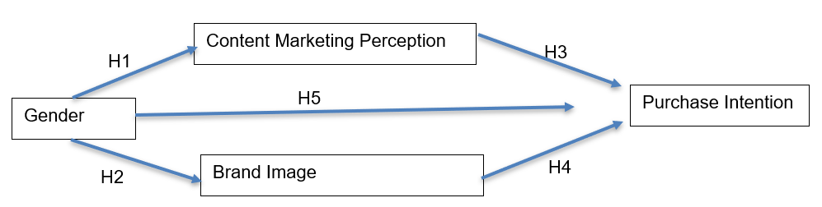
Figure 2 Model Specification

RESULTS AND DISCUSSION
Respondents Profile
The respondents are students residing in Semarang with a relatively narrow age range. The majority of the respondents (90%) fall within the age range of 20-24 years, while a smaller portion is aged 15-19 years (8.9%) and 25-29 years (1.1%). The participants in this survey consisted of 51.1% female respondents and 48.9% male respondents, indicating a reasonably balanced distribution between the two genders. Concerning their monthly expenditure levels, most respondents (60%) spend less than 1,500,000 monthly, which amounts to 54 individuals. Additionally, 28.9% of respondents spend between 1,500,000 and 3,000,000, totalling 26 individuals. Moreover, 6.7% spend between 3,000,000 and 5,000,000, amounting to 6 individuals, and 4.4% spend over 5,000,000, comprising four individuals. Among the respondents, some are employed, while others are not. The number of employed respondents is 19, accounting for 21.1%, while the unemployed are 71, constituting 78.9%.

Table 1 Respondents Profile
 | Demographic variables | %
Gender | Female | 51.1%
 | Male | 48.9%
Have a side job | Yes | 21.1%
 | Not | 78.9%
Age | 15-19 years | 8,9%
 | 20-24 years | 90.0%
 | 25-29 years | 1.1%
Monthly expenses | <1.500.000 | 60.0%
 | 1.500.000-3.000.000 | 28.9%
 | 3.000.000-5.000.000 | 6.7%
 | >5.000.000.000 | 4.4%
Usually, watch the Content Shoppe on | Instagram | 72.2%
 | Facebook | 10.0%
 | Youtube | 50.0%
 | Tiktok | 55.6%
 | Website | 1.1%
 | Twitter | 1.1%
 | Televisi | 1.1%
Source: Primary data processed

Description of Content Marketing Perceptions, Brand Image, and Purchase Intentions
Shopee's content marketing and brand image are perceived, and purchase intention tends to be high. This assessment implies that content marketing and brand image are perceived well. Each is reflected in an average value of 3.11, 3.18, and 3.04 on a scale of 1 - 5. These conditions are presented in detail in Table 2.
This study's perception of marketing content uses 12 indicators derived from Relevance, Accuracy, Value, Easy to Understand, Easy to Find, and Consistent (Patricia et al., 2015). Of the several indicators perceived, there are three indicators whose ratings tend to be low. The three indicators are that Shopee Content can help solve my problem, Shopee Content contains accurate information related to products, and Shopee Content can be trusted. Meanwhile, nine other indicators are perceived as sound. The nine indicators contain needed information, explain the current condition of a product, provide benefits, messages are easy to understand, writing can be read, are easy to find, available on social media, updated regularly, and uploaded consistently. The three best-perceived indicators are that Shopee content is available on several social media such as Instagram, Facebook and YouTube; Shopee content is easy to find; and Letters or writing on Shopee content can be read clearly.
Regarding the indicators that make up the brand image, this study refers to the formation of brand image (Aaker & Biel, 2013), namely image maker (Corporate Image), Product/consumer image (product Image, and User image. Based on these indicators, this study derives six indicators: ease of being remembered or recognized, good reputation, interesting messages or sentences, ability to meet needs (especially daily needs), and attractive logo. In the brand image variable, as a whole and according to the indicators, all are perceived to be good, especially the Shoppe brand name, which is easy to remember or recognize
Good perceptions regarding content marketing and brand image do not automatically make consumers have high purchase intentions. This phenomenon can be related to consumers who only want to visit online or offline stores to browse without any purpose. This type of consumer is only concerned with their experience walking around the store while looking around without having to shop, often called window shopping. However, this experience still allows the consumer to ultimately make a purchase if the item looks attractive, accompanied by a promo and a reasonable price. Therefore, it is crucial to hold attractive promos that are different every time so that they generate purchase intentions and, in the end, actually buy. This study found consistency between perceptions of marketing content, brand image and purchase intention. Intention to buy at Shopee tends to be high, with an average score of 3.04. Regarding purchase intentions at Shopee, consumers, in this case, students, are highly interested in buying Shopee products, recommending Shopee to others, sharing information about Shopee, and asking for information about Shopee products to people who have already shopped and know Shopee.

Table 2 Description of Content Marketing Perceptions, Brand Image, and Purchase Intentions
Indikator | Score | Category
Content Marketing Perception | 3,11 | tend to be high
Brand Image Perception | 3,18 | tend to be high
Purchase Intention | 3.04 | tend to be high
Source: Primary data processed

Path Analysis Estimation
This research aims to analyze the influence of gender on the purchase intention of the Shopee platform, with brand image perception and content marketing perception as mediating variables. Overall, this study involves four variables, consisting of 1 exogenous variable and three endogenous variables. Figure 3.1 is a path diagram that represents an overview of the research on how gender affects the purchase intention of the Shopee platform, with brand image perception and content marketing perception as mediating variables.
The path diagram illustrates the endogenous variables, including gender, purchase intention perception, and brand image perception. In detail, it shows that gender impacts purchase intention, gender also affects content marketing perception, and gender influences brand image perception. Furthermore, content marketing perception influences purchase intention, and brand image perception also affects purchase intention. Therefore, it can be concluded that Content Marketing Perception and Brand Image Perception act as mediating or intervening variables in this study.

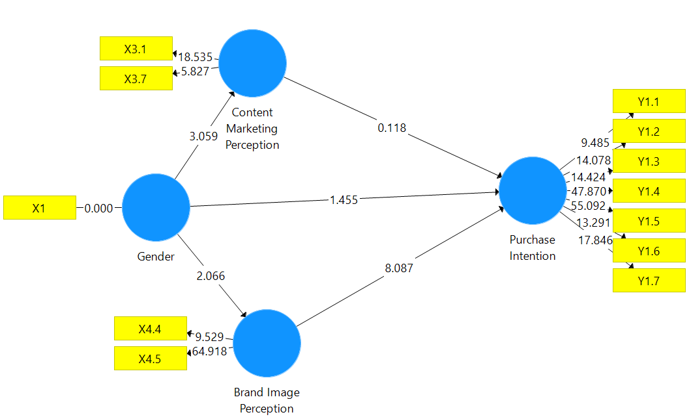

Figure 3 Path Diagram
Source: Primary data processed

Path Model Testing
Path analysis requires a convergent validity test to measure the indicators' reliability. Indicator reliability is reflected in outer loading indicators > 0.70. Meanwhile, to measure construct reliability, the Cronbach Alpha test was used. The construct of a variable is declared reliable if it has Cronchbach Alpha> 0.70. To ensure that the latent variable of a construct is different from other constructs, a discriminant validity test is performed, which is reflected in the Average Variance Extracted (AVE) value. The latency variable construct differs from the other constructs if the AVE score is > 0.5. The higher the AVE value means that the construct is more unique. Referring to the numbers presented in Table 3, the model developed in this study is reliable. Model reliability is also supported by a composite reliability score of >0.07

Table 3. Validity and Reliability Test
 | Cronbach's Alpha | rho_A | Composite Reliability | Average Variance  Extracted (AVE)
Brand Image | 0.711 | 0.929 | 0.863 | 0.760
Content Marketing | 0.719 | 0.717 | 0.848 | 0.737
Gender | 1.000 | 1.000 | 1.000 | 1.000
Purchase Intention | 0.920 | 0.942 | 0.936 | 0.678
Source: Primary data processed

Hypothesis Testing
The path analysis developed in this study includes several hypotheses: purchase intention influenced by gender, content marketing perception, and brand image perception. Additionally, there are hypotheses regarding the influence of gender on content marketing perception and brand image perception. The table above indicates that brand image perception has a positive and significant influence on purchase intention. Furthermore, content marketing perception and gender are hypothesized to have a non-significant influence on purchase intention. For these hypotheses, three hypotheses are supported statistically and two are not supported statistically.

Table 4. Path Coefficient
Variables | Original  Sample (O) | Sample Mean  (M) | Standard Deviation  (STDEV) | T Statistics  (|O/STDEV|) | P Values
Brand Image Perception -> Purchase Intention | 0.593 | 0.596 | 0.073 | 8.087 | 0.000
Content Marketing Perception -> Purchase Intention | -0.012 | -0.009 | 0.105 | 0.118 | 0.906
Gender -> Brand Image Perception | 0.212 | 0.201 | 0.102 | 2.066 | 0.039
Gender -> Content Marketing Perception | 0.254 | 0.261 | 0.083 | 3.059 | 0.002
Gender -> Purchase Intention | 0.129 | 0.127 | 0.089 | 1.455 | 0.146
Source: Primary data processed
As a result, it can be stated that gender impacts the perception of brand image and content marketing. Men and women may hold different expectations regarding environmental factors, perceptions, and consumer preferences. Brand image perception influences consumer purchase intention, encompassing attributes such as Shopee's easy recognition and memorability, positive reputation, compelling and engaging advertisements or content, uniqueness compared to similar competitors, perceived ability to fulfil consumer daily needs, and an appealing logo. On the other hand, purchase intention is not affected by gender and the perception of content marketing, which includes aspects of relevance, accuracy, value, comprehensibility, and consistency. The findings in this study are supported by research by Amalia (2020), the effect of Content Marketing on Instagram Stories @Lcheesefactory on Consumer Purchase Interest, and Ramadhan (2021), the dimensions of digital content marketing have a significant favourable influence on brand trust.

Table 5 Indirect Effects
 | Specific Indirect Effects
Gender -> Brand Image Perception -> Purchasing Intention | 0.125
Gender -> Marketing Content Perception -> Purchasing Intention | 0.003
Source: Primary data processed

This study confirms that Perceived Brand Image influences purchase intention at Shopee, Gender affects perceptions of Shopee's image, and gender influences their perception of Shopee's content marketing. There are two unsupported hypotheses: Perceived content marketing influences purchase intention at Shopee and Gender Affects Purchase Intentions at Shopee. Regarding the hypothesis that Perceived content marketing and brand image mediate the effect of gender on purchase intention at Shopee, this research only confirms the perception of content marketing as a mediating variable. Perceptions of marketing content are a partial mediating variable, reflected in the significance of the effect of gender on content marketing perceptions and the influence of content marketing perceptions on purchase intentions at Shopee.

Table 6 Coefficient of Determination (R Square)
 | R Square | R Square Adjusted
Brand Image Perception | 0.045 | 0.034
Marketing Content Perception | 0.064 | 0.054
Purchasing Intention | 0.394 | 0.373
Source: Primary data processed
The determination analysis is used to measure the ability of the developed model to explain variations in the dependent variables, which in this case are brand image perception, content marketing perception, and purchase intention. The coefficient of determination and the results of the determination test reflected in the adjusted R-square show that brand image perception contributes 3.4%, content marketing perception contributes 5.4%, and purchase intention contributes 37.33% to the model.

Table 7. Discriminant Validity
 | Brand Image | Marketing Content | Gender | Purchasing Intention
Brand Image Perception | 0.872
Marketing Content Perception | 0.212 | 0.859
Gender | 0.388 | 0.250 | 1.0000
Purchasing Intention | 0.615 | 0.249 | 0.251 | 0.824
Source: Primary data processed

CONCLUSION AND RECOMMENDATION

This study confirms that Perceived Brand Image influences purchase intention at Shopee, Gender affects perceptions of Shopee's image, and gender influences their perception of Shopee's content marketing. There are two unsupported hypotheses: Perceived content marketing influences purchase intention at Shopee and Gender Affects Purchase Intentions at Shopee. Regarding the hypothesis that Perceived content marketing and brand image mediate the effect of gender on purchase intention at Shopee, this research only confirms the perception of content marketing as a mediating variable. Perceptions of marketing content are a partial mediating variable, reflected in the significance of the effect of gender on content marketing perceptions and the influence of content marketing perceptions on purchase intentions at Shopee using popular influencers among college students.

References

Aaker, D. A., & Biel, A. L. (2013). Brand Equity &amp; Advertising (D. et al. (eds.)). Psychology Press. https://doi.org/10.4324/9781315799537
Abdurrahim, M., & Sangen. (2019). Pengaruh Content Marketing, Sales Promotion, Personal Selling, dan Advertising terhadap Minat Beli Konsumen pada Hotel Biuti di Banjarmasin. Jurnal Sains Manajemen Dan Kewirausahaan, 3(1).
Ahdiat, A. (2023). 5 E-Commerce dengan Pengunjung Terbanyak di Indonesia (Kuartal I 2023). Metadata.co.id. https://databoks.katadata.co.id/datapublish/2023/05/03/5-e-commerce-dengan-pengunjung-terbanyak-kuartal-i-2023
Amalia, C. D. (2020). Pengaruh Content Marketing di Instagram Stories @Lcheesefactory terhadap Minat Beli Konsumen. JOM FISIP, 7(1).
Fatimah, R. (2023). Pengaruh Content Marketing Instagram dan Brand Awareness terhadap Minat Beli di PS. Store Medan. Muqoddimah, 7(1).
Grohmann, B. (2009). Gender Dimensions of Brand Personality. Journal of Marketing Research, 46(1), 105–119. https://doi.org/10.1509/jmkr.46.1.105
Haitao, N. (2022). The Role of Brand Image and Product Quality on Purchase Intention (Study Literature Review). Dinasti International Journal of Management Science, 4(1), 166–174. https://doi.org/10.31933/dijms.v4i1.1466
Iwan Setiawan, Y. S. (2016). New Content Martketing : Gaya Baru Pemasaran Era Digital (S. Raynardia (ed.)). Gramedia Pustaka utama.
Maknunah, L., & Rachmat, B. (2020). The Effect of Brand Image, Brand Trust, Economic Benefits, and Brand Attitude Toward Purchase Intention on iPhone in East Java. International Journal of Multicultural and Multireligious Understanding, 7(2), 308. https://doi.org/10.18415/ijmmu.v7i2.1484
Mangido Asi. Kennyco Jonathan, H. I. (2021). Pengaruh Social Media Marketing dan Brand Image Terhadap Minat Beli Konsumen pada aplikasi Buka Lapak. E-Proceding of Management.
Pang, J., & Ding, Y. (2021). Blending package shape with the gender dimension of brand image: How and why? International Journal of Research in Marketing, 38(1), 216–231. https://doi.org/10.1016/j.ijresmar.2020.06.003
Patricia Raquel Vasques Milhinhos. (2015). The impact of content marketing on attitudes and purchase intentions of online shoppers : the case videos & tutorials and user-generated content.
Philip Kotler, Hermawan Kartajaya, I. S. (2017). Marketing 4.0: Moving from Traditional to Digital. John Wiley & Sons.
Ramadhan, M. R. (2021). The Impact Of Digital Content Marketing’s Informativeness And Entertainment On Brand Trust (A Study On The Customers Of Gojek Indonesia). JIM-FEB Universitas Brawijaya, 9(2).
Septianti, W., Setyawati, I., & Permana, D. (2021). The Effect of Halal Products and Brand Image on Purchasing Decisions with Purchase Interest as Mediating Variables. European Journal of Business and Management Research, 6(6), 271–277. https://doi.org/10.24018/ejbmr.2021.6.6.807
Shambodo, Y. (2020). Faktor Yang Mempengaruhi Persepsi Khalayak Mahasiswa Pendatang Ugm Terhadap Siaran Pawartos Ngayogyakarta Jogja TV. Jurnal Al Azhar Indonesia Seri Ilmu Sosial, 1(2).
Sultana, N. (2017). Understanding the Impact of Gender Neutral Communication on Brand Image: Trend or Tools. Lund University.
Trivedi, T. (2022). Impact of Digital Content Marketing on Purchase Intentions for Online Shopping Post Covid-19 Pandemic. International Journal of Management, Public Policy and Research, 1(2), 24–33. https://doi.org/10.55829/010204
Ujang Sumarwan, Megawati Simanjuntak, Y. (2012). Persepsi dan Preferensi Iklan Mempengaruhi Niat Beli Anak pada Produk Makanan Ringan. Jrnl Ilmu Keluarga & Konsumen, 5(2).
Yaqubi, A. Y., & Karaduman, I. (2019). The Impact of Content Marketing on Consumers’ Purchase Intention for Home Appliances: A Study in Afghanistan. The Impact of Content Marketing on Consumers’ Purchase Intention for Home Appliances: A Study in Afghanistan, 8(2).

