KORESPONDENSI DENGAN JURNAL KEUNIS -ANALISIS FAKTOR YANG MEMPENGARUHI MINAT NASABAH

SUBMIT

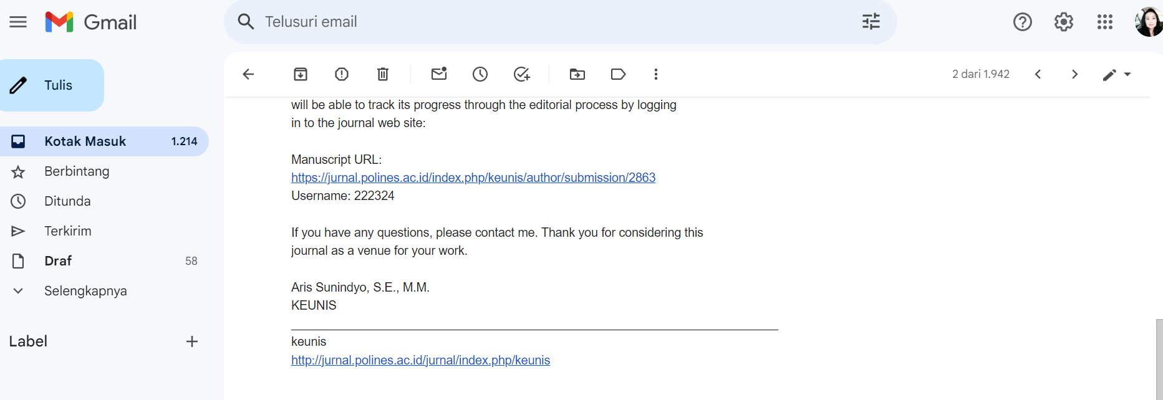

REVIEW

