KORESPONDENSI JURNAL JIPAK

REVIEW

COPY EDITING

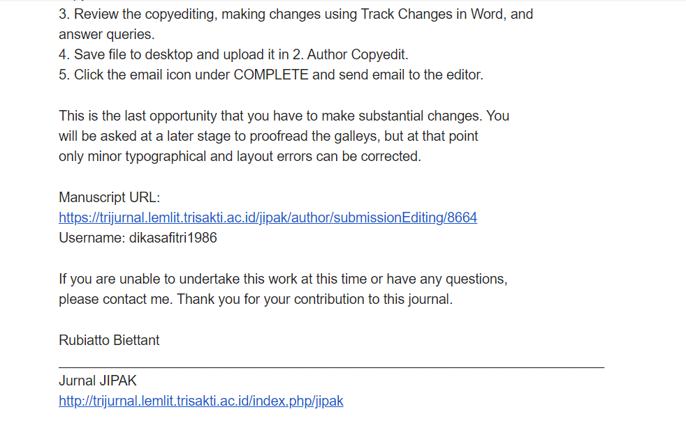

PUBLISH



