Korespondensi denganPengelola jurnal ‘Computers” PDPI

SUBMIT

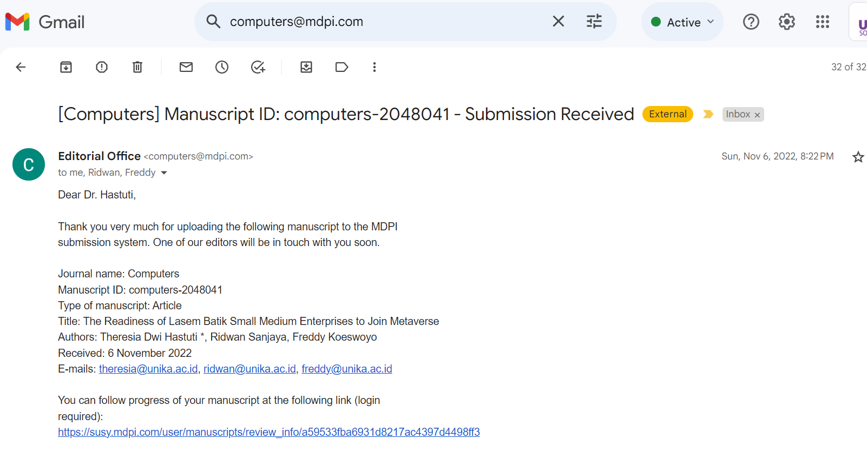

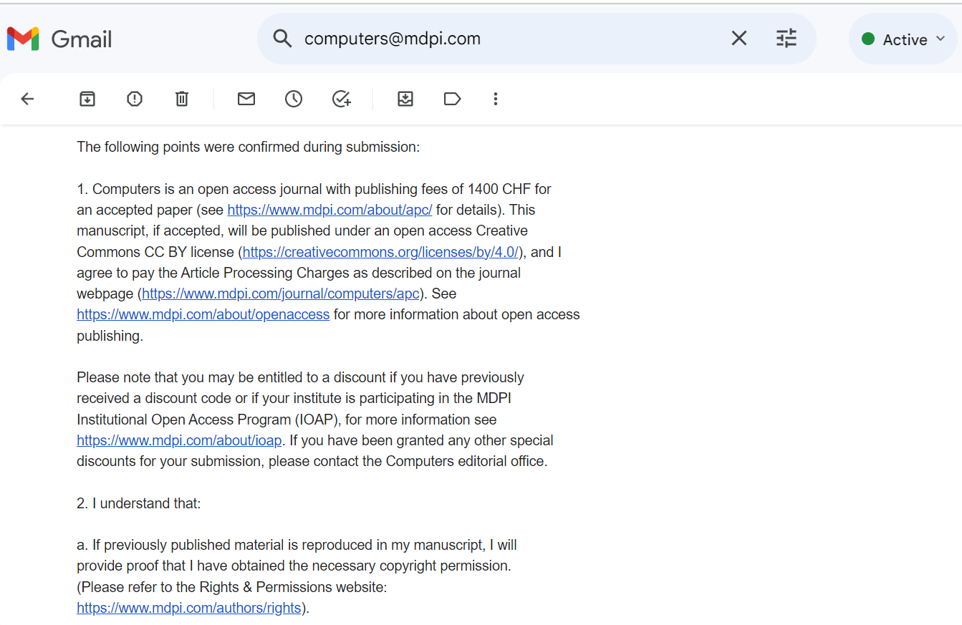

PROSES REVIEW

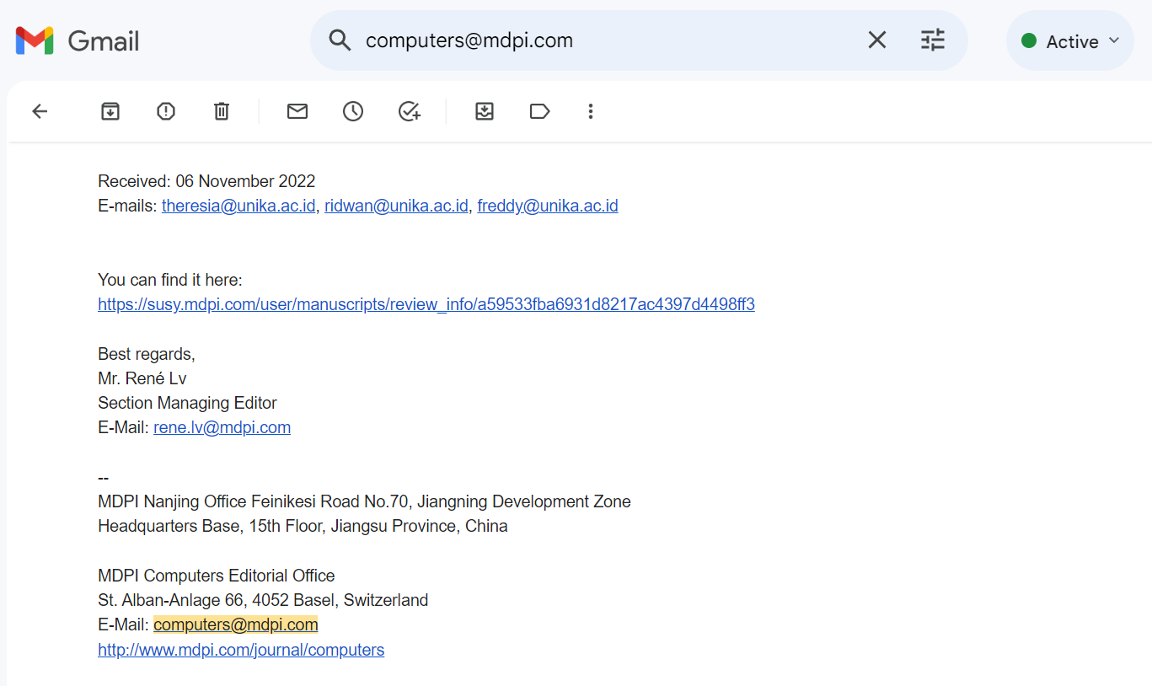

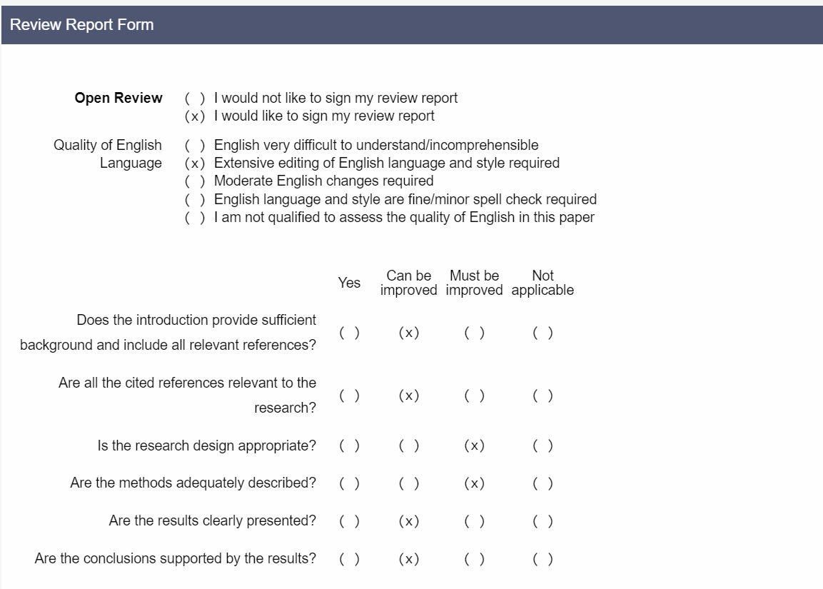

ACCEPTED

PROF TERAKHIR SEBELUM PUBLISH



