KORESPODENSI DENGAN JURNAL JBFEM

SUBMISSION

REVIEW

LOA

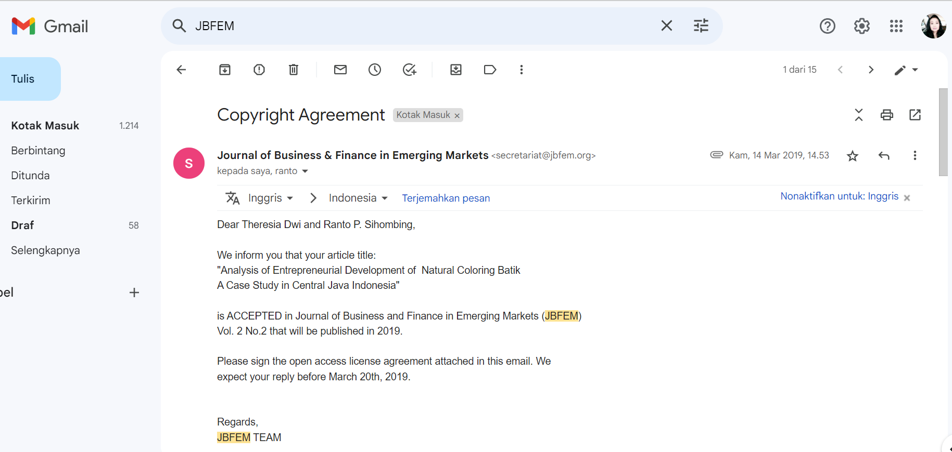

PUBLISHED

