KORESPODENSI DENGAN JURNAL IJMSSSR

SUBMISSION

REVIEW

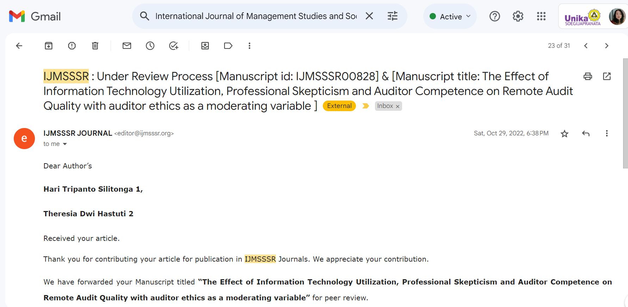

ACCEPTED

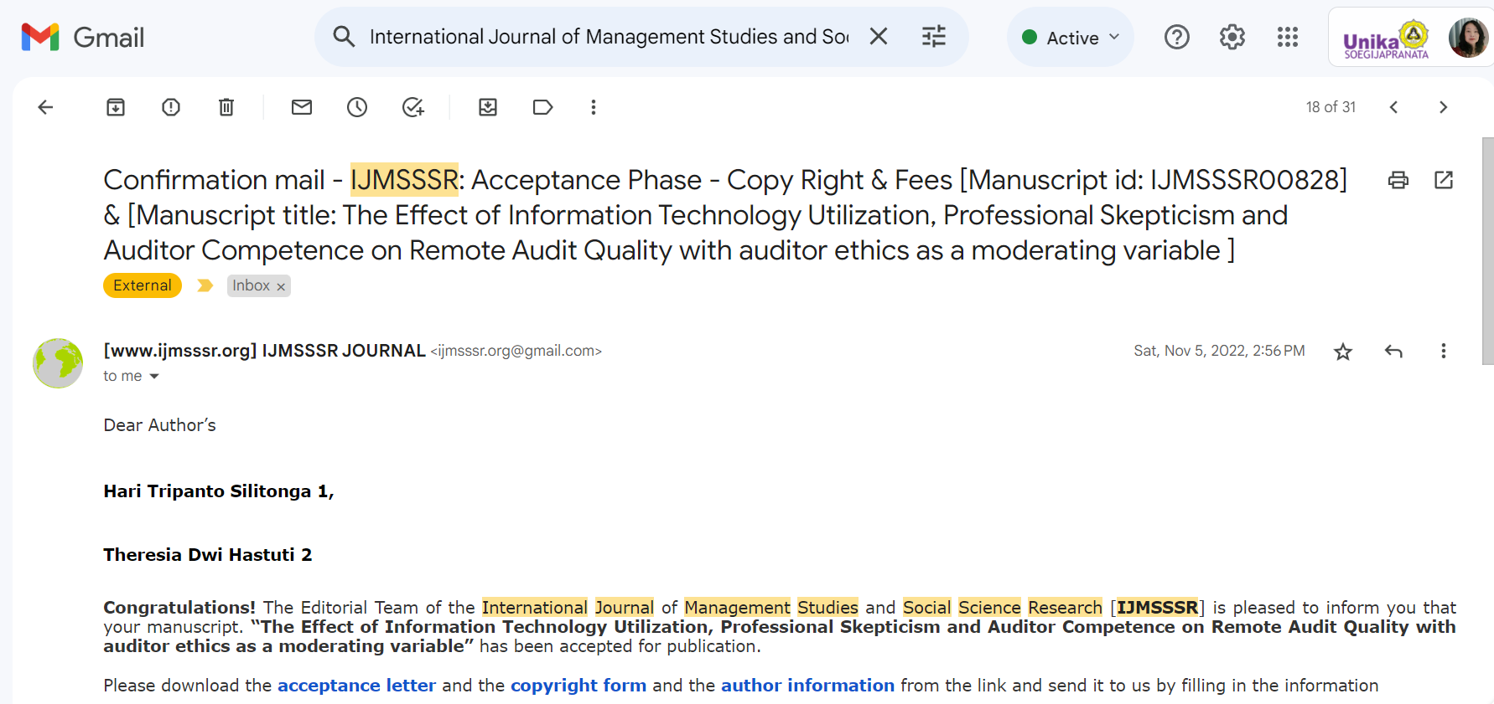

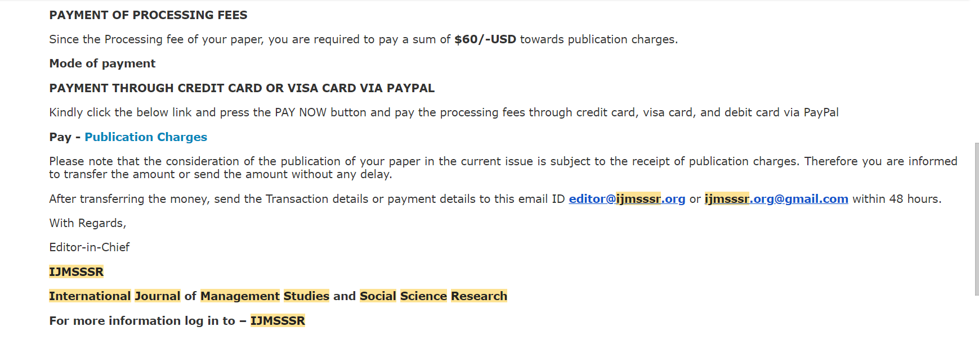

PUBLISH

