KORESPODENSI DENGAN JURNAL IJMSSSR-2

SUBMISSION

REVIEW

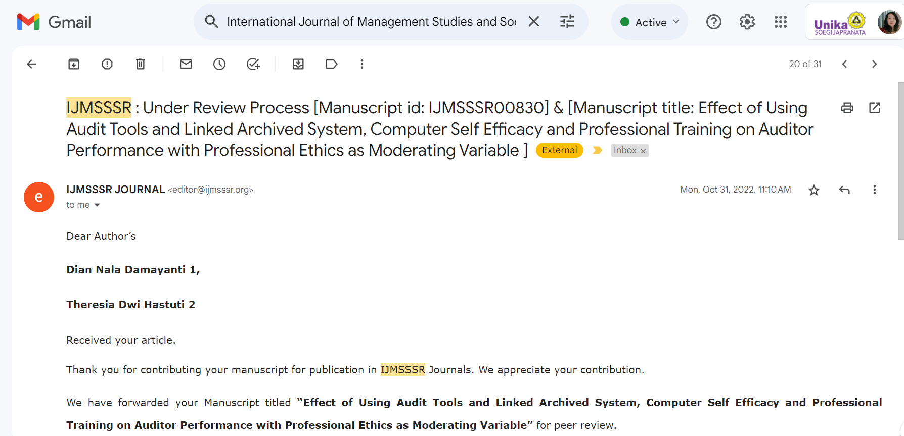

ACCEPTED

PUBLISH

