Analysis the Effect of Companies Financial Conditions, Governance, and Ownership Structure on Stock Returns during the Covid -19 Pandemic
Felicia Apriliani¹, Vena Purnamasari²

¹ Student of Accounting Department, Faculty of Economics and Business, Soegijapranata Catholic University, Semarang, Indonesia
² Lecturer of Accounting Department, Faculty of Economics and Business, Soegijapranata Catholic University, Semarang, Indonesia

*Corresponding Author: apriliani.felicia@gmail.com
__________________________________________________________________________________________
Abstract: The emergence of the Covid-19 pandemic caused an economic shocks for companies in Indonesia. The economic shock caused the stock movements during this pandemic, thus giving rise to motivation to research the characteristics of companies that can survive during the pandemic. This study will examine the effect of existing conditions of financial conditions, governance, and ownership structure on company resilience. In Indonesia, there have not been many studies that have examined the resilience of companies during the pandemic and only examined in 1 company, so this research is important to do to find out how the resilience of companies in Indonesia is in all company sectors during this pandemic. The aims of this study are to examine how the characteristics of companies that can survive during this pandemic, and the results of this study can be used as insights for those in need and for companies in Indonesia. The results of this study will show the companies with existing financial conditions, governance, and ownership structures that in a good condition, will make the stock returns from these companies are also in good condition so that the company can survive more during this pandemic.

Keywords: stocks return, financial conditions, governance, ownership structure, companies resilience
__________________________________________________________________________________________
1. Introduction
The emergence of the current Covid-19 pandemic has had many impacts on global aspects, including economic aspects. As a result of this pandemic, there have been many changes in the economy, especially in Indonesia. In Ding et al., (2020) research, it was found that there is an influence of company characteristics on stock returns during this pandemic. In Harahap et al., (2021) research, who conducted a case study at PT EastParc Hotel, he found that a company's financial performance that is in good condition can make a company survive during this pandemic. In Syafrullah & Muharam (2017) research, the results show that Social and Governance Performance has a positive and significant effect on abnormal stock returns. Then in Marpaung (2016) research, it was found that company ownership has a positive effect on stock returns.
From the studies that have been carried out, there is motivation to examine the characteristics of companies like what can survive this pandemic. Company characteristics is one of the characteristics of the company that can describe how the condition of a company. The characteristics of the company in this study are the company's financial condition, corporate governance, and company ownership structure. The resilience of a company will be seen from the company's stock returns. The focus in this research is to find out how the movement of stock returns occurs during this pandemic and the factors that influence it.
A company can be said to be immune or able to survive during this pandemic if it has a stable stock return or tends to rise. The increase and decrease in stock returns can be caused by several factors. According to data from IDX, stock movements in Indonesia decreased in March 2020, but there are only a few corporate sectors that can rise quickly, for example, mining, basic industry and chemicals, and consumer, while those that are difficult to rise and even experience a decline, for example, are property and real estate.
The existence of these stock movements raises the question of what kind of company characteristics can survive during this pandemic. This research is framed by Theory of The Firm and Signaling Theory. The theory of the firm provides a view of how companies can maximize profits and agency costs as well as the company's ownership structure. While Signaling Theory provides the view that a good company report can provide good information or signal to investors in making decisions to invest. In this time of the Covid-19 pandemic, companies need to know what are the factors that can make the company survive and investors can also get information on investing in a company. This study will assess how the influence of financial conditions, governance, and corporate ownership structure on stock returns on all sectors of companies listed on the Indonesia Stock Exchange during this pandemic.
2. Literature Review
2.1. Theory
Theory of the Firm
The theory of the company or Theory of the Firm according to Jensen & Meckling (1976) is a theory that discusses maximizing company profits, which in the discussion of the theory of the firm includes property rights and agency costs. Theory of the Firm is a theory of an organization that combines various company or organizational resources that aim to carry out company activities in the form of producing goods or services. Firm or company is an organization that exists within a company and manages existing resources within the company to provide products that are ready to be sold in the market.
This theory benefits not only the shareholders but also benefits the government and society by passing through the flow of economic activity. Company theory is widely used as the basis of economic studies, especially those related to managerial. In the Theory of the Firm, what is meant by a business company is a company that is in a combination or combination of Physical Assets and Financial Assets, systems and all kinds of information, as well as the people involved in it, such as shareholders, managers. , employees, suppliers, as well as customers or buyers, which these people are directly affected by the company's activities (Jensen & Meckling, 1976).
Signalling Theory
Signalling theory is an information signal where investors or prospective investors in company shares need financial statement information. The signal will be used by investors in making decisions whether to invest or not to invest. Because it has many things to consider. Signal theory itself has a function as an easier for investors to develop their capital in companies that have been invested. Signal theory provides an explanation of good financial statements, which is one signal or sign that the company has carried out its best operational activities. The best signal will also be welcomed by other parties (Spence, 2004)

Financial Conditions
In the journal Ding et al., (2020)said that in evaluating financial conditions it can form a stock price movement during the Covid-19 pandemic. In this study, financial condition will be measured using 4 methods : (1) Cash Ratio, (2) DAR, (3) ROA, and (4) CTO.
- Cash Ratio
Cash Ratio is the same as the total amount of cash and cash equivalents which is divided by total assets. Cash Ratio is the liquidity ratio of a company that is used to finance various company operational activities (Kasmir S. M., 2016).
Cash Ratio = $\frac{Cash and cash equivalents}{Total asset}$
- ROA
ROA is an operating profit with its own capital and foreign capital which is needed to measure a company's potential in generating profits which uses the total assets that are already available (Kasmir S. M., 2016).
ROA = $\frac{net income after taxes}{Average total asset}$
- Cash Turnover
Cash Turnover is an activity ratio used to calculate the company's efficiency in using its cash to generate revenue (Kasmir S. M., 2016).
CTO = $\frac{Revenue}{Cash and Cash Equivalents}$

- DAR
DAR is a solvency ratio that is used to measure the ratio of debt to assets of a company to measure the company's financial condition (Kasmir S. M., 2016) .
DAR = $\frac{Total Debt}{Total Asset}$

Governance
Corporate governance is a structure or system created to provide guidance on the proper and professional management of the company on the basis of the principles of accountability, fairness, independence, responsibility, transparency, and equality. According to Ding et al., (2020) the structure of corporate governance, managerial entrenchment, and the executive compensation system can influence market opinion regarding the company's resilience to Covid-19. For example, uncertainty about how big and how long the duration of this pandemic will be, world markets may prioritize flexibility including corporate mergers, corporate acquisitions, and leadership changes. These things show that companies that have good corporate governance that will be able to protect the company experience a more severe stock price reaction during the pandemic.
Corporate governance will be measured using the ESG disclosure score, especially governance, which includes executive compensation, relations between stakeholders, division of positions, rights of company stakeholders, and others (Reuters, 2017).

Ownership Structure
The company's ownership structure is a picture of the commitment of investors in delegating a certain level of handling to be delegated to managers. The ownership structure is the composition of capital including debt and equity, and also the proportion of share ownership of shareholders within the company and shareholders outside the company (Haryono et al., 2017)
According to Rozeff (1992), the ownership structure is part of the company's shares owned by the company's internal parties or the management of the company's total shares. The term ownership structure of a company is used to indicate that the important components in a company include not only the total liabilities and equity but also the percentage of institutional ownership and managerial ownership (Indarti & Extaliyus, 2013).
Managerial ownership is ownership that comes from the management of the company itself such as ownership by subsidiaries and affiliates. affected. With managerial ownership, management can be more focused and consistent in carrying out the company's operational activities so that a balance can be created between the interests of management and the interests of shareholders which can increase the performance of the company. In this study, company ownership will be categorized into “0” not having managerial ownership, and “1” having managerial ownership provided that there is managerial ownership of the company which is calculated using the formula:
Managerial Ownership = Number of Managerial Owned Shares / Total Shares outstanding
Institutional Ownership is the ownership of shares by a company or other institution. This institutional share ownership can affect the performance of a company because the institution can supervise and evaluate the company's performance (Indarti & Extaliyus, 2013). In this study, the ownership of the company will be categorized into "0" not having significant ownership, and "1" having significant ownership provided that the percentage of ownership is >20%.

Stock returns
This study will take stock price data in 4 quarters of 2020 with data sources from Bloomberg. According to Agustina & Sumartio (2014) stock is a document that states an ownership of part of a company. Shares are a sign of belonging to a person or an institution in a company or company. Stock prices always experience movement, whether it is increasing or decreasing.
In times of crisis, especially a pandemic like this, stock prices experience very significant movements. Stock price movements can be caused by various factors. This stock price movement is used as a guide or guide for shareholders in making a decision to buy a stock or when they want to invest in a company.

Covid-19 pandemic
According to Shen et al., (2020) Covid-19 is an emergency and a major concern worldwide. Tens of millions of people have been diagnosed with this virus since January 2020, and several countries have been affected by the Covid-19 pandemic. Many countries have been forced to quarantine their citizens because this virus is highly contagious. This quarantine measure has a negative impact on public demand, especially in the consumption and export sectors. On the one hand, people are expected to stay at home, so that shopping places are quiet. But on the other hand, some countries limit imports in order to prevent the transmission of the virus, which is detrimental to exporting countries.
2.2. Hypothesis
2.2.1. Company Financial Condition
Due to the Covid-19 pandemic, the company's economy experienced shocks, including the company's Cash Ratio, Cash Turnover, Return on Assets, and Debt to Asset Ratio. Cash Ratio is a company ratio used to measure the company's ability to finance the company's operations with current assets owned, ROA is one of the company's profitability ratios, which if it is not in good condition it can affect the company's stock return, Cash Turnover is one of the company's activity ratios, and the Debt to Asset Ratio is one of the company's solvency ratios. If the value of the Cash Ratio, Cash Turnover, and ROA is higher, then the company is considered able to finance the company's operational activities, which shows that the company can survive during this pandemic because the company is considered to have a good financial condition. While the DAR ratio in a company during the Covid-19 pandemic, if it increases, it can indicate that the company is in a bad condition due to the high level of debt on the company's assets, so that it can have an impact on the company's stock returns. However, in this study, the researcher was unable to determine the direction of this hypothesis because previous studies were research conducted before the Covid-19 pandemic, while for this study it was a study that examined the resilience of companies during a pandemic, so the hypothesis in this study is not trending. Company resilience can be measured by using stock returns. Good stock returns can indicate that the company can survive this pandemic. This is supported by the signal theory which states that a good company's financial statements can give a signal or information that the company's operations are also good.
Thus, the hypothesis is formulated:
H1a: Cash Ratio has an effect on stock returns during the pandemic
H1b: Return on Assets has an effect on stock returns during the pandemic
H1c: Cash Turnover has an effect on stock returns during the pandemic
H1d: Debt to Asset Ratio has an effect on stock returns during the pandemic

2.2.2. Governance
Corporate governance is one of the important components in the company. Companies that implement good corporate governance, the stock returns of the company will be good too, so that when experiencing a pandemic shocks like today, the company is more able to survive. Good corporate governance can be measured by using the principles of ESG or Environmental Social Governance with particular emphasis on governance. If a company can implement the principles of good corporate governance during this pandemic, it can make a company's stock return good too. Good stock returns indicate that the company can survive this pandemic. Good stock returns can provide information for investors about the condition of the company. However, in this study, the researcher was unable to determine the direction of this hypothesis because previous studies were research conducted before the Covid-19 pandemic, while for this study it was a study that examined the resilience of companies during a pandemic, so the hypothesis in this study is not trending.
Therefore, the hypothesis is formulated:
H2: Governance performance has an effect on stock returns during the pandemic
2.2.3. Ownership Structure
Shares are an important part of the company that can declare an ownership of the company's shares. The company's external ownership is measured by institutional ownership. Institutional ownership is ownership owned by institutions or institutions outside the company. Institutional ownership can have an influence on the company's performance because institutional parties or other institutions outside the company that own the company's shares can supervise and evaluate the company's performance. Managerial ownership is ownership owned by institutions or institutions outside the company. The greater the percentage of managerial share ownership, the management of a company will prioritize the interests of the shareholders because if a problem occurs, the management of the company must be responsible and affected. With managerial ownership, management can be more focused and consistent in carrying out the company's operational activities so that a balance can be created between the interests of management and the interests of shareholders which can increase the performance of the company.
If the company's performance is good, then the company's stock returns can also experience good conditions so that the company can be said to be resistant during this pandemic. This is related to signal theory, in which the company's performance reflected through the company's financial statements can provide signals or information to investors. However, in this study, the researcher was unable to determine the direction of this hypothesis because previous studies were research conducted before the Covid-19 pandemic, while for this study it was a study that examined the resilience of companies during a pandemic, so the hypothesis in this study is not trending.
Thus, the hypothesis is formulated:
H3a: Managerial ownership affects stock returns during the pandemic
H3b: Institutional ownership affects stock returns during the pandemic

Tables and Figures
Table 1 : Descriptive Statistics
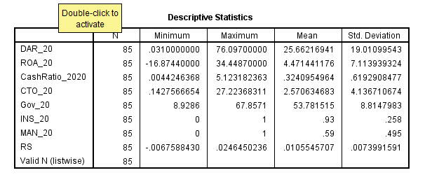
Table 2 : Normality Kolmogorov Smirnov Test
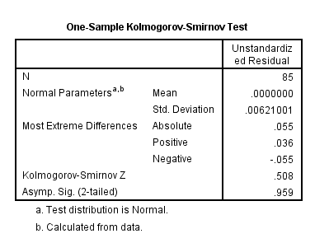

Table 3 : Glejser Test
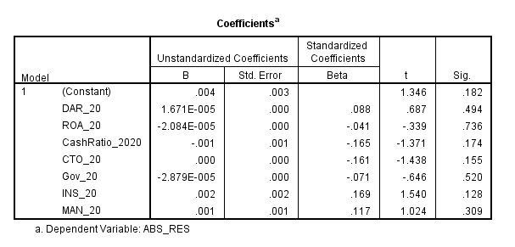

Table 4 : Multicolinearity Test
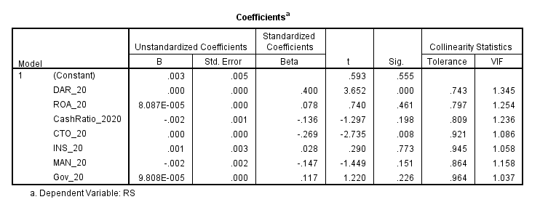
Table 5 : Coefficient Determination Test
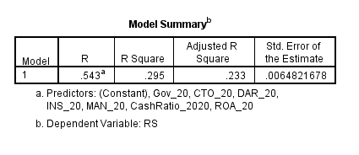

Table 6 : Simultaneous F Test
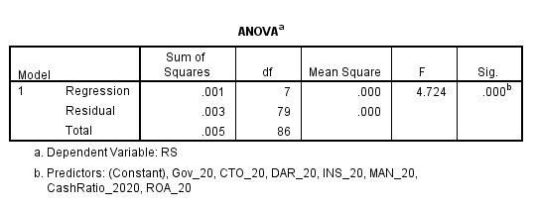
Table 7 : Significant t Test
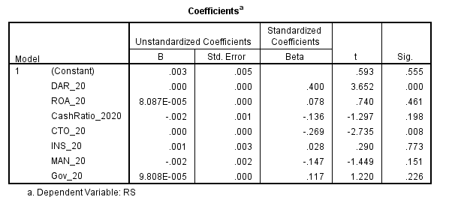
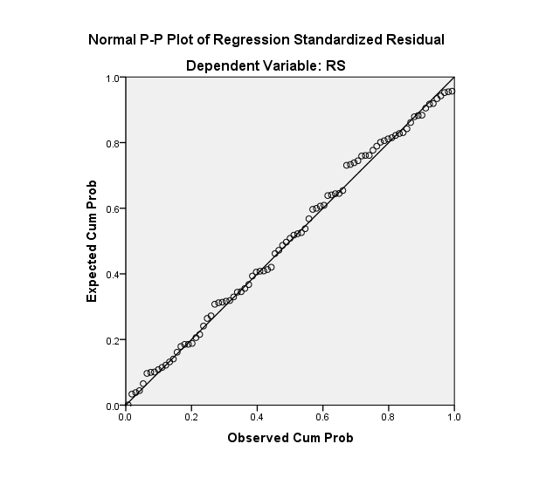
Figure 1 : Normality P Plot
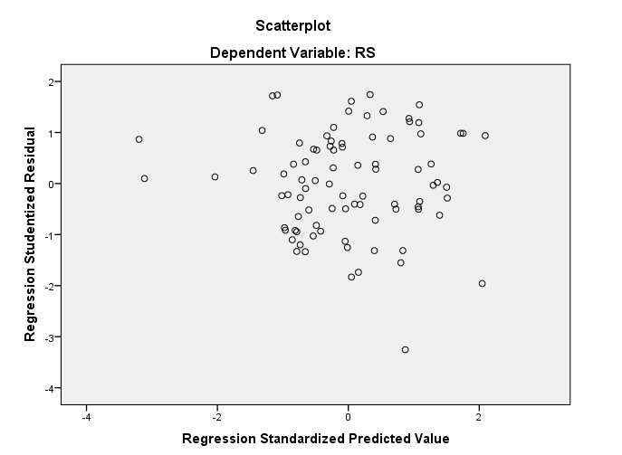
Figure 2 : Scatterplot

3. Discussion and Conclusion
3.1. Discussion
3.1.1. Company Financial Condition
From the results of the regression tests that have been carried out, the results show that Cash Turnover has a negative and significant effect on stock returns and DAR has a positive and significant effect on stock returns. While ROA and Cash Ratio have no effect on the company's stock return. From these results, it can be concluded that in abnormal conditions such as during this pandemic, DAR plays an important role in company resilience because in conditions like this the company needs an injection of funds to keep the company afloat during the pandemic.
High cash turnover can cause a decrease in company profitability. This is stated in (Deni, 2014) research, which states that high cash turnover can cause a decrease in company profitability. If the value of cash turnover decreases, the company's profitability increases. This can be caused because cash is used for other purposes such as covering losses on uncollectible accounts and maintaining unsold company inventories. Therefore H1a and H1b are rejected, H1c and H1d are accepted.

3.1.2. Governance
From the results of the regression tests that have been carried out, governance performance has no significant effect on stock returns during the pandemic. The results shown by the regression test in table 7 with a significance value of 1,220 which means that governance performance has no effect on stock returns. This is contrary to the research conducted by Syafrullah & Muharam (2017) which states that governance performance has a positive and significant effect on stock abnormal returns. From the results obtained, it can be concluded that the performance of corporate governance does not have any impact on the company's resilience during the pandemic. Therefore, hypothesis 2 is rejected.

3.1.3. Ownership Structure
From the results of the regression tests that have been carried out, the managerial and institutional ownership structure of the company has no significant effect on stock returns during the pandemic. The results shown by the regression test with a significance value of 0.151 and a beta value of -0.147 for managerial ownership and 0.773 and a beta value of 0.028 for institutional ownership, indicate that managerial ownership and institutional ownership have no effect on stock returns.
The results for managerial ownership are in line with research conducted by Marpaung (2016), the result of which is that managerial ownership has no significant effect on the risk of stock returns, but the direction is in accordance with previous research. This can be because the shares owned by the company's managerial parties are smaller than the main shareholders so that the managerial shareholders are still under the control of the company's main shareholders. Therefore H3a is rejected.
The results for institutional ownership contradict the research conducted by Marpaung (2016) which states that institutional ownership has a negative and significant effect on the riskiness of the company's stock returns. This can be because during this pandemic, the ownership of other companies' shares in a company does not increase supervision or monitoring of the management performance of a company. Therefore H3b is rejected.

3.2. Conclusion
From the results of the regression tests that have been carried out, the results show that Cash Turnover has a negative and significant effect on stock returns and DAR has a positive and significant effect on stock returns. While ROA and Cash Ratio have no effect on the company's stock return. From these results, it can be concluded that in abnormal conditions such as during this pandemic, DAR plays an important role in company resilience because in conditions like this the company needs an injection of funds to keep the company afloat during the pandemic. High cash turnover can cause a decrease in company profitability. This can be caused because cash is used for other purposes such as covering losses on uncollectible accounts and maintaining unsold company inventories.
From the results of the regression tests that have been carried out, governance performance has no significant effect on stock returns during the pandemic. The results shown by the regression test in table 7 with a significance value of 1,220 which means that governance performance has no effect on stock returns. From the results obtained, it can be concluded that the performance of corporate governance does not have any impact on the company's resilience during the pandemic.
From the results of the regression tests that have been carried out, the managerial and institutional ownership structure of the company has no significant effect on stock returns during the pandemic. The results shown by the regression test with a significance value of 0.151 and a beta value of -0.147 for managerial ownership and 0.773 and a beta value of 0.028 for institutional ownership, indicate that managerial ownership and institutional ownership have no effect on stock returns.
The results for managerial ownership are in line with research conducted by Marpaung (2016), the result of which is that managerial ownership has no significant effect on the risk of stock returns, but the direction is in accordance with previous research. This can be because the shares owned by the company's managerial parties are smaller than the main shareholders so that the managerial shareholders are still under the control of the company's main shareholders.
The results for institutional ownership contradict the research conducted by Marpaung (2016) which states that institutional ownership has a negative and significant effect on the riskiness of the company's stock returns. This can be because during this pandemic, the ownership of other companies' shares in a company does not increase supervision or monitoring of the management performance of a company.

References (APA 6th Edition Format)
Agustina, A., & Sumartio, F. (2014). Analisa Faktor-Faktor yang Mempengaruhi Pergerakan Harga Saham pada Perusahaan Pertambangan. Jurnal Wira Ekonomi Mikroskil : JWEM, 4(1), 51–60.
Deni, I. (2014). Pengaruh Tingkat Perputaran Kas, Perputaran Piutang dan Perputaran Persediaan terhadap Profitabilitas Pada Perusahaan Manufaktur yang terdaftar di Bursa Efek Indonesia. Jurnal Akuntansi. Fakultas Ekonomi. Universitas Maritim Raja Ali Haji. Kepulauan Riau, 1. htps://jurnal.umrah.ac.id
Ding, W., Levine, R., Lin, C., & Xie, W. (2020). Corporate Immunity to the COVID-19 Pandemic. National Bureau of Economic Research. https://doi.org/10.3386/w27055
Harahap, L. R., Anggraini, R., Ellys, E., & Effendy, R. Y. (2021). Analisis Rasio Keuangan Terhadap Kinerja Perusahaan Pt Eastparc Hotel, Tbk (Masa Awal Pandemi Covid-19). COMPETITIVE Jurnal Akuntansi Dan Keuangan, 5(1), 57. https://doi.org/10.31000/competitive.v5i1.4050
Haryono, S., Amarullah, F., & Fatima, E. (2017). PENGARUH STRUKTUR MODAL DAN STRUKTUR KEPEMILIKAN TERHADAP NILAI PERUSAHAAN. Jurnal Akuntansi Dan Keuangan Indonesia, 14, 119–141. https://doi.org/10.21002/jaki.2017.07
Indarti, M. K., & Extaliyus, L. (2013). Pengaruh Corporate Governance Preception Index (CGPI), Struktur Kepemilikan, dan Ukuran Perusahaan Terhadap Kinerja Keuangan. Jurnal Bisnis Dan Ekonomi, 20(2), 171–183. https://doi.org/10.1017/CBO9781107415324.004
Jensen, M. C., & Meckling, W. H. (1976). Theory of the firm: Managerial behavior, agency costs and ownership structure. Journal of Financial Economics, 3(4), 305–360. https://doi.org/10.1016/0304-405X(76)90026-X
Marpaung, J. G. (2016). PENGARUH MEKANISME TATA KELOLA PERUSAHAAN TERHADAP KEBERISIKOAN RETURN SAHAM PERUSAHAAN DI INDONESIA. PENGARUH MEKANISME TATA KELOLA PERUSAHAAN TERHADAP KEBERISIKOAN RETURN SAHAM PERUSAHAAN DI INDONESIA, 1–11.
Reuters, T. (2017). ESG Scores. ESG Scores, March.
Shen, H., Fu, M., Pan, H., Yu, Z., & Chen, Y. (2020). The Impact of the COVID-19 Pandemic on Firm Performance. Emerging Markets Finance and Trade, 56(10), 2213–2230. https://doi.org/10.1080/1540496X.2020.1785863
Spence, M. (2004). Editorial: Aktuell diskutiert. Job Market Signaling, 64(4), 419. https://doi.org/10.1055/s-2004-820924
Syafrullah, S., & Muharam, H. (2017). Analisis Pengaruh Kinerja Environmental , Social , Dan Governance ( Esg ) Terhadap Abnormal Return. Diponegoro Journal of Management, 6(2), 1–14.

