The Development of Adaptive Hydraulic Bamboo House Using the Gotong Royong Approach, An Effort to Cope with the Tidal Flood Problem in Kemijen, Semarang.

B. Tyas Susanti *, Etty Listiati*, Tri Hesti Mulyani *, Widija Suseno**

* *Faculty of Architecture and Design, Soegijapranata Catholic University, Semarang,
** Faculty of Civil Engineering, Soegijapranata Catholic University, Semarang santi@unika.ac.id

Abstract. Kemjen is one of the regions in East Semarang that has experienced severe tide problems. Various efforts have been made to overcome this problem, such as elevating the height of the house, especially for those who afford it. However, for low-income people, elevating house floor becomes very hard. The inability of low- income people to raise their homes makes their homes "sink" because the location of the house is lower than the road surface. Some efforts were made by raising the floor of the houses without raising the roof so that the houses get shorter. This study was conducted to provide alternative home designs in tidal areas by introducing a hydraulic house design made from bamboo. The design development and implementation were carried out by involving community participation. In this paper, we discuss the extent to which community participation can be mobilized and the stage of development that can involve the community. This research was conducted starting in March 2017 to make a hydraulic home design made from bamboo. In the implementation phase in February 2018, before the design was built, observations and interviews were conducted in order to get the most effective way to build the hydraulic adaptive house. Meanwhile, the design of the bamboo houses was made by taking into account the environmental factors and financial capabilities of the Kemijen community.

1. Introduction
Flooding and tide are the problems found in Semarang city. Semarang as one of the cities on the north
coast of Java has experienced tide in a fairly long period of time. One of the causes of this tidal flood is sea level rise and significant land subsidence. The area around the Old City of Semarang, which is located very close to Kemijen, is recorded based on the latest data has the land subsidence of 13.5 cm
/ year.
The problem of tidal flooding does require comprehensive management from the government and a short amount of time. While waiting for the government to handle this flood, the Kemijen community must try to live in peace with this tide problem. One of them is to elevate their houses as one of the efforts so that tide water does not enter the house. For well-off people, raising the floor of the house is not a problem, but for disadvantaged people, this is a quite hard problem because the cost of raising the house is not small, and they have to do it every five years.
The research related to bamboo house design was made as an alternative solution for Kemijen people, particularly for low income people. With a hydraulic stage house design and relatively inexpensive bamboo material, it is expected to be able to help the Kemijen community to coexist with the tidal flood. With the social capital owned by the Kemijen community, namely community participation through mutual cooperation, the construction of a hydraulic stage house made from bamboo will be able to be well-applied because the costs incurred will be cheaper, and the togetherness between the residents will be maintained

2. Methods
This study used a qualitative approach . The research location was the RW IV area which is the most severely affected area in Kemijen village. This research was a continuation of the previous research which was about hydraulic house design using bamboo material. At this stage, the hydraulic house design was implemented and built in one of the houses of the residents who were severely affected by tidal flood.
The approach used in this research stage was free interview method and in-depth interviews. The initial stage of the application of the hydraulic house design made from bamboo began with an interview with the chairman of RW IV and several community leaders to explore the possibility of implementing the hydraulic house design in the house of one of the residents. The consideration taken to choose a

location was a house with the owner who did not have financial ability to raise his house so that the house was most severely affected by tide. The selection of home locations was also the results of interviews and agreements between the research team and the RW administrators, as well as homeowners. The agreement also covered on how the house was built with the help of the community.
Focus Group Discussion (FGD) was part of the implementation stage of the hydraulic home design. The FGD was conducted by involving the management of RW IV, the Head of Kemijen Village, the RW IV residents, homeowners and the research team. The FGD was conducted at the location of the construction of the hydraulic house, and the input from the FGD participants became the input for the research team to improve the construction of the hydraulic house

3. Results and Discussion
3.1. Hydraulic Stage Houses Using Bamboo Material
Based on the data from the BMKG in 2016, the height of the tide that has occurred in Semarang is around 1 meter. Therefore, the proposed model of the house is a stage house 1.5 meters high from the ground/ road surface. The adaptive houses proposed using a bamboo house construction stage system. According to Frick, Heinz [1], a stage house is the most suitable construction for a bamboo- framed house because all parts of the building are detached from the ground and open to the wind. Bamboo is the main choice considering that bamboo is a relatively light material, inexpensive and relatively easy to find.
The hydraulic properties of this stage house allow the height of the house to be adjusted to the height of the tide using manual method. At the time of tide, this stage house can be raised to a height of approximately 1.5 meters. However, when there is no tide, the height of the house can also be lowered again. With this alternative hydraulic house, it is expected that the homeowner's habit of filling the floor of the houses/ raising the floor is no longer done so that the houses no longer "sinks" or becomes "short".
The raising of the hydraulic houses was done manually using human power. Therefore, it is very important to use the materials which are light in nature. The material selection also took into account
environmental factor that is close to beach location so that this aspect had to be considered to avoid
the rapid corrosion of the materials made of metal / iron. The lower floor column (stage) used galvanized iron which can be raised manually using hydraulic system

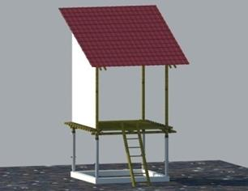
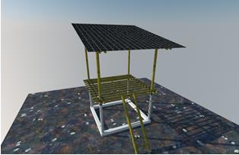

Figure 1 The Design of Hydraulic Adaptive House Using Bamboo Material [2]

3.2. Mutual Cooperation as a Form of Community Participation
Mutual cooperation is defined as a form of community participation and activities that help each other to achieve a specific goal that has been mutually agreed upon. In this mutual cooperation activity, there are elements of togetherness, volunteerism, kinship, help and participation. Mutual cooperation, by Koentjaraningrat, is defined as an activity carried out jointly with community members, carried out voluntarily and without pay, and carried out to provide benefits to the community [3]. In this mutual cooperation, the matter that cannot be abandoned is that everyone who participates will contribute according to ability and without sacrificing self-interest [4].
In this mutual cooperation activity, the bottom up process becomes very important, and the community is included in each stage of the process in which the activity is carried out. Zakaria [5] said that, in this

bottom up process with the added initiative of the community to carry out joint activities, this could be referred to as a form of horizontal participation. According to Sundariningrum in Sugiyah [6], this kind of participation can be categorized as direct participation. Furthermore, direct participation can be interpreted as a form of participation in which everyone can contribute and participate directly by expressing opinions, views, and activities.

3.3. Application of mutual cooperation in the construction of hydraulic house
This hydraulic house design, before built in the RW IV area which was the most affected by tide, was socialized to the community through the FGD forum (Focus Group Discussion). In the FGD held at the end of 2017, the design was presented. On this occasion, the input from the community was very helpful to improve the hydraulic house design in accordance with the local environment and their needs.
In making a hydraulic house design, community participation was found in the discussions during the
FGD. The FGD process was held at the meeting hall and attended by all residents. The FGD was held at night so that most of the residents could attend. In the meeting, the research team presented the designs that had been made and then followed by a discussion with the residents. In the discussion, almost all residents gave their input, especially related to the conditions of the environment which were submerged in tide, the structure that was in accordance with the conditions of the soil and environment, and whether the design was in accordance with the needs of the Kemijen community. The inputs from the community were accommodated by the team to refine the design before the design was applied. In this FGD activity, the community participation was very significant in the form of contributions of thought and input, not in the form of physical participation.
The physical participation in the form of mutual cooperation can be seen when the Kemijen community faced tidal flooding and other environmental problems such as floods caused by high rainfall. When a big flood struck the Kemijen Area, wealthy people were able to provide their places for the community to evacuate; public kitchen was immediately opened; and some people would immediately seek assistance to the government services. To anticipate flooding, the community also cooperated to buy pumps used to drain water that inundated their settlements and threw it into the river, while the maintenance costs came from the residents' donation.
The mutual cooperation of the Kemijen community as social capital was used to build a hydraulic adaptive house at the house of Mr. Heri/ Mrs. Hanifah. Mr. Heri is one of the residents in RW IV whose
financial ability did not allow him to raise his house. In addition, the condition of his house was very
humid because it was always inundated with tide. It was one of the reasons for choosing the house as a location to apply the hydraulic adaptive house design made from bamboo
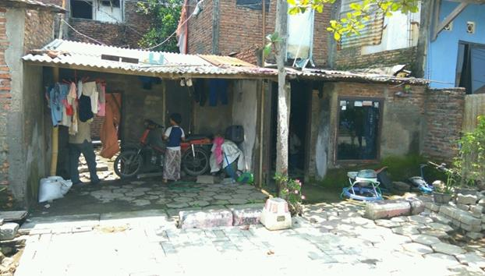

Figure 3: The house of Mr. Heri’s family, the location of the hydraulic house construction with the material of Bamboo

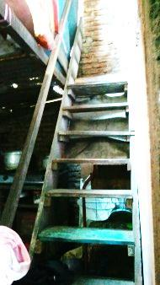

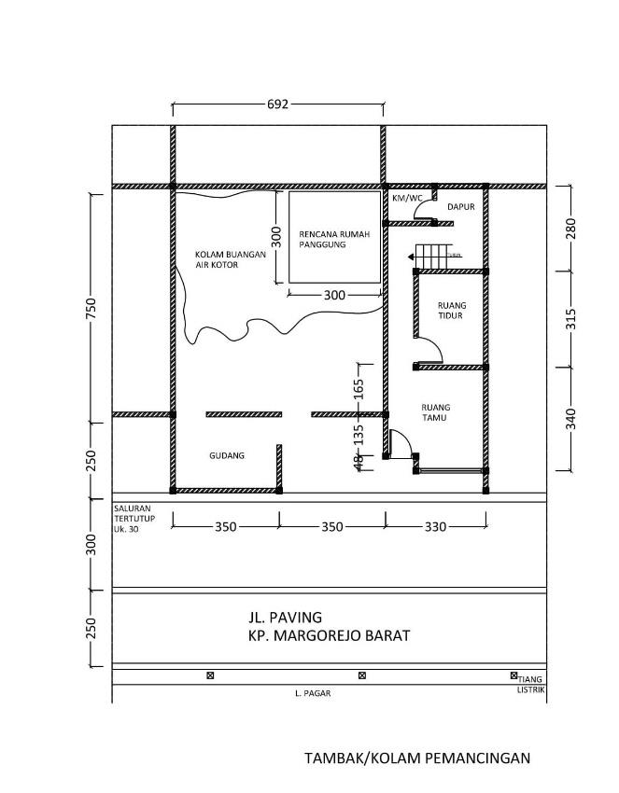

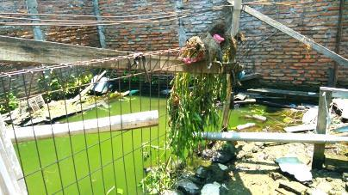

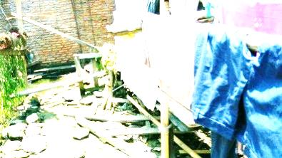

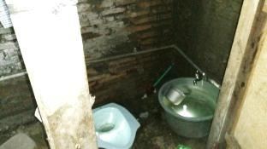

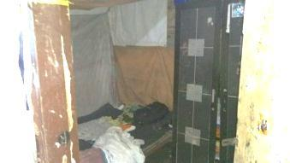

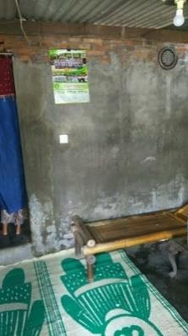

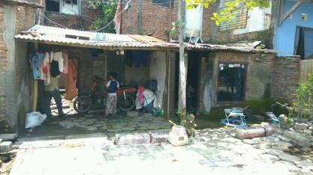

Figure 4 : The plan and physical condition of Mr. Heri’s house

This hydraulic house construction process included the stages of: 1) Preparation work, 2) Bamboo preservation and foundation installation, 3) Installation of sloof, 4) galvanized pipe installation (hydraulic pillar), 5) Installation of stage house floor and 6) Hydraulic Test of Stage House Pole

1. Preparation work
Preparation work was the initial stage which was marked by cleaning the location where the hydraulic house would be built. The land next to the house of Mr. Heri/ Mrs. Hanifah was very dirty, filled with piles of garbage and flooded with water. Therefore, junk and waste goods had to be disposed first. The location cleaning process was carried out together with Mr. Heri's family and some residents who lived next to the cleaning location. This work was carried out mainly by male residents. On weekdays, there were not many people who could help because they also had to work. The inundation of tide water next to the house was then used to soak the bamboos so that the bamboos was getting more durable.

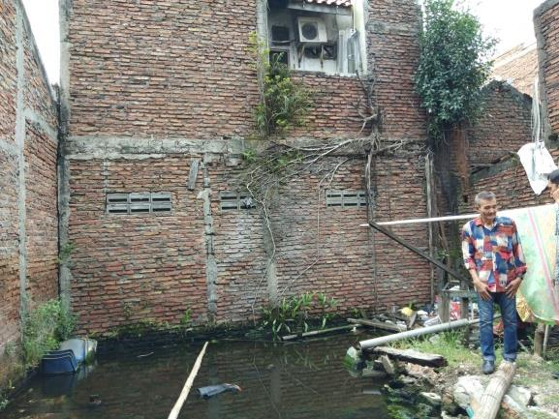

Figure 5: inundation location next to the house used to soak bamboos

2. Bamboo preservation and installation of foundation
Bamboo was the main ingredient of the hydraulic house. The bamboos used must be soaked first so that it lasts longer. Community involvement in this case was in bamboo preservation process. Because the number of bamboos was quite a lot, so it could not be soaked only on the land next to the house. Then, other fields had to be found. By deliberation, it was finally agreed to use a pond near the house that could be used for soaking. The soaking process was carried out by the constructor, the owner of the house, and assisted by a number of nearby residents.

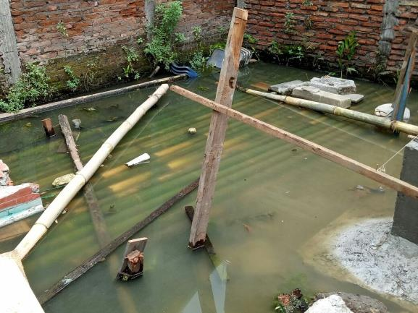

Figure 6: soaking part of the bamboo next to Mr. Heri's house

Foundation installation work is a job that requires a skill, so the work stage was carried out by a constructor with the expertise in this work under the supervision of the research team

Figure 7: Left: The erection of a bamboo pile as a base for reinforced concrete foundation
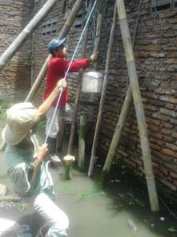

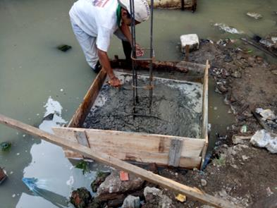

Right: the making of foot plate reinforced concrete foundation.

3. Installations of Sloof, Galvanized Pipe (Hydraulic Pole) and Stage House Floors.

In the three stages above, community participation was very limited. The participation was only in the provision of snacks provided by the host and some women from the surrounding community. Because the three stages of the work were very technical, they were handled by professional constructors. However, the learning process was still carried out to make them understand how to build it when they want to build similar houses later. The learning process was carried out to Mr. Heri and several residents who came to be invited to discuss by the team at each stage. The hope was that they understand the stages that must be done, how each stage is carried out, and so on.
For the foot plate foundation, it was made 50 cm higher than the road level with a size of 20x20 cm. The function of the sloofs was for hydraulic building binders.

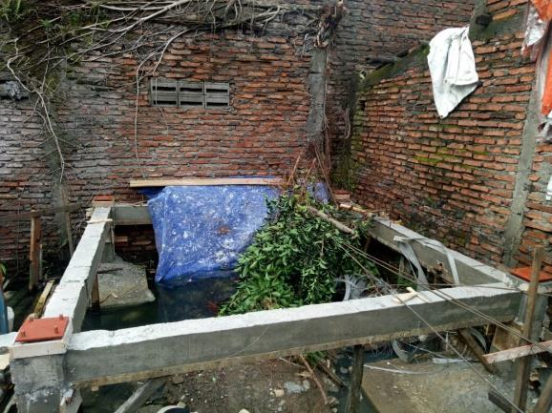

Figure 8: the sloofs used as the building binder for the “Hydraulic House”

Making supporting pillar was the most important part of making the hydraulic house. It was made in hydraulic so that it could be raised and lowered. The construction had to be prepared in the workshop and could not be done at the location. The material of this supporting pillar was galvanized pipe which is not easily corroded and resistant to sea/ brackish water. At this stage, there was absolutely no community participation.

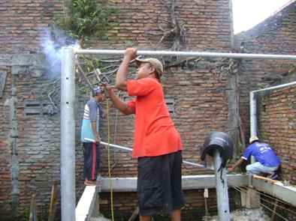
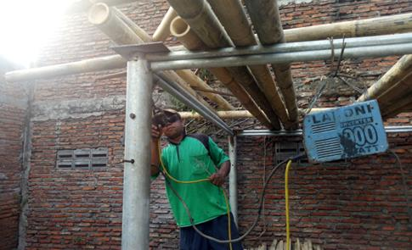

Figure 9: The making and installation of hydraulic pillar made of galvanized pipe

In the installation of the stage house floors, community participation began to be seen again. Here, the floors of the stage house made of bamboo started to be prepared. The bamboos that had been soaked for a long time were then taken and prepared to be used as floor materials. The removal of the bamboos from the soaking site was carried out together with the constructors, homeowners, and several community members, and then some of them began to help in cutting the bamboos according to the needs. The works were performed voluntarily.

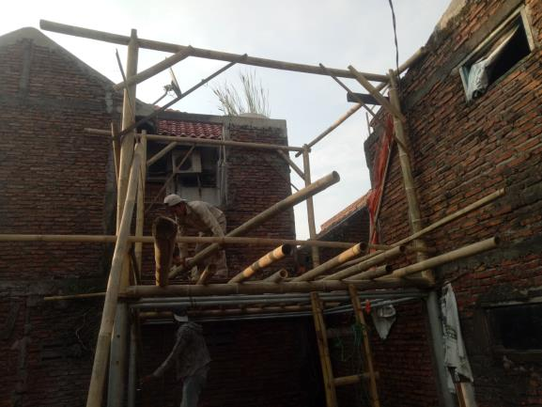
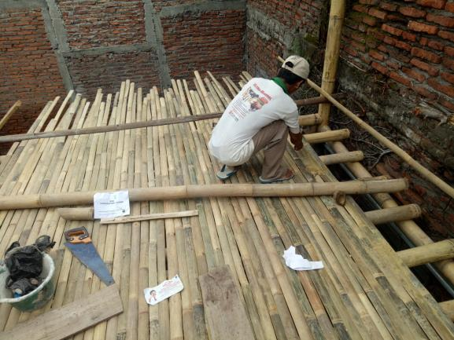

Figure 10: Installation of bamboo columns and floor

4) Hydrolic Test of Stage House Pole
This hydraulic house test was performed by raising the galvanized poles so that the floor of the stage house moved up. Jack/ tipping tool used was a car jack with a maximum load of 5 kg. Therefore, the building materials chosen and used in the house construction were light materials, such as bamboo and light steel.
At this stage, a cooperation was needed because, when raising it, at least four people were needed to jointly raise the hydraulic poles. There were four poles to be be lifted / jacked together. For this
stage, the assistance of the residents, especially men, was needed because it requires power to raise
the galvanized poles. Here, not only the homeowners, but the closest neighbors also helped in this trial.

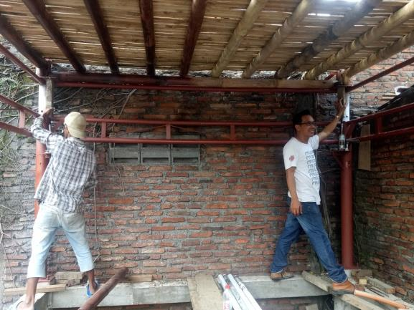
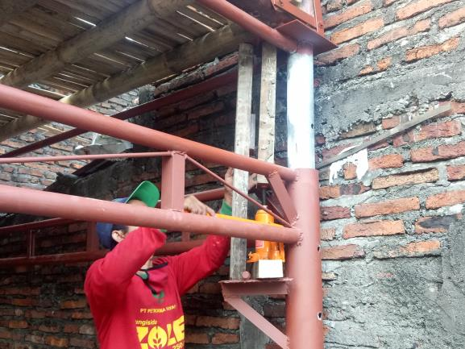

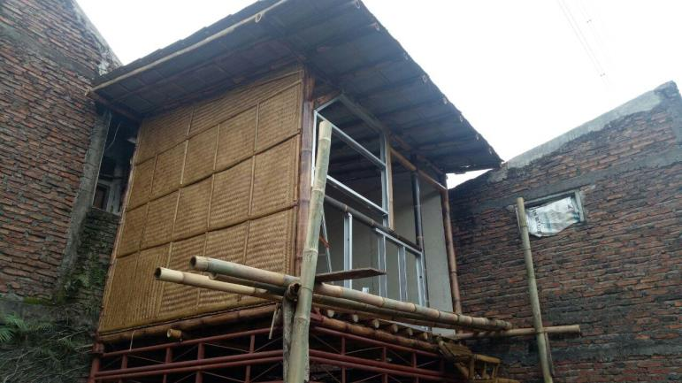

Figure 11: Hydraulic pole test by raising poles

Regarding the community involvement in the construction of this bamboo-based hydraulic house, community participation was found mostly when the community was asked to provide inputs on the hydraulic house design in the FGD forum. In this case, the participation was in the form of input and thought, not in physical form. Physical participation was found in several stages of the construction, but

the people involved were only the residents whose houses were close to the location of the hydraulic house construction. Meanwhile, during the FGD and design socialization, there were far more people who attended.
There were several things that hinder the physical participation of the community, including the lack of skills or technical skills so that the residents could only participate in the works that did not require special
skills. In addition, the other constraint was that more construction works were held on weekdays so that
the residents could only help on holidays or when they were not working. Although, according to residents, mutual cooperation activities by involving the residents was not as easy as before, in certain
conditions in which the community considers the problem as a common problem, community
participation can still be expected.

4.Conclusion
The main purpose of this activity was actually the transfer of knowledge, and it was carried out both in
the FGD forum and pior to this activity, during the works, and after the work was completed. However, not only in the FGD forum but also in the construction process, the inputs from homeowners and the chief of the RT were always accommodated with the aim that the application of this hydraulic house was truly in accordance with the wishes and needs of its users.
The community participation in the form of mutual cooperation was carried out especially in the works that did not require skills or expertises. Their participation could be seen in the activities, such as land
clearing, soaking bamboo, carrying bamboo to the building location, and during the trial in assisting to
raise the hydraulic poles. Community participation does not mean that the community participates in all activities but their role is adjusted to the ability of the community. Community participation in the form
of mutual cooperation is a concern of the community towards each other with the awareness that the
problem faced is a common problem existing before them.

5. Acknowledgement
The writers would like to gratitude to the Head of the Kemijen Village as well as all the managers of Kemijen Village who gave assistances to the researches for collecting data and for constructing the
hydrolic stage house. A big thank also delivered to the Hery’s Family for his cooperation and permission to use his land for constructing the stage house. This research was funded by the KEMENRISTEKDIKTI (the Ministry of Research, Technology, and Higher Education) through the scheme of Penelitian
Unggulan Perguruan Tinggi (the Superior Research of Higher Education).

References

[1] Frick, Heinz,. Ilmu Konstruksi Bambu- Pengantar Konstruksi Bambu. Penerbit Kanisius. Yogyakarta, 2004 [2] Etty E. Listiati, Tri Hesti Mulyani, B.Tyas Susanti, Widija Soeseno, Model Desain Rumah yang Adaptif Terhadap Rob di Kelurahan Kemijen Semarang. Laporan Penelitian PUPT Dikti, Universitas Katolik
Soegijapranata, Semarang, 2017
[3] K o e n t j a r a n i n g r a t A n t h r o p o l o g i D a n K e b u d a y a a n . G r a m e d i a . J a k a r t a . 2 0 0 5 [4] Mubyarto, Pengantar Ekonomi Pertanian. Lembaga Penelitian, Pendidikan dan Penerangan Ekonomi dan
Sosial, Jakarta, 1977
[5] Zakaria, Konsep Tentang Partisipasi. [Internet] Available from
<http://cvrahmat.blogspot.com/2011/04/konsep-tentang-partisipasi.html> (Accesed 28 May 2017)
[6] Sugiyah, Partisipasi Komite Sekolah dalam Penyelenggaraan Rintisan Sekolah Bertaraf Internasional di Sekolah Dasar (SD) Negeri IV, Wates, Kabupaten Kulon Progo . Tesis, PPs-UNY, 2001

